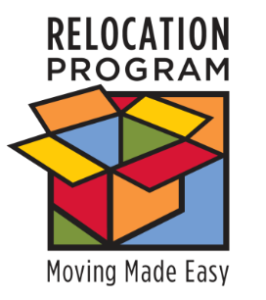
UNIT FLYER

Sponsor Training Available!
http://apps.militaryonesource.mil/esat

Having trouble helping your sponsors perform their job?
WE CAN HELP!
Check out the new comprehensive application for sponsorship training, communication and management.

eSponsorship Application & Training - eSAT:
http://apps.militaryonesource.mil/esat
The online application provides:
- Registration
- Training
- Certificate for your files
- Sponsorship duty checklist
- Newcomer and family needs assessment
- Congratulations and welcome letter templates and packages
- Links to important DoD and service moving websites
- Reporting module
- Customer satisfaction surveys
Contact: INSERT YOUR CONTACT INFORMATION

SPONSOR FLYER

So, now you’re a sponsor?
http://apps.militaryonesource.mil/esat

Don’t have a clue where to start?
We can help!
Sponsorship is an important unit responsibility. All the training and resources you need can be found within this new comprehensive application.
eSponsorship Application & Training - eSAT:
http://apps.militaryonesource.mil/esat
The online application provides:
- Registration
- Training
- Certificate for your files
- Sponsorship duty checklist
- Newcomer and family needs assessment
- Congratulations and welcome letter templates and packages
- Links to important DoD and service moving websites
- Reporting module
- Customer satisfaction surveys
Contact: INSERT YOUR CONTACT INFORMATION

