About the email:

April is Month of the Military Child. The email below is a template you can use to reach out to your colleagues in the MC&FP community to increase awareness of the Month of the Military Child email signature block and provide guidance on how it should be used. Plan to send this email to your network ahead of April.

Subject line: Month of the Military Child signature block

Body copy:

Dear Colleagues,

Thank you all for the work you do in service to our military families. During the month of April, as we observe Month of the Military Child, the Defense Department will launch a campaign to recognize the unique contributions of military children. Please join us in celebrating them by adding the campaign graphic and landing page link to your email signature block throughout April 2024.

I also encourage you to visit the 2024 Month of the Military Child landing page, which has been updated to provide the military community with links to the most current resources.

V/r,

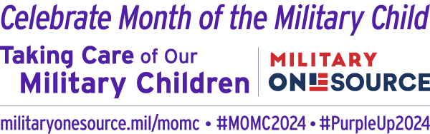

Visit militaryonesource.mil/momc.

