REACH—S
Resources Exist, Asking Can Help—Spouse
FACILITATOR’S MANUAL—Reserve and National Guard
Version 1, MAY 2021 (OPA-2021-035, PERSEREC-PA-20-01)

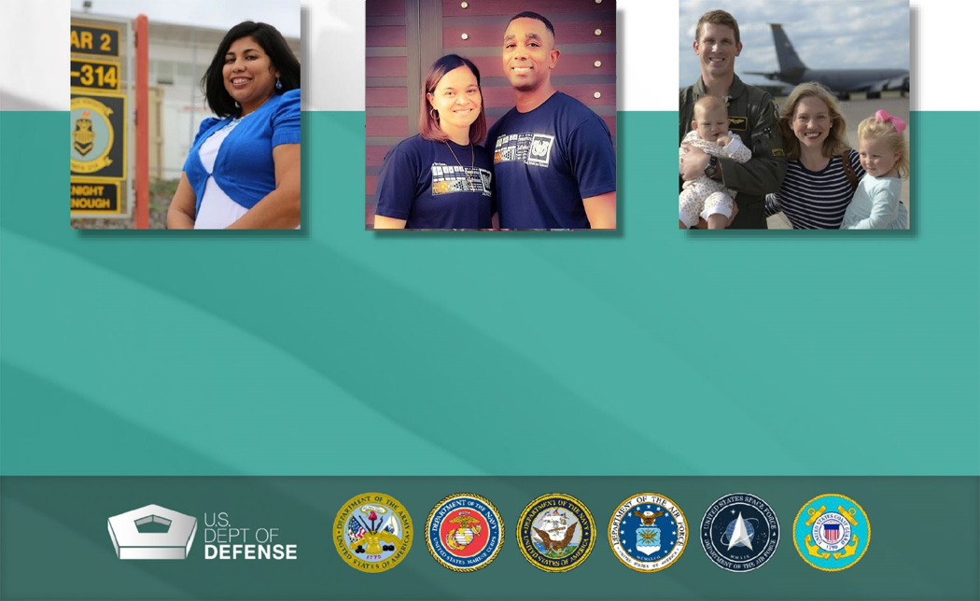

Table of Contents
REACH—S Resources Exist, Asking Can Help—Spouse 1
Table of Contents 2
Acronym List 5
1.0 INTRODUCTION 6
2.0 PURPOSE—Why implement REACH–S? 7
LEARNING OUTCOMES 7
3.0 BEHAVIOR—How do we motivate military spouses to reach out for help? 7
TAKEWAY 8
4.0 PROCESS—What happens during a REACH–S session? 8
5.0 PARTICIPANTS—Who is the REACH–S target audience? 9
6.0 FACILITATORS—Why is your role so important? 9
7.0 MOTIVATIONAL INTERVIEWING BASICS 10
8.0 PREPARATION AND LOGISTICS 11
8.1 Preparing to Lead Your First REACH—S Session 11
8.2 Session Organization 11
8.3 Session Group Size and Dynamics 13
8.4 Creating an Optimal Seating Arrangement 14
8.5 Equipment Specifications 14
8.6 Participant Recruitment and Advance Communication 14
8.7 Facilitator Preparation 15
8.8 Detailed REACH—S Session Agenda 18
8.9 Distress Protocol 22
9.0 REACH—S SLIDES WITH FACILITATOR’S TALKING POINTS 23
Session 1 24
SLIDE 1: REACH—S Title Slide 25
SLIDE 2: Session 1 Roadmap 27
SLIDE 3: Military Spouse Challenges 29
SLIDE 4: Barriers to Help Seeking 31
SLIDE 5: Mental Health Resources for Military Spouses 33
SLIDE 6: Mobile Resilience Tools 37
SLIDE 7: Fear of Being Perceived as Broken 40
SLIDE 8: Switching Providers 43
SLIDE 9: Practical Concerns 45
SLIDE 10: Military OneSource: 24/7 Support for the Military Community 47
SLIDE 11: Practice Call 51
SLIDE 12: The Importance of Self-Care 55
SLIDE 13: Self-Care and Mental Wellness Strategies 57
SLIDE 14: Takeaways 60
Session 2 62
SLIDE 1: REACH—S Title Slide 63
SLIDE 2: Session 2 Roadmap 65
SLIDE 3: Service Member Challenges 67
SLIDE 4: Service Member Barriers to Help Seeking 69
SLIDE 5: Handling Things on Their Own 71
SLIDE 6: Fear of Being Perceived as Broken 73
SLIDE 7: Mental Health Treatment and Career Outcomes 75
SLIDE 8: Mental Health Resources for Military Members 78
SLIDE 9: Mobile Resilience Tools 81
SLIDE 10: Military OneSource: 24/7 Support for the Military Community 84
SLIDE 11: Military OneSource Testimonials 88
SLIDE 12: Practice Call 90
SLIDE 13: Suicide Prevention Skills 94
SLIDE 14: Signs and Symptoms of Suicide Risk 95
SLIDE 15: Question, Persuade, Refer 97
SLIDE 16: Takeaways 100
10.0 REACH—S REFERENCES 102
10.1 Sections 2.0 and 3.0 102
10.2 Session 1 102
10.3 Session 2 106
APPENDIX A: REACH—S Virtual Sessions 109
A1. Facilitating a Virtual REACH–S Session 109
A2. Creating an Optimal Virtual Environment 109
A3. Equipment Specifications 111
A4. Facilitator Preparation 111
A5. Virtual Distress Protocol 114
APPENDIX B: Motivational Interviewing Worksheets 115
B1. Motivational Interviewing Principles and Techniques 115
B3. Motivational Interviewing Self-Test 117
B4. Helpful Responses Questionnaire 118
APPENDIX C: Question 21 on the Standard Form 86 120
APPENDIX D: How to Find Local Resources 130
D1. Local Resource Sections in the Handout 130
D2. How to Find Local Resource Information 130

Acronym List
ACRONYM | DEFINITION
A | Affirmations
AA | Avoid Arguing
C-SSRS | Columbia-Suicide Severity Rating Scale
COVID-19 | Coronavirus Disease 2019
DD | Develop Discrepancy
DOD | Department of Defense
DSPO | Defense Suicide Prevention Office
EE | Express Empathy
FRG | Family Readiness Group
FRO | Family Readiness Officer
IT | Information Technology
MC&FP | Military Community and Family Policy
MCL/VCL | Military/Veterans Crisis Line
MFLC | Military and Family Life Counselor
MTF | Military Treatment Facility
O | Open-Ended Questions
OPA | Office of People Analytics
PCS | Permanent Change of Station
PERSEREC | Defense Personnel and Security Research Center
POC | Point of Contact
PTS | Post-Traumatic Stress
QPR | Question, Persuade, Refer
REACH—S | Resources Exist, Asking Can Help—Spouse
RR | Roll with Resistance
SF-86 | Standard Form 86 Questionnaire for National Security Positions
SME | Subject Matter Expert
SOFS-A | Status of Forces Survey of Active Duty Members
SPPM | Suicide Prevention Program Manager
VA | Department of Veterans Affairs
VPI | Violence Prevention Integrator

1.0 INTRODUCTION
Resources Exist, Asking Can Help—Spouse was created to help spouses, significant others and family members of active duty, reserve and National Guard service members develop a proactive mindset around mental health and help seeking. REACH—S cultivates this mindset by empowering military spouses to overcome perceived barriers to care and use Department of Defense, service branch and local resources to find the mental health help they need. REACH—S addresses spouses’ barriers to care, connects them to resources and increases awareness of self-care practices. Because spouses often play an influential role in their service members’ well-being and decision-making, REACH—S also equips them with the knowledge and skills to encourage their service member to reach out for help. REACH—S embodies the public health approach to suicide prevention by teaching spouses the warning signs of suicide and bystander intervention techniques.
REACH—S is implemented through small group discussions that can be in person or virtual. This facilitator’s manual accompanies the REACH—S slides. As the REACH—S session facilitator, you will help military spouses:
- Recognize and overcome personal barriers to care
- Understand and help address their service members’ barriers to care
- Get connected with resources
By design, REACH—S is a flexible tool. REACH—S can be used as a stand-alone training or it can be integrated as a complementary module into suicide prevention training. It can also be used for family resilience building and is applicable to all military spouses, irrespective of their service branch or component. There are, however, separate versions of the REACH—S Facilitator’s Manual and slides for active-duty and Reserve Component audiences.
Two sessions of REACH—S are available:
- Session 1 focuses on the military spouse’s barriers to seeking mental health care, solutions to these barriers and self-care practices.
- Session 2 focuses on the service member’s barriers to seeking mental health care and teaches military spouses suicide prevention skills.
REACH—S was developed in 2020-2021 by the Defense Personnel and Security Research Center, a division of the Office of People Analytics, in coordination with Military Community and Family Policy, the Defense Suicide Prevention Office and the military service branches.

2.0 PURPOSE—Why implement REACH–S?
Research shows that military spouses exhibit similar rates of mental health disorders to service members,,, and they are significantly more likely to have had serious psychological problems within the past month than civilian spouses.⁵ Furthermore, up to 44% of military spouses do not receive the mental health care they need.⁵ Lack of awareness of available resources, stigma, practical concerns and fear of negative impact on their service members’ careers are all cited as barriers to obtaining proper care.^{3,6,7,8,9} Similarly, the Status of Forces Survey of Active Duty Members data from 2018¹⁰ indicate that approximately half of military personnel who need mental health support do not access resources and experience distress in silence. What if we could better connect military spouses and their service members with helpful resources before their problems spiral out of control? That is what REACH—S aims to do. The premise behind REACH—S is to eliminate barriers to care that stand in the way of help seeking and to promote a sense of hopefulness and connection.

LEARNING OUTCOMES
After participating in both REACH—S sessions, military spouses will be able to:
- Recognize the benefits of proactive help seeking for themselves and their service member
- Generate solutions to common barriers to mental health help seeking
- Identify confidential and non-confidential resources for mental health and other issues they and their service member are facing
- Know what to expect when they call Military OneSource and understand how this resource can help them and their family
- Understand the benefits of self-care and how to integrate self-care practices into their schedule
- Know the signs and symptoms of suicide risk and how to respond

3.0 BEHAVIOR—How do we motivate military spouses to reach out for help?
According to Expectancy-Value Theory,¹¹ there are three key ingredients in motivating someone to engage in a behavior:
- Expectancies for Success: Military spouses should have the knowledge and understanding of available resources, and should believe that if they reach out to them, they will receive effective support.
- Values: Military spouses should find meaning in reaching out for help, and understand how available resources can help them and their service member thrive.
- Costs: Military spouses’ perception of costs (i.e., barriers to care) associated with reaching out for help (e.g., “if I go to mental health, I might be looked down upon”) should be minimized to the greatest extent possible. These barriers can be addressed with data, facts and support for help seeking.

TAKEWAY
Even if we put into place the most effective resources and educate military spouses about their value, they may still be reluctant to use them unless we can address their perceived barriers to care. REACH—S targets all three components of the Expectancy-Value Theory:
- It builds up military spouses’ confidence about using resources
- It demonstrates the value of existing resources
- It addresses barriers that stand in the way of help seeking

4.0 PROCESS—What happens during a REACH–S session?
A REACH—S session has six key components:
- Introduction and Overview: You will introduce yourself to the participants and provide an overview of REACH—S, including its background and purpose.
- Unique Challenges: You will engage participants in a conversation about the unique challenges that military spouses (Session 1) or service members (Session 2) face, and how reaching out for help can help them overcome these challenges.
- Barriers to Seeking Mental Health Care: You will conduct an interactive discussion about barriers to care. REACH—S draws its content for this portion of the session from research studies, SOFS-A survey findings and discussions with subject matter experts (SMEs). Your job as facilitator is to leave no barrier to care unaddressed during this portion of REACH—S.
- In Session 1, focused on the military spouses’ barriers, you will address: (a) lack of awareness of available resources, (b) concerns about the stigma associated with seeking help, (c) continuity of care challenges, and (d) practical concerns, such as child care and the difficulty of scheduling appointments.
- In Session 2, focused on the service members’ barriers, you will address: (a) preference for self-reliance, (b) perception of being “broken,” (c) negative career impact, and (d) not knowing which resources to use.
- Practice Call to Military OneSource: You will make a practice call to Military OneSource together with your participants. The practice call is designed to demonstrate to military spouses how easy it is to call this resource for help with any of their or their service member’s military life-related problems, and to build up their confidence about using Military OneSource in the future.
- Self-Care (Session 1) or Suicide Prevention Skills (Session 2): You will lead a discussion on the importance of self-care in Session 1 and suicide risk awareness/bystander intervention in Session 2. Self-care is an often neglected, but very important, activity that aids in the maintenance and nourishment of one’s mental and physical health. Suicide prevention skills, on the other hand, are important for ensuring that warnings signs are recognized in others as early as possible, so that they could receive proper care. We recommend conducting Session 2 at least one month after Session 1, so as not to cause participant fatigue.
- Takeaways and Resources Handout: You will ask participants to share and discuss their key takeaways from the session. You will also review the Resources Handout with participants and introduce any local resource representatives who are present. For example, it is powerful to have a chaplain attend the REACH—S sessions to highlight the 100% confidentiality of their services, put a name to a face and encourage military spouses to reach out for help. It may be equally powerful to have a Military and Family Life Counselor or a representative from the mental health clinic attend the REACH—S sessions to introduce themselves. You are encouraged to consider which resources your target audience will find most useful and request their participation in REACH—S sessions.

5.0 PARTICIPANTS—Who is the REACH–S target audience?
REACH—S sessions are relevant to all military spouses. If we are trying to create a culture change around mental health and help seeking in the military community, it needs to happen at all levels of rank and across all service branches and components. None of us is immune to the problems life brings; we are all a part of this transformation. Therefore, it is critical that you invite both enlisted and officer spouses to participate in REACH—S sessions.
We recommend that you let participants attend any scheduled session rather than group them by rank. We encourage this mixing for two reasons: (a) To demonstrate that no matter the service member’s rank, all spouses face similar issues, concerns and obstacles that impact their mental health, and (b) to help facilitate a stronger sense of community among military spouses at a given installation. However, we acknowledge that every installation’s culture is different, so use your own discretion when grouping participants.
Although REACH—S was created with military spouses in mind, please note that close family members or acquaintances of the service member (e.g., parents, significant others) are also encouraged to attend.

6.0 FACILITATORS—Why is your role so important?
As a REACH—S facilitator, you are in a powerful position to change the attitudes around mental health and help seeking among military spouses. In this facilitator’s manual, we give you a foundation for structuring your REACH—S sessions, but we leave the rest up to you. We recognize that you know your audience best, so tailor your presentation style, pace and key messages to the needs of your audience. Most important, remember that a REACH—S session should feel like a stimulating conversation rather than a training or a briefing. In this manual, we offer many tools and tips for creating an atmosphere that encourages participants to join that conversation.
Ideally, you will have prior experience in interacting with reserve and National Guard military spouses and facilitating suicide prevention and resilience trainings. However, passion, conscientiousness and a desire to make a positive impact all supersede formal experience with facilitation. You should be able to connect with your group authentically and stimulate open sharing of thoughts and ideas. Establishing credibility with participants is critical, particularly in light of the sensitivity of some topics discussed during the session. Your credibility helps reduce judgment and stigma related to mental health and help seeking.
As a facilitator, you will:
- Provide the structure, guide the conversation and adapt REACH—S to meet your participants’ needs
- Create a safe environment for participants to share ideas and contribute to the discussion
- Be a good listener and ask questions that stimulate new thinking
- Have a sense of timing and use humor when and where appropriate
- Connect with the group by being authentic and open
- Display kindness and interest in getting others to practice self-care
- Be non-judgmental
- Be open to the concerns expressed by participants―make sure to acknowledge their validity
- Use motivational interviewing techniques to draw attention to positive experiences, ideas and recommendations shared by participants
- Shift focus away from negative experiences and concerns by asking how to improve things in the future or what others should do differently to make someone more comfortable with the idea of reaching out for help
- Have experience with responding to a mental health crisis¹²

TIP: Many military spouses are independent by nature. While that is an admirable trait in many situations, it can sometimes make it harder for them to ask for help. Try to connect with participants on their level without disparaging their values. If you feel comfortable, share examples of how you may have been in their shoes in the past.

7.0 MOTIVATIONAL INTERVIEWING BASICS
Motivational Interviewing is a helpful tool that you can use to make your REACH—S sessions more interactive and draw your participants into a conversation about mental health and help seeking. It uses a questioning approach that attempts to move an individual away from a state of uncertainty and toward finding motivation to make positive decisions and accomplish established goals. See APPENDIX B: Motivational Interviewing Worksheets for some hands-on practice with this new skill.
Motivational interviewing involves specific strategies, such as:
- Asking open-ended questions
- Discussing pros and cons of change
- Examining values
- Giving affirmation to strengthen self-understanding and resolve
You will be applying these strategies when you facilitate REACH—S. Your goal is to stimulate a productive discussion that encourages participants to seek help the next time they are in a stressful situation. To do this, use reflective listening to restate the participants’ words, so that they can hear their reasons and motivations stated aloud. Give positive feedback to participants when they identify problems and express an interest in changing a behavior—in this case, reaching out for help when needed. Lastly, assess participants’ degree of readiness to seek help by asking questions that begin with “On a scale from 1 to 10, where 1 is not at all likely and 10 is very likely, how likely is it that you might use … ?”
When facilitating a REACH—S session, consider using the following motivational interviewing practices:
- Be open to understanding the participants’ issues
- Remember that participants are capable of making their own choices
- Summarize for participants what you hear by using reflective listening and restating
- Ask participants to brainstorm their own ideas for change
- Help participants identify successes and challenges from their past and relate them to their current motivation to change
- Reassure participants that ambivalence to change is normal

8.0 PREPARATION AND LOGISTICS

8.1 Preparing to Lead Your First REACH—S Session
It is imperative that you closely review the REACH—S Facilitator’s Manual, Session 1 and Session 2 slide decks, Resources Handout, and Session 1 and 2 demonstration videos before leading your first REACH—S session. The videos feature a full-length facilitated REACH—S session with military spouses to serve as an example for you. Other facilitators have also found it beneficial to do a practice run with a primary REACH—S point of contact at their installation. This individual is typically a suicide prevention program manager, violence prevention integrator, chaplain or another professional who is overseeing implementation of REACH—S at the local level. Contact them to schedule some dedicated one-on-one time for REACH—S practice and feedback.
We have provided helpful guidance for how to present the REACH—S Session 1 and Session 2 slides in Section 9.0 of this manual. We strongly recommend that you present the information in your own words and personalize it to make REACH—S engaging and meaningful to your audience—all while covering the main discussion points outlined on each slide. Some of the best facilitators we observed while developing REACH—S used humor, shared personal examples and employed reflective listening techniques to draw their participants into the conversation. And, of course, practice makes better, so the more you practice ahead of time, the more prepared you will be.

8.2 Session Organization
REACH—S Session 1 and Session 2 consist of 14 and 16 slides, respectively, which are divided into six sections. Although REACH—S is meant to flow like a group discussion rather than a briefing or a formal training, the slides provide the structure and content for the conversation. In the table below, the Slide # column tells you which slides make up a particular section. The Time column specifies approximately how long you should plan to spend on each section. It is imperative that you practice your pacing by doing a dry run of the entire REACH—S session beforehand to give yourself a realistic sense of how long each section takes and where you may need to adjust your timing. All the slides are equally important; we do not want you to speed through any of them. See Section 8.8 for a detailed version of the session agenda.
SECTION # | SLIDE # | TIME | SECTION TOPIC | SECTION DESCRIPTION
Section 1 | Slides 1-2 | 8 min | Introduction and Overview | Facilitator introduction and REACH—S roadmap
Section 2 | Slide 3 | 10 min | Unique Challenges | S1: Conversation about the unique challenges that military spouses face  S2: Conversation about the unique challenges that service members face
Section 3 | Slides 4-9 | 25 min | Barriers to Seeking Mental Health Care | S1: Discussion about top barriers to help seeking reported by military spouses and solutions to these barriers  S2: Discussion about top barriers to help seeking reported by service members and solutions to these barriers
Section 4 | S1: Slides 10-11  S2: Slides 10-12 | 17 min | Practice Call to Military OneSource | S1: Review of Military OneSource resources and a brief practice call to Military OneSource to demonstrate its value  S2: Review of Military OneSource resources, testimonials from military spouses who used Military OneSource, and a brief practice call to Military OneSource to demonstrate its value
Section 5 | S1: Slides 12-13  S2: Slides 13-15 | 20 min | S1: Self-Care  S2: Suicide Prevention Skills | S1: Discussion about the importance of practicing self-care  S2: Discussion about warning signs of suicide risk and how to use the QPR technique
Section 6 | S1: Slide 14  S2: Slide 16 | 10 min | Wrap-Up and Resources Handout | Review of takeaways and Resources Handout
Total |  | 90 min

8.3 Session Group Size and Dynamics
The optimal group size for a REACH—S session is 10 participants, with a minimum of five and a maximum of 15. When preparing to facilitate a REACH—S session, consider the following tips:
SMALL GROUPS  Many participants feel more comfortable sharing when the group size is small. However, if it is too small (e.g., less than five), you might not obtain the diversity of experiences that will stimulate a meaningful discussion. | LARGE GROUPS  Participants who are uncomfortable speaking up may take advantage of the anonymity of a larger group and be less likely to share. In addition, some participants may feel pressure to agree with statements endorsed by the majority, even if they do not personally agree with them.
GROUP SIZE CONSIDERATIONS
To promote positive group dynamics, reiterate that the discussion is confidential and participants are free to share as much or as little as they would like about their experiences with help seeking. Encourage participants to share openly.
As you move through the session, evaluate the group dynamics by observing the following:
- Is there balanced sharing?
- Is everyone listening to each other?
- Is there interaction between participants?
- Are people helping each other with suggestions?
In the same fashion, evaluate each participant’s dynamics within the group by observing the following:
- Who takes the most initiative to speak up and share?
- Who takes the least initiative to share?
- How can you encourage the least outspoken participants to share their ideas?
Be mindful of the following contextual factors that can either promote or inhibit positive group dynamics:
SUCCESS DRIVERS  - Engaging and charismatic facilitator  - Ability to convey utility value (i.e., real-life relevance) of the REACH—S session  - Participants who answer and ask questions | SUCCESS BARRIERS  - Busy lifestyles  - Stigmatized nature of the content area  - Participants’ difficulty in understanding military culture and phrases
GROUP DYNAMICS

8.4 Creating an Optimal Seating Arrangement
A seating arrangement can have a powerful impact on the level of trust, connection, and sharing in the room. The following tips primarily apply to REACH—S sessions conducted in person. Refer to APPENDIX A: REACH—S Virtual Sessions for additional guidance on how to set up a “virtual room” to be welcoming and inviting to your participants.
- Instead of traditional rows, create a u-shape or circular seating arrangement that allows all participants to see you and their peers at the same time
- Resist the urge to stand behind a podium; instead, sit at the table with your participants or walk around

8.5 Equipment Specifications
The following audiovisual equipment and other supplies are necessary for leading an in person REACH—S session (see APPENDIX A: REACH—S Virtual Sessions for equipment guidance specific to virtual sessions).
ELECTRONIC  - Projector compatible with a laptop computer and cables with projection screen (at least 6’ x 6’) and audio speakers or large screen monitor/TV with audio  - Electronic remote to advance slides  - Pointer (preferably laser type)*  - Telephone with a speaker function  - Personal cellphone  * Optional | NON-ELECTRONIC  - Dry erase board with dry erase markers and eraser or flip chart with markers*  - Session handouts (e.g., REACH—S slides; APPENDIX C: Question 21 on the Standard Form 86; Resources Handout)  - Attendance sign-in sheets  * Optional

8.6 Participant Recruitment and Advance Communication
Work with your installation-level REACH—S POC to determine how to advertise and invite participants to REACH—S sessions and when to schedule them. Under optimal circumstances, group size should not exceed 15 participants.
Inform participants of the following ahead of their session:
- REACH—S session start and end times
- Location, maps, directions to the location and parking instructions
- The need to bring personal cellphones (unless not permitted in the room where a REACH—S session will be held)

8.7 Facilitator Preparation
Below is a checklist of key activities to complete before, during and after an in person REACH—S session (a similar checklist for virtual REACH—S sessions is in APPENDIX A: REACH—S Virtual Sessions). In addition, please review the “Pre-Session” and “During the Session” preparation sections that follow.
 | Checklist of Key Activities
2 Weeks Before The Session | - If you do not have facility access, contact installation security to get a pass/permit/be put on a list, or have an appropriate escort ready.  - Reserve a room with a speakerphone for 2.5 hours.  - Plan 30 minutes for setup, 90 minutes for the REACH—S session, and 30 minutes for cleanup.  - If possible, also reserve the room the day before to conduct a dry run of the session.  - Notify participants of date, time, location and directions.  - Ensure an information technology technician will be on hand on the day of the session.  - Invite command leadership to attend the first five minutes to help welcome everyone and open up the discussion.  - Invite local resource representatives to attend (e.g., chaplain, MFLC, financial counselor, mental health clinic POC).
1 Week Before The Session | - Send reminder emails to participants.  - Identify local resources and prepare handouts to distribute to participants after the REACH—S session (e.g., Resources Handout).  - Confirm availability of command leadership and resource representatives.
1 Day Before The Session | - Print any materials you plan to use or distribute to participants (e.g., sign-in sheet, Resources Handout, REACH—S slides, APPENDIX C: Question 21 on the Standard Form 86).  - Test all equipment.  - Conduct a dry run of the session in the room where it will be held.
On The Day Of The Session | - Arrive at least 30 minutes early to set up the room.  - Post directional signs.  - Test the speakerphone on the room phone to make sure it is working (or make sure your cellphone is on hand).  - Arrange seating in a U-shaped or circular arrangement (if possible).  - Display slides.  - Arrange handouts for distribution.  - Set up dry erase board or flip chart (if using).  - Ensure you know how to adjust the projection screen and lighting controls.
After The Session | - Follow up with any participant(s) whose questions require further research.
PRE-SESSION PREPARATION LIST
Prepare for your REACH—S session by completing the tasks outlined in the Checklist of Key Activities. In addition, review and complete the following items:
- Contact command leadership and the local resource representatives (e.g., chaplain, MFLC, or mental health clinic POC) to ensure that they can attend the session or verify their virtual attendance capabilities for the day of the session. Review the distress protocol in Section 8.9 with the resource representatives in case someone needs their professional support.
- Watch the REACH—S demonstration videos.
- Review the REACH—S Facilitator’s Manual, REACH—S Session 1 or Session 2 slides, and any information you received related to your participants’ background.
- Fill in your name, location and date on Slide 1.
- Fill in the Local Resources section of the Resources Handout on pages 8-9, 12, and 24 with any specific installation and local resources you wish to share with your target audience (e.g., chaplain, mental health clinic information; see APPENDIX D: How to Find Local Resources for further guidance).
- Coordinate with the chaplain, MFLC, SPPM, or VPI regarding any additional handouts that would be helpful to the session participants. They will likely already have some handouts you could use for this purpose.
- Decide whether you will distribute hard copies of REACH—S slides at the end of the session or whether you will send participants an electronic copy of the slides after the session. We recommend handing out the slides after the session to avoid distracting participants.
- Be prepared for a participant to self-disclose potentially concerning information during the session (e.g., marital conflict, significant financial debt, high levels of stress or even possible thoughts of self-harm).
- If participants self-disclose, be aware that they may feel vulnerable and need support. Review the distress protocol in Section 8.9 and know how to respond. Also know how to engage your support team (e.g., chaplain, MFLC) to ensure that the individual receives help.
- As you begin thinking about how to engage your participants, consider the following ground rules (you may also want to display them on a dry erase board or a flip chart during the session):
- Share your thoughts.
- Ask questions.
- Respect the opinions, attitudes and experiences of others.
- Respect the privacy of others.
- Silence your cellphones and other devices.
DURING THE SESSION
- Tell participants that the session will take about 90 minutes and that you will do your best to make it as interesting and useful for them as possible.
- Start on time and keep the discussion on track.
- Keep sections within the estimated time limits provided in Section 8.2 Session Organization.
- Steer the discussion in a productive direction and refocus participants on key topics when they divert from them.
- Ensure that all questions you pose to participants directly relate to the learning outcomes outlined in Section 2.0 PURPOSE—Why implement REACH–S of this manual.
- Avoid YES or NO questions. Use open-ended questions instead to draw participants into the discussion.
- If you observe that participants are still hesitant to speak up, consider reframing the question using a 1 to 10 scale. For example, “On a scale from 1 to 10, where 1 is not at all likely and 10 is very likely, how helpful do you think it would be for you or someone you know to seek help in the future for financial concerns? Please show your rating by holding up the corresponding number of fingers.”
- Use motivational interviewing techniques (see Section 7.0 Motivational Interviewing Basics and APPENDIX B: Motivational Interviewing Worksheets) that encourage participants to make positive behavioral changes. This often involves amplifying positive comments and avoiding prolonged discussions of negative comments. Remember that your goal is to help participants see that there is great value in seeking help for their problems.
- Use reflective listening by repeating what a participant has said and then posing a question that allows the participant to generate alternative approaches for how they could address the issue. For example, “So it sounds like you are so busy at work that you are not finding much time to go to appointments during the work day, so let’s think about resources that are available to you 24/7 that you can access when you are not at work.”
- If participants are hesitant to talk about themselves, present questions in a way that allows them to respond about their peers. For example, “How would you go about suggesting to a fellow spouse to call Military OneSource when you see them struggling?”
- If a participant asks you a question that you do not know how to answer, know that it is OK! As a first line of defense, turn to any other resource representative attending the session (e.g., a chaplain) and see if they have the answer. Next, check to see if another participant can answer the question. If nobody has the answer, say “I don’t know, but I can find out and follow up with you!” and then make it a point to find out the answer and follow up with all participants at a later time. This small gesture can feel very meaningful to the individual who asked the question.

TIP: Provide a printout of the REACH—S slides to anyone who wants a copy. Hand these out AFTER the session to avoid distracting participants. Alternatively, send your session participants an electronic copy of the slides after the session.

8.8 Detailed REACH—S Session Agenda

Section #  Slide #  Time | Section  Topic | Section Description | Materials | Facilitation Tips
Section 1  (Slides 1-2)  8 min | Introduction and Overview | - Introduce yourself; share a short personal story that relates to help seeking; explain why REACH—S is important to you personally.  - Describe the purpose of REACH—S.  - Outline the session content.  - Reassure participants that this is a safe space to share, but how much they share is up to them. | - Slides  - Flip chart or dry erase board (optional) | - Build initial rapport with the audience.  - Convey the overall importance of proactive help seeking.
Section 2  (Slide 3)  10 min | Unique Challenges | - Start by sharing the finding that military spouses (S1) or service members (S2) report high incidences of mental health issues and ask the audience why they think that might be.  - Steer the conversation toward the understanding that military spouses (S1) or service members (S2) face many uniquely difficult challenges.  - End the discussion of the unique challenges by explaining that one of the goals of REACH—S is to help overcome these challenges by reaching out for help. | - Slides  - Flip chart or dry erase board (optional) | - Make a strong connection between overcoming challenges and reaching out for help to resources.  - Be aware of when the conversation gets emotionally charged or derailed.  - Use motivational interviewing techniques when possible.
Section 3  (Slides 4-9)  25 min | Barriers to Seeking Mental Health Care | - Define “barrier to care.”  - Ask participants what barriers stand in the way of reaching out for help with a mental health issue for military spouses (S1) or service members (S2).  - Review literature and SME (S1) or DOD SOFS-A (S2) data on barriers to mental health help seeking.  - Address each of the barriers to care with evidence from research, policies, surveys and programs, and discuss participants’ own ideas for how to overcome them.  - Review the range of available confidential and non-confidential resources.  - Present Military OneSource as an important and broadly relevant resource and describe its services (e.g., 24/7 call, live chat). | - Slides  - Flip chart or dry erase board (optional) | - Be aware of when the conversation gets emotionally charged or derailed.  - Use rating scales (1-10) to gather information and build participant engagement.  - Identify common resources used by audience members.  - Look for opportunities to weave in how using Military OneSource may fit in with participants’ goals, priorities and values.
Section 4  (S1: Slides 10-11)  (S2: Slides 10-12)  17 min | Practice Call to Military OneSource | - Discuss the Military OneSource resources.  - S2: Discuss the Military OneSource testimonials.  - Make a “live call” to Military OneSource.  - Discuss participants’ reactions to the phone call.  - Ask participants to enter the Military OneSource phone number into their cellphones. | - Slides  - Audio speakers  - Room phone or facilitator’s cellphone  - Participant cellphones | - Discuss participants’ reactions to the call and ask how likely they are to suggest someone call Military OneSource in the future.  - Reinforce participant strengths by reflecting and amplifying positive comments about their willingness to reach out.
Section 5  (S1: Slides 12-13)  (S2: Slides 13-15)  20 min | Self-Care (S1)  or  Suicide Prevention Skills (S2) | - S1: Describe self-care and its importance.  - S1: Discuss self-care and ways to incorporate it into one’s routine.  - S2: Explain that sometimes we are unable to prevent crises from escalating.  - S2: Describe and discuss the signs of suicide risk.  - S2: Introduce and review the QPR technique. | - Slides | - S1: Steer the conversation toward encouraging the integration of self-care into everyday routine.  - S2: Be prepared for participants to share personal experiences with suicide (review Section 8.9 Distress Protocol).
Section 6  (S1: Slide 14)  (S2: Slide 16)  10 min | Takeaways and Resources Handout | - Review takeaways.  - Have resources present in the room introduce themselves and answer any questions.  - Describe various resources available to participants and distribute the Resources Handout as soon as you are finished going over slides 14 (S1) or 16 (S2).  - Remain in the room to answer any questions from participants who wish to speak privately or who appear distressed and need help. | - Slides  - Session handout(s) | - Begin by summarizing the feedback from the group. That way it feels like the facilitator has “heard” the participants; (e.g., “what I’m hearing from you is ...”).  - Reinforce how finding the right resource for any situation may help participants stay on course with their goals and thrive.

8.9 Distress Protocol
There is minimal risk that REACH—S will cause psychological or physical distress to participants. However, if a participant becomes distressed during the session, stop or pause the session and accompany the distressed participant to a private area, preferably where the participant can sit down. Assess the severity of the participant’s distress and then contact the chaplain (or the mental health clinic representative and/or MFLC, if present) and request that they attend to the participant’s needs. Work with the individual and chaplain (or enlisted religious affairs personnel/mental health support staff/MFLC) to determine whether follow-up mental health care is necessary.

OPTING TO SEEK MENTAL HEALTH CARE
Assess the situation and ask the participant if they would like to see a provider in the local mental health clinic, Military Treatment Facility or other applicable mental health provider. If you determine that the participant is at high risk for distress or would like to speak with a provider to possibly seek mental health care, contact the local clinic/MTF/mental health provider and remain with the chaplain (if present) and participant while they wait for follow up or see the mental health care provider. Communicate with the participants and session coordinator about rescheduling the session for another day.
OPTING NOT TO SEEK MENTAL HEALTH CARE
If the participant chooses not to see a mental health care provider and is at a low level of distress, ask if they would like to continue with the REACH—S session or be excused. If the participant chooses to leave, ask the participant to coordinate with the chaplain or contact a family member or a friend who can help them get home safely. Ask the participant to wait until the family member or friend arrives. Ask if the participant is willing to share their phone number, so that you can follow up with them.
EVENT REPORTING AND FOLLOW-UP
Report the event to the local REACH—S POC and follow up with the participant and the attending mental health care provider (if one was seen) to ensure a safe outcome.

9.0 REACH—S SLIDES WITH FACILITATOR’S TALKING POINTS
REACH—S Session 1 consists of 14 slides; Session 2 consists of 16 slides. Each slide has detailed SAMPLE TALKING POINTS associated with it, identified by the words SAY and ASK, that we have provided as an example. We recognize, however, that you know your audience best, so we want to encourage you to tailor your presentation style, pace and key messages to the needs of your audience. While the talking points constitute one way of presenting the information on the slides, we expect that you may find a more natural way of presenting it. Follow your intuition and experience and construct your own natural way of introducing the material, while keeping in mind the purpose of each slide.
In the end, remember to cover the main points on each slide in order to preserve the integrity of the REACH—S session and maintain consistency of how REACH—S is delivered across sessions. The main points on each slide are identified by the words MAIN DISCUSSION POINTS. Each slide also has specific guidance on how to present the material displayed on it and manage the group discussion.
The rest of this section presents instructions regarding ANIMATIONS, MATERIALS, CUES for you and facilitator TIPS for each of the slides. Notice that most slides have questions that you will have to ask the audience—this helps ensure that the session is interactive! Above all, remember that a REACH—S session should feel like a stimulating conversation rather than a training or a briefing. You can also consult the references list in Section 10.0 REACH—S REFERENCES to learn more about the topics and resources covered in REACH—S slides.

Session 1
Overcoming Barriers, Finding Resources and Thriving as a Military Spouse

SLIDE 1: REACH—S Title Slide
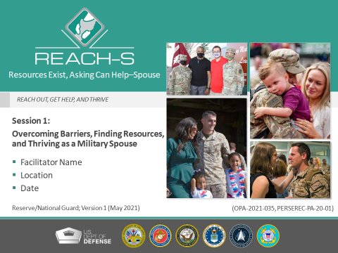
ANIMATIONS:
None.
MATERIALS:
None.
MAIN DISCUSSION POINTS:
On this slide, we will discuss the following topics:
1. Facilitator Introduction
2. What Is REACH—S

SAMPLE TALKING POINTS:
[Topic 1: Facilitator Introduction]
SAY:
- Welcome, everyone! Thanks for being here today.
- Before we get started, I’d like to introduce myself. [Insert a brief personal introduction].

CUE:
If command leadership is attending the session, ask them to make brief welcoming remarks before departing.

[Topic 2: What Is REACH—S]
SAY:
- So you’re probably wondering what REACH—S is and what it’s all about?
- REACH—S stands for “Resources Exist, Asking Can Help—Spouse.”
- And it’s all about taking care of problems we might be having before they get too overwhelming. It’s about self-care.
- We’re not going to use the term “training.” This is not a training—it’s a conversation! I would like to hear from you today and hope you’ll join me in this discussion.
- The goal of this session is to empower you to help yourself.
- I want you to leave here today with a new mindset about asking for help. Reaching out for help is important—not just for you, but for everyone around you. Just like on airplanes, we all have to put our oxygen masks on first before we can help others. We have a duty to take care of ourselves. I hope this session will show you how easy it is to take the first step and get help when you first think you may have a problem.
- Some of the resources described here may not apply to you if you’re not a military spouse. However, the handout that I’ll pass out [or email] to you at the end of this session identifies resources applicable to all of you.

TIP: Participants may include reserve and National Guard spouses, significant others and parents of service members. Try to tailor your talking points to your audience.

ASK:
- One quick question, are there any spouses in attendance who are also currently serving in the military?

TIP: If there are, during the session, make sure to engage them in a discussion about their experience with resources in both the service member and spouse roles.
SAY:
- There are two REACH—S sessions. You’re attending the first one today. Session 2 will be scheduled for a later date. Each session presents unique and valuable information. You’ll get the most benefit by attending both sessions.

TIP: If you already know when Session 2 is scheduled, be sure to let participants know.

SLIDE 2: Session 1 Roadmap
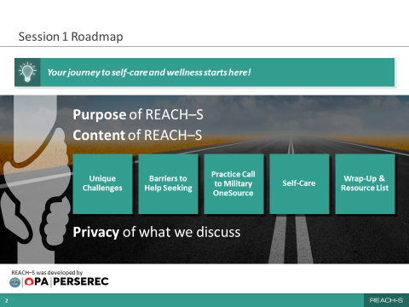
ANIMATIONS:
None.
MATERIALS:
None.
MAIN DISCUSSION POINTS:
On this slide, we will discuss the following topics:
- REACH—S Purpose
- Content of the Session
- Privacy of What We Discuss

SAMPLE TALKING POINTS:
[Topic 1: REACH—S Purpose]
SAY:
- REACH—S was developed by DOD’s Office of People Analytics. It was developed to help familiarize military spouses with available mental health resources and encourage them to use those resources when they need them.
- The idea behind REACH—S is very simple. If more of us reach out for help before our problems get out of control, we can help change the mindset around mental health and help seeking!
- Creating this sort of a culture change requires everyone’s help.
- So, with that in mind, the most critical goal of this session is to help you develop the confidence and skills to get the help you need in the future, when the need arises.

[Topic 2: Content of the Session]
SAY:
- We’ll start today by discussing the unique challenges that military spouses face.
- We’ll also talk about some of the barriers to help seeking that you might encounter and resources that are available to you.
- For practice, we’ll make a call to Military OneSource to get a better feel for what this resource has to offer.
- Then we’ll talk about self-care, what it is and why it’s so important for our mental health.
- Finally, we’ll discuss key takeaways, wrap up the session and distribute the handout.
- Today’s session should take about an hour and a half, but we may get out sooner than that.

[Topic 3: Privacy of What We Discuss]
SAY:
- Let’s go through some “housekeeping” notes before we begin.
- My aim is to provide a comfortable and safe environment for you to discuss your concerns and experiences about seeking help for any issue in your life.
- To that end, what’s said in the group stays in the group.
- We need to feel comfortable to share and, hopefully, make some new connections while we’re here.
- To make this a safe space to share, we must respect everyone’s confidentiality.
- If you need to leave the room temporarily, just give me a thumbs up to let me know that you’re OK. If I don’t see that, I’ll follow up with you to make sure you’re OK.
- Feel free to speak up at any time.

SLIDE 3: Military Spouse Challenges
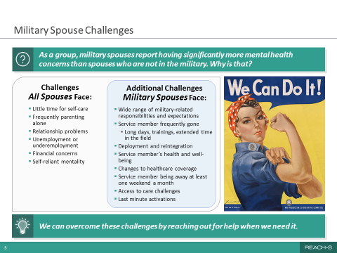
ANIMATIONS:
This slide will appear with only the top question revealed at first. You will then be cued to advance the rest of the slide.

MATERIALS:
Flip chart or dry erase board (optional).

MAIN DISCUSSION POINTS:
On this slide, we will discuss the following topics:
- Rates of Military Spouse Mental Health Concerns
- Challenges Military Spouses Face

SAMPLE TALKING POINTS:
[Topic 1: Rates of Military Spouse Mental Health Concerns]
SAY:
- To start us off, I want to get your thoughts on something. Why do you think military spouses report having significantly more mental health concerns than spouses who are not in the military?

TIP: Steer the conversation toward the unique challenges military spouses face. This is your first opportunity to begin building a meaningful open dialogue.

SAY:
- Thank you for sharing your thoughts. That was some great insight.

CUE:
Click to advance the rest of the slide.
[Topic 2: Challenges Military Spouses Face]
SAY:
- As you can see here, in the box on the left, there are general challenges that all spouses tend to face.
- But military spouses face some unique challenges. They include:
- Wide range of military-related responsibilities and expectations
- Service member frequently gone
- Long days, trainings, extended time in the field
- Deployment and reintegration
- Service member’s health and well-being
- Access to care challenges
- Changes to health care coverage
- Last-minute activations
- Military member being away at least one weekend a month

TIP: It’s helpful to expand on each one of the challenges identified or, if time is limited, to select a few to discuss briefly. Providing examples can help participants really feel connected to the content.

ASK:
- What challenges have you faced during your time as a military spouse?

TIP: On a dry erase board or flip chart, write down the challenges military spouses identify that are not presented on the slide. This will help validate their opinions.

SAY:
- And that’s why we’re here today, to help you overcome these challenges by providing the tools and knowledge for reaching out for help when you need it.

SLIDE 4: Barriers to Help Seeking
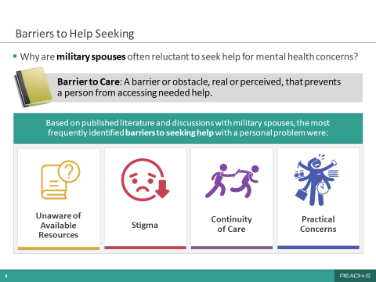
ANIMATIONS:
This slide will first appear with only the top question. You will then be cued to bring up the “Barrier to Care” definition. You will then be cued to advance the rest of the slide.

MATERIALS:
None.

MAIN DISCUSSION POINTS:
On this slide, we will discuss the following topics:
- Why Military Spouses May Be Reluctant to Seek Mental Health Help
- Frequently Identified Barriers to Care

SAMPLE TALKING POINTS:

[Topic 1: Why Military Spouses May Be Reluctant to Seek Mental Health Help]
ASK:
- We talked about some of the challenges military spouses face. Why do you think spouses of service members choose not to seek help?

TIP: Steer the discussion toward the idea of “barriers” that prevent military spouses from getting help for their mental health needs. Doing this will help set up the discussion for the rest of the slide.

CUE:
Click to advance the “Barrier to Care” definition.

SAY:
- A barrier to care is defined as “an obstacle, real or perceived, that prevents a person from accessing needed help.” Understanding what those barriers are can help us understand why some people may be reluctant to seek help, especially for mental health concerns.

ASK:
- What stands out about that definition for you?

SAY:
- As we discussed, what’s important about this definition is that the barrier feels real to the person, and it guides how they interact with the world.

ASK:
- So what do you think are some barriers to care for military spouses that might stop them from reaching out for help?
[Topic 2: Frequently Identified Barriers to Care]
CUE:
Click to advance the rest of the slide.

SAY:
- Now, let’s look at some research findings from literature and interviews with military spouses to see how the barriers we discussed line up with what’s shown here.
- The first barrier to care is being unaware of available resources. You may not know where to go for mental health services or how to find a counselor who understands your needs.
- Second, many worry about stigma. Maybe you’re embarrassed to seek mental health care or worried about your confidentiality.
- Another barrier to care is related to concerns about continuity of care. Sometimes changes in activation status can lead to disruptions in health care coverage and, therefore, providers.
- Finally, there are also practical concerns. You may be worried about scheduling an appointment, wait time, or cost of treatment and insurance issues.
- Now that we’ve identified the barriers that matter to you, let’s spend some time discussing solutions and strategies for addressing each of them.

SLIDE 5: Mental Health Resources for Military Spouses
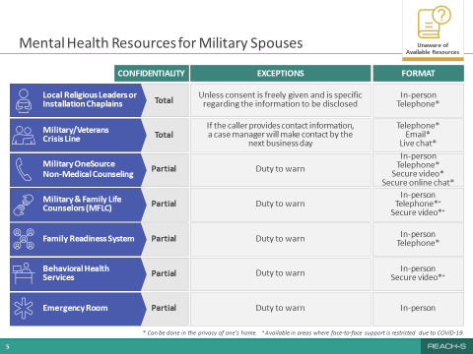
ANIMATIONS:
None.

MATERIALS:
None.

MAIN DISCUSSION POINTS:
On this slide, we will discuss the following topics:
- Mental Health Resources for Military Spouses
- Resources for General Mental Health Questions or Issues
- Resources for Mental Health Treatment

SAMPLE TALKING POINTS:
[Topic 1: Mental Health Resources for Military Spouses]
ASK:
- So, who would you call if you had a mental health concern for yourself?

TIP: To help guide the discussion, gauge participants’ knowledge of available resources; then use motivational interviewing skills to support the discussion surrounding resources and help seeking.

SAY:
- One barrier to care that could prevent you from seeking help is simply not knowing what resource to turn to.
- With so many available resources out there, it’s hard to know which one to choose.

TIP: Steer the discussion toward verified and established resources. If needed, clarify that the slide focuses on military resources available to military spouses and does not focus on community-based resources. Mention that the Resources Handout has all of this information and more.

- Let’s talk specifically about the various mental health resources available to you because I want to highlight some important distinctions between them.
- A few quick notes about this table:
- The asterisk and plus sign at the bottom indicate:
- *Can be done in the privacy of one’s home.
- ⁺ Available in areas where face-to-face support is restricted due to COVID-19.
- Duty to warn means that if someone shares an intention to harm themselves or others, such as children, domestic partners or elderly, service providers must report these situations to the authorities.

[Topic 2: Resources for General Mental Health Questions or Issues]
ASK:
- How many of you know the chaplain associated with your service member’s unit?

SAY:
- Chaplains work not only with military personnel, but in most cases, their families as well. They are a great resource because they offer total confidentiality unless you specifically allow them to share what you have talked about with, for example, another provider. They can meet in person or by phone. You can also meet with your local religious leaders in your community for support.
- If you don’t know the chaplain assigned to your spouse’s unit, ask your spouse or contact his or her unit to get the chaplain’s contact information.
- Chaplains are happy to speak with anyone, regardless of their religious beliefs. And religion doesn’t have to be a topic of conversation.
- The next resource is the Military/Veterans Crisis Line. It’s a free, confidential resource that’s available to anyone, and the staff are specially trained in helping service members, spouses and veterans. They can provide help and assistance at any time—even if you’re not in an immediate crisis.

ASK:
- Who has heard of or used Military OneSource?

SAY:
- I really want to highlight Military OneSource because it has so many resources. It can provide support for almost any problem you’re facing, via phone, in person, secure video or online chat. It’s truly a great place to start, especially if you don’t know where to go. Whether you’re dealing with a financial issue, stress at work or a relationship issue, Military OneSource can help you. Most important, Military OneSource offers confidential non-medical counseling. But just be aware that it comes with a provider’s duty to warn if there are concerns about self-harm or safety of others, or if there is illegal activity involved.

ASK:
- Now, who has heard of or used a Military and Family Life Counselor, or MFLC, before?

SAY:
- MFLCs are a really great resource. They support service members and their families and provide non-medical counseling. They do not take notes during their sessions, so there is no paper trail. Just note that, similar to Military OneSource counselors, they also have a duty to warn if there are concerns about self-harm or safety of others, or if there is illegal activity.
- They can meet with you in person or by phone or secure video. An MFLC can meet with you anywhere on or off base except your house or your vehicle. So they could meet you at a café or even a playground. They will also meet you outside of normal working hours if scheduling is an issue.

TIP: Not all installations have the MFLC program available. Verify whether your installation has an MFLC and make note of their contact information. If there are no MFLCs nearby, focus the conversation on local counseling services available at your installation.

- Next we have the family readiness system. This system is a network of agencies, programs, services and individuals that all work together in support of service members and their families. The system’s programs and roles include the family readiness group, the key spouse, the Navy ombudsman and family readiness officer.
- I’d like to highlight a few of these here. Some of these may be very familiar to you!

ASK:
- Which service branch are your spouses a part of? I’ll go through those specifically.

TIP: You may know the answer to this question, so only ask if you don’t know.

TIP: You only need to highlight or review the resources below that relate to the service branches applicable to the audience. If you do not know the options available to the family members attending, such as at joint bases, please research these before your session.
SAY:
- Family Readiness Group (Army and Navy):
- The FRG is a unit-specific group made up of family members, volunteers and soldiers/sailors. It provides resources and support and keeps families informed on unit matters to ensure readiness and resilience.
- Key Spouse Program (Air Force):
- Key spouses are commander-appointed and establish communication between the command, service members and their families. Key spouses provide resources to service members and their families to enhance unit cohesion.
- Navy Ombudsman (Navy):
- A Navy ombudsman represents the commanding officer and communicates information and resources available from the command to families.
- FRO (Marine Corps):
- The FRO is the link to Marines and their families and provides communication, resources and family readiness support.

ASK:
- Have any of you used these programs?
[Topic 3: Resources for Mental Health Treatment]
SAY:
- Then there are the behavioral health services or military treatment facilities, which are available when your spouse is on activated status, and possibly during other times depending on your insurance. Their confidentiality level is also partial because of the duty to warn requirements. Typically, they will meet you in person or by secure video.
- And finally, going to an emergency room is an effective way to obtain immediate assistance for a mental health crisis. Their first priority is your health and safety, but they do have a duty to warn.
- The biggest takeaway from what we went over: Don’t give up on your quest for mental health support! You could have a negative experience with one provider and the next one could change your life!

ASK:
- That was a lot of information I went over. Does anyone have any questions about the various military-related resources available to you or when to use them?

SLIDE 6: Mobile Resilience Tools
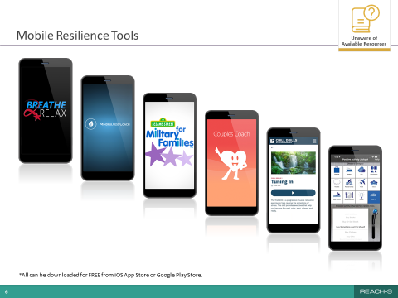
ANIMATIONS:
None.

MATERIALS:
None.

MAIN DISCUSSION POINTS:
On this slide, we will discuss the following topics:
- Availability of Mobile Self-Help Apps
- Purpose and Features of Several Mobile Apps

SAMPLE TALKING POINTS:
[Topic 1: Availability of Mobile Self-Help Apps]
SAY:
- What if you still don’t feel comfortable reaching out to a counselor?
- Well, good news! There are mobile resources that you can access privately through your phone.
- There are many free helpful apps to help you maintain and improve your mental health. The ones highlighted here were specifically developed for the military population and their families by the DOD or the Department of Veterans Affairs.
- The best part about using an app is that it’s confidential and you have instant access.

[Topic 2: Purpose and Features of Several Mobile Apps]
SAY:
- These free apps, available from the iOS App Store or the Google Play Store, can help you manage your mood, reduce stress, learn mindfulness and meditation techniques, and improve sleep, among other things.
- One app that’s shown here, Breathe2Relax, can help you manage your stress and anxiety with deep-breathing exercises involving a common relaxation technique called belly breathing.
- Sesame Street for Military Families puts all of Sesame Street’s resources for military families in a handy app! They have bilingual and engaging videos, articles, storybooks, parent guides and more to help you support your children as they encounter transitions common to military families.
- Another great app is Couples Coach. This app is designed for partners who want to improve their relationship and explore new ways to connect. It goes through exercises on how to use “I messages” and “active listening.” This app is very dynamic and interactive.

ASK:
- Has anyone used any of these apps or used other ones?
- Did you find them useful?

TIP: Participants may list apps not shown on the slide, such as Calm and Headspace. The Calm app is a popular paid app that contains content for meditation, music, sleep, movement and nature scenes. Headspace is a paid app focused on mindfulness and meditation to reduce stress and improve happiness.

TIP: Make sure you have downloaded the apps shown on the slide yourself and interacted with them, so that you can share your own experiences. You may need to steer the discussion in a different direction if participants report none or few positive experiences with the mobile apps. If a participant asks for more information about a specific app, you can refer them to the following descriptions.

Mobile Resilience Tools
- Breathe2Relax is a mobile stress management tool. Built on the iPhone and Android mobile app platforms, Breathe2Relax teaches users hands-on diaphragmatic breathing exercises that helps stabilize their mood and control anger.
- Mindfulness Coach is an app developed by the VA that teaches users how to practice mindfulness. The app provides a slow-paced, self-guided training program designed to help people understand and adopt a simple mindfulness practice. It has many features, including an assessment to help track progress over time, customizable reminders, and access to other support and crisis resources.
- Sesame Street for Military Families puts all of Sesame’s bilingual (English & Spanish) resources for military families in one useful place. Using a mobile device to access engaging videos, articles, storybooks, parent guides and more can help parents support their preschool and school-aged children as they encounter transitions common to military families.
- Couples Coach is designed for partners who wish to improve their relationship and explore new ways to connect. The app takes users through five levels of expert-written educational and engaging behavioral exercises informed by science. Popular exercises, such as “Using I Messages” and “Active Listening” are brought to life in a dynamic and interactive format.
- Chill Drills are audio exercises developed especially for the military community that are designed to help users relax and manage their symptoms of stress.
- Positive Activity Jackpot uses a behavioral therapy called Pleasant Event Scheduling, which is used to overcome depression and build resilience. This app features augmented reality technology to help users find nearby enjoyable activities and makes activity suggestions with local options and the ability to invite friends.

SLIDE 7: Fear of Being Perceived as Broken
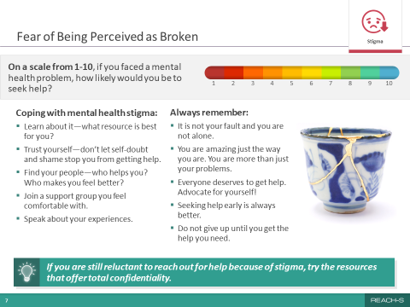
ANIMATIONS:
This slide will appear first with only the top question. You will then be cued to advance the rest of the slide.

MATERIALS:
None.

MAIN DISCUSSION POINTS:
On this slide, we will discuss the following topics:
- Coping With Mental Health Stigma
- Always Remember

SAMPLE TALKING POINTS:
[Topic 1: Coping With Mental Health Stigma]
SAY:
- If you remember, stigma was one of the barriers identified in the beginning of our session. An example of a stigma is the worry that others might see you as “broken” if you reach out for help.

ASK:
- What does “being broken” mean to you and why is this perception not helpful?
- On a scale of 1 to 10, where 1 is not at all likely and 10 is very likely, how likely would you be to use one or more of the resources we just discussed for a mental health issue? Show of fingers, please!

CUE:
Click to advance the rest of the slide.

SAY:
- What about seeing someone for a broken bone? Mental and physical health are equally important for one’s overall well-being and functioning.
- Stigma can be defined as a set of negative and often unfair beliefs that a society or group of people have about something. In this case, the negative beliefs are concerning mental health and help seeking.
- Some of the effects of stigma include reluctance to seek help or treatment when it’s needed; feelings of shame, hopelessness and isolation; lack of understanding by friends, family or others; fewer opportunities for work, school or social activities; and bullying, physical violence or harassment. Let’s talk about how we can overcome stigma related to getting mental health support.
- Learn about it—what resource is best for you?
- Trust yourself—don’t let self-doubt and shame stop you from getting help.
- Find your people—who helps you? Who makes you feel better?
- Join a support group you feel comfortable with.
- Speak about your experiences.
[Topic 2: Always Remember]

- We all have the inner strength to get us through tough times. Know that…
- It’s not your fault and you’re not alone.
- You’re amazing just the way you are. You are more than just your problems.
- Everyone deserves to get help. Advocate for yourself!
- Seeking help early is always better.
- Don’t give up until you get the help you need.

ASK:
- How many of you have heard of kintsugi [kin-tsu-gi] before?

SAY:
- It’s the Japanese art of repairing broken pottery by mending the areas of breakage with lacquer dusted or mixed with powdered gold, silver or platinum. You can see a beautiful example here on the slide.
- As a philosophy, it treats breakage and repair as part of the history of an object rather than something to disguise. It embraces the flaw or imperfection and, in a way, celebrates the object’s journey.
- I like to think about our mental health that way. We are all on a journey, and what we learn on the journey makes us stronger and more unique.

SAY:
- On the bottom of the slide it says “If you are still reluctant to reach out for help because of stigma, try the resources that offer total confidentiality.” Bottom line, we want you to get the help you need!

TIP: If you would like to engage participants and feel they would be receptive, you can ask one of the participants to read the statement by saying “Can I get someone to read the bottom lightbulb statement?”

- I hope that you’ve learned about some of your resource options. There are many that respect your privacy and confidentiality and are accessible and effective, even if you still have concerns about stigma.

SLIDE 8: Switching Providers
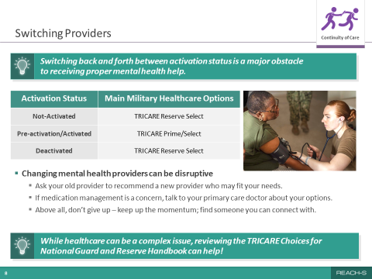
ANIMATIONS:
This slide will first appear with only the top lightbulb statement. You will then be cued to advance the rest of the slide.

MATERIALS:
None.

MAIN DISCUSSION POINTS:
- Transitioning Between Activation Status
- Changing Mental Health Providers

SAMPLE TALKING POINTS:
[Topic 1: Transitioning Between Activation Status]
SAY:
- One of the barriers mentioned previously was related to health care concerns.

ASK:
- Is switching back and forth between reserve/National Guard activation a major obstacle to receiving proper mental health care?

TIP: Discuss participant experiences with transitioning between activation status and military mental health care options.

CUE:
Click to load the rest of slide.

SAY:
- One thing we need to think about is how activation status affects the type of health care you can qualify for. Paying attention to the timing of activation status changes is key to maintaining your regular health care services like prescriptions or checkups. Time management is critical for a seamless transition between the main health care options presented here. Using the TRICARE Reserve Select insurance, when not activated, and the TRICARE Prime/Select insurance when activated can reduce health insurance issues.

ASK:
- Does anyone have any tips to share that helped you personally navigate these transitions?

TIP: Avoid conversations excessively dwelling on the difficulties. Focus on ways to overcome them and reference other information in the slide deck, if helpful.

[Topic 2: Changing Mental Health Providers]
SAY:
- Changing mental health providers can be difficult. Here are a few suggestions to make it easier. You can ask your old provider to recommend a new provider who would be a good match for you. If medication management is a concern, talk to your primary care doctor about your options. Don’t give up! Keep working to find someone you can connect with.
- Another great resource is the TRICARE Choices for National Guard and Reserve Handbook. The resources handout that I’ll give you at the end of the session contains the link to it. I recommend you consult it. It has lots of good information and resources.

SLIDE 9: Practical Concerns
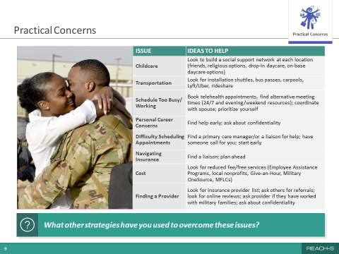
ANIMATIONS:
None.

MATERIALS:
Flip chart or dry erase board (optional).

MAIN DISCUSSION POINTS:
On this slide, we will discuss the following topic:
- Practical Concerns That Military Spouses Face

SAMPLE TALKING POINTS:
[Topic 1: Practical Concerns That Military Spouses Face]
SAY:
- Other big barriers to getting mental health support for military spouses may be practical concerns.

ASK:
- What are some practical issues that interfere with your ability to seek mental health help?

TIP: Write down the practical concerns that audience members express on a flip chart or dry erase board to help validate their opinions.

SAY:
- As you see on this slide, many practical concerns can present barriers to seeking help.
- Child care is a definite concern, but here are some options to think about, such as social support or drop-in day care.
- For those with a dual income household, scheduling appointments can be a challenge. Luckily, many mental health resources are flexible with their scheduling and format.
- When navigating insurance, the TRICARE website can be a very helpful resource. You can review their covered services there; and if needed, you can reach out to the Military Health System Nurse Advice Line. It is available 24/7 by phone, web chat or video chat.
- Cost may be a factor in seeking help. There are some programs out there, such as Give-an-Hour, that will meet with service members and their spouses for free therapy sessions. Remember that non-medical counseling with an MFLC or Military OneSource is always free.

TIP: Review as many of the topics in depth as needed to fully engage the audience.

ASK:
- Have you encountered some of these same issues?
- Do you have any other ideas or resources that could be included?
- What other strategies have you used to overcome these issues?

SAY:
- The handout I’ll give you at the end of the session will have links to some of these resources.

TIP: Acknowledge the strategies the spouses suggest and write them down on a flip chart or dry erase board.

SLIDE 10: Military OneSource: 24/7 Support for the Military Community
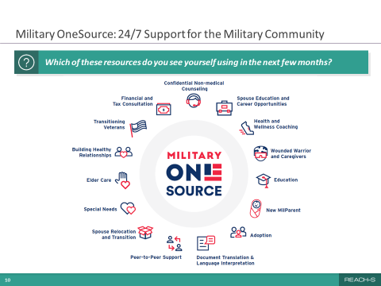
ANIMATIONS:
None.

MATERIALS:
None.

MAIN DISCUSSION POINTS:
On this slide, we will discuss the following topic:
- Programs Offered by Military OneSource

SAMPLE TALKING POINTS:
[Topic 1: Programs Offered by Military OneSource]
ASK:
- Have you ever experienced or heard about anyone else’s experience with Military OneSource?

SAY:
- As we’ve talked about, Military OneSource offers confidential non-medical counseling to service members and their families, but it’s actually much more than that. It’s a great place to go when you don’t know where to start.
- In a nutshell, Military OneSource is a free, 24/7, call center and website with “chat” options. It provides comprehensive information on every aspect of military life, including deployment, reintegration, physical fitness, stress management, relocation, parenting, taxes and financial planning. You name it, and they probably have something about it on their website!
- I’m going to walk you through some of the programs that Military OneSource offers, many of which are available to you day or night. As I describe them, I want you to think about how they could be useful to you, and then we’ll discuss your thoughts.
- First and foremost, Military OneSource offers confidential non-medical counseling for help with military life issues, such as relationship conflicts, stress management, adjustment and deployment challenges, and grief or loss. The counseling can be delivered face to face or by phone, online chat or secure video. You can receive up to 12 sessions per issue. What’s cool is that while you’re on the phone with the consultant, they will help you schedule your first appointment with a local non-medical counseling provider. It makes it so easy to get started!
- Military OneSource also offers financial counseling by phone, video and in person to help you develop a budget. And they answer questions related to savings, investments and debt issues. Military OneSource also offers free phone tax consultations and the electronic filing of a federal tax return and up to three state returns through its website.

TIP: To keep participants engaged, feel free to ask a question, such as “Who here gets stressed out about taxes? Wouldn’t it be nice to get some free support during that time of year?”

- Military OneSource can also connect you with a health and wellness coach to help you achieve your physical fitness, weight loss, stress management or nutritional goals. So if you’re struggling to find a good fitness routine, they can help you get on track. Coaches can offer their support by phone, online chat and video.
- And if you need to talk to someone who truly understands you, Military OneSource also offers peer-to-peer support with consultants who have first-hand experience of being a service member or a military spouse. So let’s say you’re having a problem, you can call and speak to another spouse with military experience who may have faced the same problem!
- And, last, Military OneSource offers their own mobile resilience tools. These are different than the ones we discussed previously and are completely free! Here’s an interesting fact. The most frequently downloaded tool from Military OneSource is the Chill Drills, which has now also been made into an app.

TIP: You do not have to review all of the following tools and services. Highlight the ones you think are most relevant to the audience.

Military OneSource Tools
- Chill Drills are a set of deep-breathing relaxation recordings designed to lower your heart rate, lower your blood pressure and reduce the level of stress hormones in your body. There are six audio/video files that cover the following topics:
- What’s a Chill Drill
- Tuning In
- Releasing Stress
- Easing Back Pain
- Getting to Sleep
- Music to Chill By
Military OneSource Services
- Information and Referral: Master’s level consultants provide information and referral on a wide range of topics including deployment, reintegration, financial, relationship issues, grief, spouse employment and education, parenting and life skills.
- Confidential Non-medical Counseling: Licensed and credentialed clinical providers are available for up to 12 sessions per issue to address daily life issues before they compromise military and family readiness.
- Spouse Education and Career Opportunities: Certified career coaches provide expert education and career guidance to military spouses, as well as offer comprehensive information, tools and resources to support career exploration; education, training, and licensing; employment readiness; and career connections.
- Health and Wellness Coaching: Service members and their families can get help achieving their health and wellness goals. Coaches offer support for different areas of wellness—from weight management, fitness and nutrition to stress management and life transitions.
- Wounded Warrior and Caregivers: This consultation provides immediate assistance to wounded, ill, injured and recovering service members, their families, and their caregivers. Consultants offer information about health care, facilities and benefits.
- Education: Consultants can connect service members and their dependents to programs, schools and services aligned with their educational needs. They also offer information about local public and private schools, support choosing a college, help finding financial assistance, and referrals for tutoring, scholarships and grant programs.
- New MilParent: Expectant parents and parents of children age 5 and under can get personalized consultant support and resources for self-care, sleep issues, toilet training, managing difficult behaviors, single parenting, finding child care and more.
- Adoption: Military OneSource consultants can help military families begin the adoption process, find military-related financial assistance, and identify agencies that offer additional support and resources. Consultants also offer information about adoption agencies and support groups.
- Document Translation & Language Interpretation: Language interpretation is available 24/7 in more than 150 languages. Official document translations are certified and notarized, when needed.
- Peer-to-Peer Support: Peer-to-Peer Support consultants are veterans, current members of the Reserve Component or military spouses. They offer experience, knowledge, training, tools and other resources to help identify and meet the needs of those they support.
- Spouse Relocation and Transition: Consultants help military spouses create individualized action plans and find relevant resources related to housing, child care, education, work-life referrals, health and wellness coaching, non-medical counseling services and more.
- Special Needs: Consultants help address questions and concerns about the care and education of family members with special needs—both children and adults. They can provide information about the Exceptional Family Member Program, special education cycle, specialized doctors and more.
- Elder Care: Military OneSource consultants can connect those caring for elders with local resources for seniors and provide guidance on what to consider before parents or older relatives need long-term care.
- Building Healthy Relationships: Consultants use an education-based, motivational interviewing model to support those seeking to build a healthy relationship foundation or maintain an already successful relationship. Consultations are available in seven curriculum areas with guided exercises on topics including staying connected while away, reconnecting after deployment and communication refreshers.
- Transitioning Veterans: Consultants provide personalized support to service members in the process of transitioning to civilian life. They help transitioning service members identify goals, navigate benefits and resources, such as VA assistance, and prepare for civilian career and education opportunities.
- Financial and Tax Consultation: Online e-filing software and tax consultants can help service members and their families with tax situations unique to the military. Accredited financial counselors can assist with budgeting, money management, debt and other financial topics to include savings and retirement plans.

ASK:
- Which of these resources would you like to use in the next few months?

SLIDE 11: Practice Call
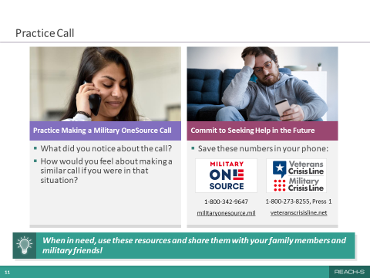
ANIMATIONS:
This slide will first appear showing only the left section. You will then be cued to advance the right section of the slide.

MATERIALS:
Room phone or facilitator’s cellphone; participant cellphones.

MAIN DISCUSSION POINTS:
On this slide, we will discuss the following topics:
- Conduct a “Live” Practice Call to Military OneSource
- Ask for a Commitment to Use Military OneSource in the Future

SAMPLE TALKING POINTS:
[Topic 1: Conduct a “Live” Practice Call to Military OneSource]
SAY:
- Now I’d like to demonstrate how easy it is to actually call Military OneSource!

ASK:
- Could I have a volunteer who will help me make the call?

SAY:
- Here’s how it’s going to work. We’re going to pick an issue to call about as a group. We won’t give out any personal details, and we’ll work through the call together, step-by-step, just to see what sort of support Military OneSource could offer with the issue we pick. Any takers?

TIP: If no one volunteers, pick someone you think will feel comfortable making the call in front of the group. Or make the call by yourself.

TIP: Once you have facilitated a few REACH—S sessions and know what to expect, feel free to change the format of this activity from a large group call into one where participants make calls in pairs. Check in with each pair during the calls to ensure that things are going well. If they need your help with guiding the call, feel free to assist.

SAY:
- Thank you for volunteering [name of participant]. Everyone, let’s pick an issue to call about.

TIP: If participants don’t suggest specific topics, suggest calling about help with managing a long-distance relationship, feeling stressed while spouse is out on deployment, or feeling down or lonely. If participants make several suggestions, select the most appropriate and least contentious one. As an alternative, if participants can’t decide on a topic, feel free to suggest one that came up earlier in the discussion.

CUE:
Once you decide on a topic as a group, help the volunteer make the call to Military OneSource using the speakerphone on the room phone. Aim for the call to take no more than five minutes. Identify yourself at the beginning of the call as the “REACH—S session facilitator” and introduce the volunteer. Let the Military OneSource triage consultant know that you’re making this call in front of a group and that, in the interest of time, you’d like to skip through the collection of demographics and go straight to the issue you’re calling about. If the room does not have a phone or it is not working, make the call using the speaker option on your cellphone.

TIP: Remember that Military OneSource can provide support for non-medical issues, such as stress, relationship problems, workplace challenges and financial concerns. The practice call should focus on those types of issues. Don’t select call topics that are more likely to require therapy or medication to treat, such as depression, anxiety attacks, post-traumatic stress or substance abuse. Avoid making calls about legal matters, such as drunk driving offenses, because the call center may have a duty to warn.

Example Practice Call (simplified)
Below is an example of how a typical call might go. Please review it ahead of time. Be familiar with the script, but don’t read it verbatim during the call. Also, be sure to modify what you say to focus on the issue your group selected. You want the conversation to flow naturally. In the example below, you are the caller. This is a simplified example of how the conversation might flow and what questions you may be asked by the triage consultant. Feel free to provide your own name and phone number or make up a fictional one.
Caller: Hi, I’m calling because I heard you might be able to help me with a problem I’m having at home.
Military OneSource: Hi, can I get your name and a number to reach you in case we lose contact?
Caller: Sure, my name is ______. You can reach me at ______-_______-_________. I wanted to let you know that I’m calling as part of a REACH—S session. This is just a practice call and I’ll be talking about a fictional situation. But for the purposes of this call, please treat me as though I’m a military spouse calling in with an issue.
Military OneSource: Great. Now tell me a little bit about why you called us today.
Caller: Well, I’m having trouble at home. I’m a perfectionist and I’m too hard on myself. I’ve got two kids and the house is never clean. And I’ve been feeling lonely lately since my spouse works long hours. It’s really starting to stress me out.
Military OneSource: Well, first, let me say, I’m sorry you’re going through this. We’ll do our best to help you. Let me tell you about some of the resources we can provide. The first is non-medical counseling. It is … [Describes it].
Caller: That sounds like it could be helpful. Is it like therapy? Is it going to cost me? Will I need to use TRICARE?
Military OneSource: Well Ma’am, it’s a free service through Military OneSource. Confidential non-medical counseling is solution focused and isn’t like therapy in several ways … [Clarifies the difference between non-medical counseling and therapy]. We also have a peer-to-peer support program staffed with military spouses and ... [Explains what peer-to-peer support is].
Caller: Both the confidential non-medical counseling and the peer support program sound like they can help. I’m interested in both of them, but I’m concerned about privacy. I don’t want anyone knowing what I’m doing.
Military OneSource: Both resources are confidential; however, they do have a duty to warn under certain circumstances. Can I review the “limits of confidentiality” with you? [Reviews limits of confidentiality].
Caller: That’s great news. I was really worried about that. When can I get started?
Military OneSource: Great! I’m glad we found something that works for you. I just need to collect some information from you….

SAY:
- Thank you, _________ [name of participant]! That went really well.
- Now, when you call Military OneSource on your own, they’ll need a bit more information to get started. They’ll need to know your spouse’s service branch, pay grade and installation. They’ll also ask for your personal email address.

ASK:
- How did you think the call went?
- How would you feel about making a similar call if you were in this situation?

TIP: Reinforce participant strengths by reflecting and amplifying positive comments about their willingness to reach out.

CUE:
Click to advance the right section of the slide.

[Topic 2: Ask for a Commitment to Use Military OneSource in the Future]
ASK:
- Do you think you could commit to calling Military OneSource if you struggle with something in the future?

SAY:
- If you have your phone with you, put these two numbers into your contacts right now: Military OneSource: 800-342-9647 and MCL/VCL: 800-273-8255.
- Now you’ll be prepared. Also, if you see someone in your family or a military friend struggling with something in their life, you’ll be able to pull out your phone and share these resources with them.

SLIDE 12: The Importance of Self-Care
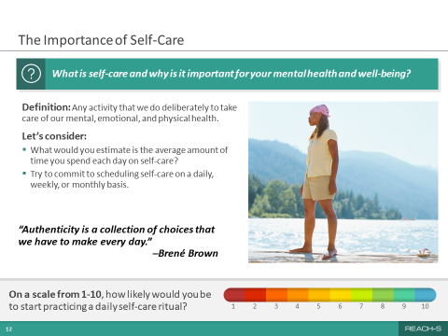
ANIMATIONS:
This slide will first appear with only the top question. You will then be cued to advance the rest of the slide.

MATERIALS:
None.

MAIN DISCUSSION POINTS:
On this slide, we will discuss the following topics:
- The Definition of Self-Care
- Discussion About Personal Self-Care Practices

SAMPLE TALKING POINTS:
[Topic 1: The Definition of Self-Care]
SAY:
- Now let’s talk about taking care of ourselves.

ASK:
- What is self-care and why is it important for your mental health and overall well-being?

TIP: Steer the conversation toward positive aspects of self-care.

CUE:
Click to advance the rest of the slide after the self-care discussion.

ASK:
- Can someone read what the definition of self-care is?
- Definition: Self-care is an activity we choose to do that takes care of our mental, emotional and physical heath.
- What are some of the barriers to practicing self-care that military spouses might face?

SAY:
- Although it can be hard, it’s important to make time for self-care.

[Topic 2: Discussion About Personal Self-Care Practices]
ASK:
- What would you estimate is the average amount of time military spouses spend each day on self-care?
- What are some ways we can make time for self-care?
- What are some things we can schedule for self-care on a daily, weekly and monthly basis?
- How likely would you be to start practicing a daily self-care routine? Why?
- Why did you choose that number?

TIP: If the numbers are low, using motivational interviewing skills, ask what can be done to help increase the likelihood of adopting a regular self-care routine.

- Can you try to commit to scheduling self-care on a daily, weekly or monthly basis?
- What are some new self-care plans you think you could start doing?

SAY:
- I like this quote by Brené Brown “Authenticity is a collection of choices that we have to make every day.”

ASK:
- What does this quote mean to you?
- How does it relate to what we just discussed?

TIP: Steer the conversation toward the understanding that we are what we do. If what we do encompasses self-care practices, then self-care becomes a part of us.

SLIDE 13: Self-Care and Mental Wellness Strategies
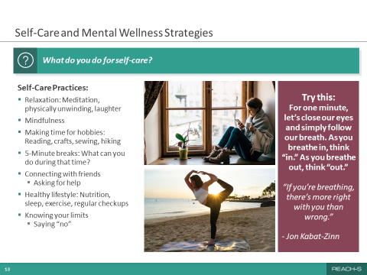
ANIMATIONS:
This slide will first appear with the top banner question and images only. You will then be cued to advance the rest of the slide.

MATERIALS:
None.

MAIN DISCUSSION POINTS:
On this slide, we will discuss the following topics:
- Identifying Common Self-Care Practices
- Breathing Exercise

SAMPLE TALKING POINTS:
[Topic 1: Identifying Common Self-Care Practices]
SAY:
- Let’s talk about some strategies to increase self-care in our lives.

TIP: Stimulate discussion between participants and facilitate the sharing of ideas.

CUE:
Click to advance the rest of the slide after addressing the top banner question.

SAY:
- Here are some of the many options we can call on to incorporate self-care into our daily, weekly and monthly routines.
- Relaxation can mean different things to different people. It might mean watching a television show or spending time meditating.

ASK:
- How many of you know what meditation is?
- What does “physically unwinding” mean to you?

SAY:
- And laughter, finding ways to laugh can really help.
- Science shows that laughter has been shown to alter dopamine and serotonin activity, which can help reduce depression. Also, endorphins are secreted during laughter when people are uncomfortable or in a depressed mood.

ASK:
- Who knows what mindfulness is? It’s different from meditation.

SAY:
- One basic definition is “Mindfulness is awareness that arises through paying attention, on purpose, in the present moment, non-judgmentally.”
- When we practice mindfulness, we reduce stress and increase our attention to our own and others’ well-being. Developing a mindfulness practice gives us time to focus non-judgmentally on our thoughts and the habits of the mind, which can allow us to reenergize and refocus on our daily lives.

ASK:
- Who has some hobbies they find fun? Who fits them into their schedule regularly?
- What are some of the things you love to do? Things you could do for hours and not notice that time has passed?
- What can you do in five minutes?

TIP: If nobody volunteers, some suggestions may include drinking water, doing some basic stretches or watching a funny video.

ASK:
- Who here loves to connect with friends?

SAY:
- Checking in regularly and sharing experiences can help us feel connected. If you can, check in in person by taking morning walks or having dinner together.
- And don’t be afraid to ask for help if you need it.
ASK:
- What have you been doing to keep in touch with family and friends?

SAY:
- Remember that a healthy lifestyle is always important. A healthy lifestyle includes maintaining good nutrition, sleep and exercise. It also includes getting regular health checkups.
- We all know how important these are, but we often put them last.
- You’ll feel better and have more energy if you prioritize these things.
- Knowing your limits can be tough. Sometimes you have to say “no” to extra responsibilities that would make your life more stressful. Keep some of your free time for yourself! Burnout is a real thing. If we can take steps to avoid it, we’ll feel better and be more present for our families.

ASK:
- Who struggles with this?
- Which of these practices that we talked about are you most likely to use?
- Do you have other activities that you find helpful?
[Topic 2: Breathing Exercise]
SAY:
- Let’s try this activity. It may feel a little awkward, but let’s give it a shot.
- For one minute, focus on your breath as it happens naturally. Sit with your eyes closed and think to yourself “in” when you take a breath in and think “out” when you breathe out. Don’t force the breath into any predetermined speed. Simply observe the breathing process as it happens. If you notice your mind wandering, gently bring your focus back to your breath. I’ll start the timer.

TIP: Participants may or may not participate in the breathing exercise, which is fine. If participants seem fidgety, or time is a concern, do the exercise for a shorter amount of time (e.g., less than one minute). At the end, share what you felt while doing the exercise to help participants understand the type of feedback you’re looking for.

ASK:
- Was that difficult to do? Why or why not?
- Did you find your mind drifting away from the breath?
- What did you do when you noticed this happening?
- Do you think you’ll be able to use this meditation technique in your everyday life?

SAY:
- There are many different breathing and meditation techniques. The one we just tried is one of the simplest and most useful for all circumstances.

SLIDE 14: Takeaways
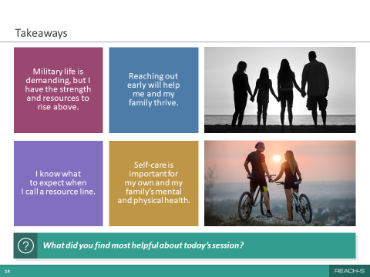
ANIMATIONS:
None.

MATERIALS:
None.

MAIN DISCUSSION POINTS:
On this slide, we will discuss the following topic:
- Key Takeaways

SAMPLE TALKING POINTS:
[Topic 1: Key Takeaways]
CUE:
If a chaplain, MFLC, Military OneSource representative, or mental health clinic POC is attending the
session, introduce them to participants and have them briefly describe their services.

SAY:
- We’ve almost reached the end of the session. Here are some of the key takeaways that I hope you carry with you after you leave this room.
- Let’s try something a little different—I’m going to ask four of you to read these out loud to us.

ASK:
- [Participant name], could you please start us off with the first one?
CUE:
Continue until all takeaways have been read.

ASK:
- What did you find most helpful about today’s session? Is there something you’re taking away that isn’t listed here?

TIP: Be open to criticism about the session while also emphasizing the overall purpose of the session.

SAY:
- I want to thank you so much for taking the time to attend today’s session. I know it’s not easy to make time in your schedule when you have work or children to tend to.
- I have a handout that I’ll pass out [or email] that lists a wide variety of resources that I think you’ll find useful.
- The next REACH—S session, Session 2, focuses on your service member’s barriers to care and suicide prevention strategies.

TIP: If you already know when the REACH—S Session 2 is scheduled for, share this information with participants.

- Thank you again for attending, and thanks for taking part in the discussions. I think we really made some connections and learned some things from each other.
- I’ll stick around for a bit if you have any questions or comments for me.

TIP: Feel free to provide your contact information to participants.

Session 2
Supporting Your Service Member’s Mental Health and Well-Being

SLIDE 1: REACH—S Title Slide
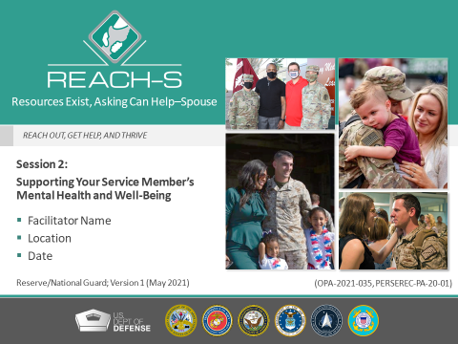
ANIMATIONS:
None.
MATERIALS:
None.
MAIN DISCUSSION POINTS:
On this slide, we will discuss the following topics:
- Facilitator Introduction
- What Is REACH—S

SAMPLE TALKING POINTS:
[Topic 1: Facilitator Introduction]
SAY:
- Welcome, everyone! Thanks for being here today.
- Before we get started, I’d like to introduce myself. [Insert a brief personal introduction].

CUE:
If command leadership is attending the session, ask them to make brief welcoming remarks before departing.

[Topic 2: What Is REACH—S]
SAY:
- So you’re probably wondering what REACH—S is and what it’s all about.
- REACH—S stands for “Resources Exist, Asking Can Help—Spouse.”
- REACH—S is all about taking care of ourselves early before our problems get too overwhelming. It’s about self-care.
- We’re not going to use the term “training.” This is not a training—it’s a conversation! I’d like to hear from you today and hope you’ll all engage in this discussion with me.
- The goal today is to empower you to help your service member if they ever need support.
- I want you to leave here today with a new mindset about asking for help. Reaching out for help is important—not just for you but for everyone around you. We have a duty to take care of ourselves. I hope this session will show you how easy it is for our service members to take the first step and get help when they first think they may have a problem.
- Some of the resources described here may not apply to you if you’re not a military spouse. However, I have a handout that I’ll pass out [or email] at the end of this session that identifies resources applicable to all of you.

TIP: Participants may include active-duty spouses, significant others and parents of service members. Try to tailor your talking points to your audience.

ASK:
- One quick question, are there any spouses in attendance who are also currently serving in the military?

TIP: If there are, make sure to engage them in a discussion about their experience with resources in both the service member and spouse roles throughout the REACH—S session, if applicable.

SAY:
- There are two REACH—S sessions. You’re attending the second one today.

ASK:
- Has anyone attended Session 1?

SAY:
- Each session presents unique and valuable information, so if you haven’t already, be sure to attend Session 1.

TIP: If you already know when Session 1 is scheduled for, be sure to share this information with the participants.

SLIDE 2: Session 2 Roadmap
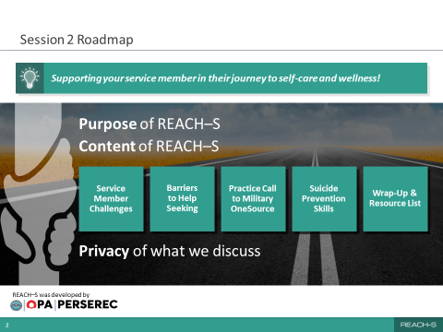
ANIMATIONS:
None.
MATERIALS:
None.
MAIN DISCUSSION POINTS:
On this slide, we will discuss the following topics:
- REACH—S Purpose
- Content of the Session
- Privacy of What We Discuss

SAMPLE TALKING POINTS:
[Topic 1: REACH—S Purpose]
SAY:
- REACH—S was developed by DOD’s Office of People Analytics. It was developed to help familiarize military spouses with available mental health resources and to encourage them to use those resources when they need them.
- The idea behind REACH—S is very simple. If more of us reach out for help before our problems get out of control, we can help change the mindset around mental health and help seeking!
- Creating this sort of a culture change requires everyone’s help.
- In Session 1, we talked about your barriers to care, but today we are going to focus on your service member. We are going to talk about their barriers to care and ways to tackle them.
- So, with that, the most critical goal of this session is to help you understand what the available mental health resources are for your spouse if the need ever arises.
[Topic 2: Content of the Session]
SAY:
- We’ll start today with a discussion of the unique challenges that service members face.
- Then we’ll talk about some of the barriers to help seeking that service members might encounter and resources that are available to them.
- We’ll make a practice call to Military OneSource after that, just to get a better feel for what that resource has to offer.
- We’ll learn some suicide awareness basics and review the steps you can take as a bystander when someone you know is suicidal.
- And, finally, we’ll discuss key takeaways, wrap up and distribute the handout.
- Today’s session should take about an hour and a half, but we may get out sooner than that.

[Topic 3: Privacy of What We Discuss]
SAY:
- Let’s go through some “housekeeping” rules before we begin.
- My aim is to provide a comfortable and safe environment for you to discuss your concerns and experiences about seeking help for any issues in your life.
- To that end, what’s said in the group stays in the group. To make this a safe space to share, we must respect everyone’s confidentiality.
- If you need to leave the room temporarily, just give me a thumbs up to let me know that you’re OK. If I don’t see that, I’ll follow up with you to make sure you’re OK.
- Feel free to speak up at any time.

SLIDE 3: Service Member Challenges
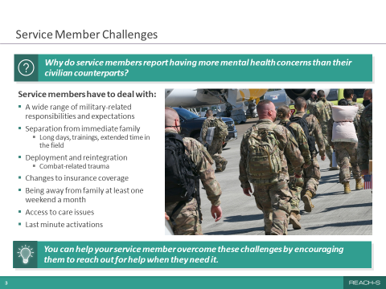
ANIMATIONS:
This slide will first appear with only the title and the top question. You will then be cued to advance the rest of the slide.
MATERIALS:
Flip chart or dry erase board (optional).
MAIN DISCUSSION POINTS:
On this slide, we will discuss the following topics:
- Rates of Service Members’ Mental Health Concerns
- Challenges Service Members Face

SAMPLE TALKING POINTS:
[Topic 1: Rates of Service Members’ Mental Health Concerns]
ASK:
- To start us off, I want to get your thoughts on something. Why do you think service members report having more mental health concerns than their civilian counterparts? What challenges do they face?

TIP: Discuss the possible reasons why service members report having higher incidences of mental health concerns than their civilian counterparts. Steer the conversation toward the unique challenges that service members face.

SAY:
- Thank you for sharing your thoughts. Those were some great insights.

CUE:
Click to advance the rest of the slide after the top banner discussion.

[Topic 2: Challenges Service Members Face]
SAY:
- As you can see here, there are some challenges that all service members tend to face.
- Military-related responsibilities and expectations and the unpredictability of their schedule
- Separations from immediate family
- Including long days, trainings and extended time in the field
- Deployment and reintegration
- Including combat-related trauma
- Changes to insurance coverage based on activation status
- Being away from family at least one weekend a month
- Access to care issues
- Last minute activations

TIP: It’s helpful to expand on each one of the challenges identified or, if time is limited, select a few to discuss briefly. Providing examples can help participants really feel connected to the content.

- These challenges and general life stressors, if unchecked, can sometimes lead to mental health concerns.

ASK:
- What are some challenges that your service member or someone you know faced during your time as a military spouse?

TIP: If you can, write on a dry erase board or flip chart the challenges military spouses suggest that are not presented on the slide. This will help validate their opinions.

SAY:
- And that’s why we’re here today, to help you help your service members overcome these challenges by providing the tools for reaching out for help when they need it.

SLIDE 4: Service Member Barriers to Help Seeking
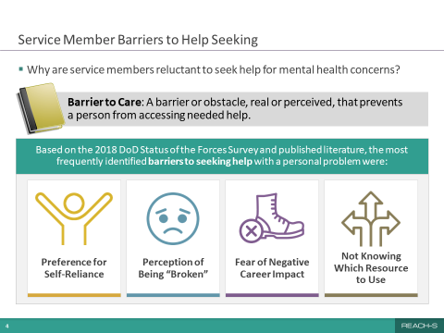
ANIMATIONS:
This slide will first appear with only the top question. You will then be cued to bring up the “Barrier to Care” definition. You will then be cued to advance the rest of the slide.

MATERIALS:
None.
MAIN DISCUSSION POINTS:
On this slide, we will discuss the following topics:
- Why Are Service Members Reluctant to Seek Mental Health Help
- Frequently Identified Barriers to Care

SAMPLE TALKING POINTS:

[Topic 1: Why Are Service Members Reluctant to Seek Mental Health Help]
ASK:
- If reaching out for support can help service members achieve their personal life goals, then why do so many of them avoid it? Why do service members choose not to seek help?

TIP: Steer the discussion toward the idea of “barriers” that get in the way of help seeking. Doing this will help validate the focus of the rest of the slide.

CUE:
Click to advance the “Barrier to Care” definition.

SAY:
- A barrier to care is defined as “an obstacle, real or perceived, that prevents a person from accessing needed help.”
- Understanding the barriers can help us understand why service members may be reluctant to seek help, especially for mental health concerns.
- What’s important about this definition is that the barrier feels real to the person and it guides how they interact with the world.

[Topic 2: Frequently Identified Barriers to Care]
CUE:
Click to advance the rest of the slide.

SAY:
- Let’s look at some official data to see how the barriers we discussed line up with survey results.
- Results from the 2018 SOFS-A identified some of the top reasons service members give for not seeking help.
- Service members reported that they typically prefer to be self-reliant. They want to solve their own problems.
- They may think they’ll be seen as “broken” or weak by their peers or leaders. Perhaps they’re embarrassed to ask for help.
- They may fear that their unit leadership will find out that they sought treatment and treat them differently for doing so. Or, worse yet, they worry that they will lose their security clearance as a result.
- And, finally they may not know which resources to use.

ASK:
- Looking at these barriers, who thinks that these are surprising?
- What seems most surprising to you?

SAY:
- Now that we’ve discussed the barriers that matter to service members, we’re going to spend some time discussing solutions and strategies for addressing each one of them, so that no service member will hesitate to reach out for help.

SLIDE 5: Handling Things on Their Own
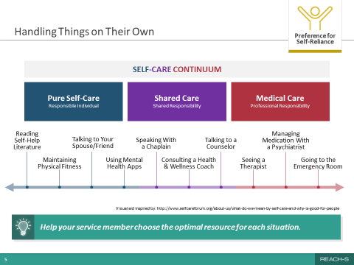
ANIMATIONS:
None.

MATERIALS:
None.

MAIN DISCUSSION POINTS:
On this slide, we will discuss the following topics:
- Self-Reliance, Shared Care and Pure Medical Care
- Self-Care Continuum

SAMPLE TALKING POINTS:
[Topic 1: Self-Reliance, Shared Care and Pure Medical Care]
ASK:
- When struggles come up that your service member cannot resolve on their own, what resources could they use?

SAY:
- From the Status of Forces Survey, we see that most service members prefer to handle things on their own when addressing mental health issues.
- This could be part of the military culture, but what we don’t want is for our service members to just keep going on as usual, avoiding their problem completely.
- What handling things on their own truly means is that they actively take steps to help themselves get through the problem.
- Service members often prefer to rely on themselves when it comes to mental health care, but, depending on the severity of the issue, self-care may not be enough.
- It’s helpful to look at mental health care on a continuum. The self-care continuum ranges from pure self-care—taking proactive measures on their own—to shared care—consulting with health care providers—to medical care for more serious and life-threatening issues.
- The earlier help is sought, the better the outcome in most cases.
- Self-reliant actions on the pure self-care side of the spectrum —talking to your spouse or friends, reading self-help books, working out and staying fit, or even using self-help apps—can work really well for straightforward problems and prevent them from becoming more serious.

ASK:
- By a show of hands, how many of you see your service member making these types of choices?

SAY:
- Unfortunately, not all problems are straightforward. Sometimes, life’s stressors can become so overwhelming and persistent that professional assistance is the only way forward. And that’s okay. In these cases, self-care shifts to the right side of this spectrum and comes in the form of therapy from a psychiatrist or psychologist or, for more life-threatening situations like suicidal behaviors, a visit to the emergency room.
- More often than not, though, mental health issues require a blend of self-care and medical care, or what’s called “shared care.” For your service member, that could mean speaking with a chaplain, getting non-medical counseling, or getting help from a health and wellness coach.

ASK:
- How many of you think that getting help with taxes might be a way to support your mental health?
- Or help with taking care of an elderly parent?

TIP: When discussing the self-care continuum, make sure to go over some of the examples for each type of care (e.g., speaking with a chaplain for shared care) to help cement the concepts.
[Topic 2: Self-Care Continuum]
SAY:
- We’ll explore some of these resources later in this session, but for now, it’s important that you understand that mental health issues can range from simple, able to be handled on one’s own, to complex, requiring professional support.
- Regardless of where the issue falls on the continuum, your service member can choose the optimal resource for each situation.
- And they should not give up until they get the help they need. That’s what REACH—S is all about—taking action to address the problem rather than avoiding it.
- By the end of today, I hope that you’ll feel more empowered to help your service member choose the optimal resource for any situation.

SLIDE 6: Fear of Being Perceived as Broken
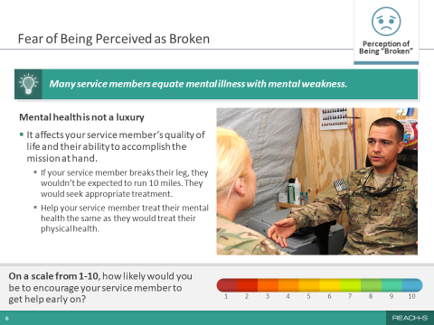
ANIMATIONS:
This slide will first appear with only the top banner. You will then be cued to advance the rest of the slide.

MATERIALS:
None.

MAIN DISCUSSION POINTS:
On this slide, we will discuss the following topics:
- Perception of Being Broken
- Mental Health and Physical Health Issues Are Common and Treatable

SAMPLE TALKING POINTS:
[Topic 1: Perception of Being Broken]
SAY:
- Recall that on the Status of Forces Survey, many service members were worried about being perceived as “broken” by their peers or chain of command if they reached out for help. Some even worried about their families’ perception of them.
- Service members often don’t seek help because they want to avoid appearing weak.

ASK:
- What do you think being “broken” means to your service member and why is this perception not helpful?
- How can you, as a spouse, help your service member believe that seeking help is not a weakness but shows their strength?

SAY:
- Having mental health issues doesn’t mean that your service member is broken, it just means they need some healing.
- Mental health is not a luxury, especially for our service members who defend our country.

[Topic 2: Mental Health and Physical Health Issues Are Common and Treatable]
CUE:
Click to advance the rest of the slide.

SAY:
- If your service member broke a leg, they wouldn’t run 10 miles, they’d seek appropriate treatment.
- Help your service member treat their mental health the same as they treat their physical health.
- Getting help early can lead to early and better resolution of issues and reduces the likelihood that others will find out about the issues.

TIP: Consider sharing a personal story that demonstrates the positive impacts of getting help early.

ASK:
- On a scale from 1 to 10, where a 1 is not at all likely and a 10 is very likely, how likely would you be to encourage your service member to get help early on?

TIP: If a participant responds with a low rating, try to address their concerns. Use motivational interviewing skills to guide the discussion. If nobody speaks up, you could share a personal experience to prompt more discussion. Then ask the question again.

SLIDE 7: Mental Health Treatment and Career Outcomes
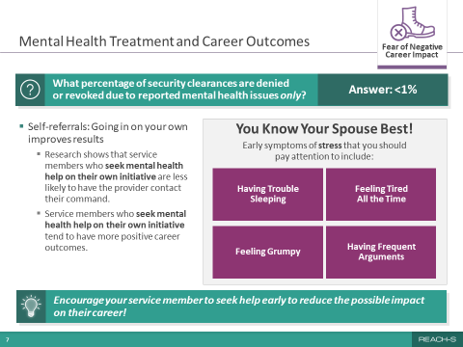
ANIMATIONS:
This slide will first appear with only the top question. You will then be cued to bring up the answer, and then again, to advance the rest of the slide.

MATERIALS:
None.

MAIN DISCUSSION POINTS:
On this slide, we will discuss the following topics:
- Mental Health and Career Concerns
- Symptoms of Stress

SAMPLE TALKING POINTS:
[Topic 1: Mental Health and Career Concerns]
SAY:
- One key concern that I know many service members have is whether seeking mental health treatment could affect their security clearance, which is their access to classified or sensitive information.

ASK:
- Do you know what percentage of security clearances are denied or revoked due to reported mental health issues alone?

CUE:
Click to bring up the answer.

SAY:
- Some of you were close! You’ll be pleased to know that of those who reported mental health concerns, less than 1% had their security clearances denied or revoked due to mental health issues.
- That’s a very small percentage! It indicates that your service member shouldn’t be afraid of losing their security clearance as a result of seeking help for mental health issues alone.
- I want to clarify that this is true for those reporting only a mental health issue. If they also reported a substance abuse issue or illegal behavior, the percentage could be higher.

TIP: This topic might generate a lot of discussion, which is why it’s very helpful to have a copy of the relevant Standard Form 86 Questionnaire for National Security Positions (SF-86, 2016 version) pages on hand from APPENDIX C: Question 21 on the Standard Form 86. The <1% statistic is based on data that describe the percentage of clearances that were revoked or denied due to reported mental health issues ONLY, meaning there were no other adjudicative issues present in the subject’s background. It demonstrates that service members who seek mental health support generally do not suffer an impact to their clearance. However, be prepared to acknowledge that clearance concerns, especially for military personnel in career fields requiring routine access to classified information, are valid. If a service member is very worried about confidentiality, point out that they may want to speak with a totally confidential resource, such as a chaplain. These data came from PERSEREC, a division of OPA.

CUE:
Click to advance the rest of the slide.

SAY:
- Seeking help early can have positive career outcomes. The earlier a mental health issue is addressed, the more likely the solution will be relatively simple and have no adverse effect on the service member’s career.
- In addition, providers are less likely to contact your service member’s command if they self- refer.

ASK:
- So think about it this way. If your service member had cancer, you’d want them to act early to ensure better outcomes, wouldn’t you? Before it gets to stage 4.

SAY:
- It’s the same with your service member’s career. Addressing an issue before it becomes a larger problem is the best way to guarantee success.
- If your spouse is in a career path with special reporting requirements, there are some confidential resources that are useful, such as a chaplain.
- In the end, getting mental health help (and reporting it, as required) is what matters most.

[Topic 2: Symptoms of Stress]
ASK:
- So how do we know when we or others need to seek help? How about when they start feeling stressed?

SAY:
- Early symptoms of stress could include having difficulty sleeping, feeling excessively tired, being grumpy or having frequent arguments with people. Other symptoms might include feeling isolated or lonely, having frequent headaches and increased drinking of alcohol.
- Those are all signs that we might need to reach out for help, or suggest our spouse reach out, before the problem gets worse.
- You know your spouse best. You’re with them when they’re at home, where they feel comfortable and show their vulnerable side. You might be able to see some of these signs and can start a conversation about it with your spouse.
- Remember, finding help does not always have to be formal. It could consist of talking to you or a buddy about the issue or reading a self-help book.
- After today’s session, I hope you’ll be better equipped to identify early symptoms of stress and to look for new trends in behaviors that might signify that something is bothering someone.

ASK:
- Now I want to hear from you. What do you do to reduce stress?
- And what do your spouses do when they are stressed?

TIP: This question may have the potential to generate emotional responses in participants, if, for example, the participant shares that their spouse uses a negative coping mechanism. Be prepared to use the distress protocol if necessary.

SAY:
- To sum up, encourage your service member to seek help early to reduce the possible impact on their career!

TIP: Emphasize this point, as it is a key takeaway.

SLIDE 8: Mental Health Resources for Military Members
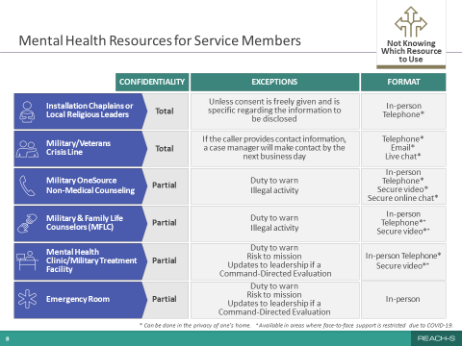
ANIMATIONS:
None.

MATERIALS:
None.

MAIN DISCUSSION POINTS:
On this slide, we will discuss the following topics:
- The Range of Mental Health Resources Available
- Resources for General Mental Health Questions or Issues
- Resources for Mental Health Treatment

SAMPLE TALKING POINTS:
[Topic 1: The Range of Mental Health Resources Available]
SAY:
- So another barrier to care that could prevent service members from seeking help is simply not knowing what resource to turn to.
- With so many resources out there, it’s hard to know which one to choose.

TIP: Steer the discussion toward verified and established resources. If needed, clarify that the slide is focusing on military resources available to the service member and does not focus on community-based resources. Mention that the handout they will be given has all of this information and more.
- Let’s talk specifically about the various mental health resources available to your service member because I want to highlight some important distinctions between them.
- A few quick notes about this table:
- The asterisk and plus sign at the bottom indicate:
- *Can be done in the privacy of one’s home.
- ⁺Available in areas where face-to-face support is restricted due to COVID-19.
- Duty to warn means that if someone shares an intention to harm themselves or others, such as children, domestic partners, or elderly, service providers must report these situations to the authorities.

[Topic 2: Resources for General Mental Health Questions or Issues]
ASK:
- How many of you know the chaplain associated with your service member’s unit?

SAY:
- Chaplains work not only with military personnel, but in most cases, with their families as well. They are a great resource because they offer total confidentiality. Your service member’s information will not be shared with anyone else unless they specifically allow it. They can meet in person or talk on the phone.
- Chaplains are happy to speak with anyone, regardless of their religious beliefs. And religion does not have to be a topic of conversation.
- Your service member can also meet with their own preferred religious leaders in your community for support.
- The MCL/VCL is a free, confidential resource that’s available to anyone, civilian or military. They are specially trained to help service members, military spouses and veterans. They can provide immediate assistance at any time, even if you’re not experiencing a crisis.

ASK:
- Who’s heard of or used Military OneSource before?

SAY:
- I really want to highlight Military OneSource because it has so many resources. It can provide support for almost any problem you’re facing, via phone, in person or by secure video or online chat. It’s truly a great place to start, especially if you don’t know where to go. Whether you’re dealing with a financial issue, stress at work or a relationship issue, Military OneSource can help you. Most important, Military OneSource offers confidential non-medical counseling. But just be aware that it comes with a provider’s duty to warn if there are concerns about self-harm or safety of others, or if there is illegal activity involved.

ASK:
- Now, who’s heard of or used a Military and Family Life Counselor, or MFLC, before?

SAY:
- Well, MFLCs are a really useful resource. They support service members and their families and provide non-medical counseling. They don’t take notes during their sessions, so there’s no paper trail. Just note that, similar to Military OneSource counselors, they also have a duty to warn if there are concerns about self-harm or safety of others, or if there is illegal activity.
- An MFLC can meet with you in person or by phone or secure video. And it can be anywhere on or off base, except your house or your vehicle. So they could meet you at a café or even a playground. They’ll also meet you outside of normal working hours if scheduling is an issue.

TIP: Not all installations have the MFLC program available. Verify whether your installation has an MFLC and make note of their contact information. If there are no MFLCs nearby, you can focus the conversation on local counseling services available at your installation.

[Topic 3: Resources for Mental Health Treatment]
SAY:
- Then there are the mental health clinics/military treatment facilities, which are available when your spouse is in activated status, and possibly during other times depending on your insurance. Their confidentiality level is also partial because of the duty to warn requirements. Typically, the available formats are in person and by telephone.
- And, finally, going to an emergency room is an effective way to obtain immediate assistance for a mental health crisis. Their first priority is your service member’s health and safety, but they do have a duty to warn.
- The biggest takeaway I have for you is to remind your service member to not give up on their quest for mental health support! They could have a negative experience with one provider, and the next one could change their life! There are good providers out there. We don’t always find the right match for our needs right off the bat.

ASK:
- We covered a lot of information with this slide. Does anyone have any questions about these resources for your service member or when to use them?

SLIDE 9: Mobile Resilience Tools
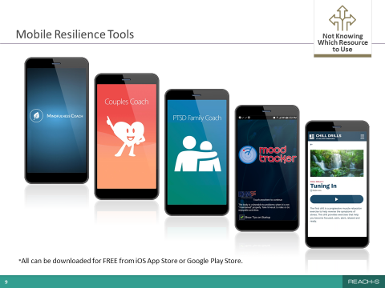
ANIMATIONS:
None.

MATERIALS:
None.

MAIN DISCUSSION POINTS:
On this slide, we will discuss the following topics:
- Availability of Mobile Self-Help Apps
- Purpose and Features of Several Mobile Apps

SAMPLE TALKING POINTS:
[Topic 1: Availability of Mobile Self-Help Apps]
SAY:
- What if your service member still doesn’t feel comfortable reaching out to a counselor?
- Well, good news! There are mobile resources that they can access privately through their phone.
- Remember the self-care continuum that we talked about earlier and how the left side showed informal ways they can get help with an issue by being proactive? This is one of them!
- These apps are helpful for service members, and their spouses, who are concerned about confidentiality.
- The best part about using an app is that you have instant access to them on your phones.
[Topic 2: Purpose and Features of Several Mobile Apps]
SAY:
- These free apps, available in the iOS App Store or the Google Play Store, can help you manage your mood, reduce stress, learn mindfulness and meditation techniques, and improve sleep, among other things.
- Some of them are designed especially for military personnel and their families by the DOD or the VA.

TIP: Acknowledge that participants who have attended Session 1 may be familiar with some of the apps presented.

- For example, one app, Mindfulness Coach, helps guide people in developing a mindfulness practice.
- There’s also Couples Coach for partners who want to improve their relationship and explore new ways to connect.
- Another app, called Mood Tracker, can help you monitor your mood over time and identify specific triggers that make you feel stressed. It’ll even graph them for you!

ASK:
- Has anyone used any of these types of apps? Does your service member use any of these?
- Did you find them useful?

TIP: Participants may list apps not shown on the slide, such as the apps Calm and Headspace. The Calm app is a popular paid app that contains content for meditation, music, sleep, movement and nature scenes. Headspace is a paid app focused on mindfulness and meditation to reduce stress and improve happiness.

TIP: Make sure you have downloaded the apps shown on the slide yourself and interacted with them so that you can share your own experiences. You may need to steer the discussion in a different direction if participants report none or few positive experiences with the mobile apps. If a participant asks for more information about a specific app, you can refer to the following descriptions.

Mobile Resilience Tools
- Mindfulness Coach is an app developed by the VA that teaches users how to practice mindfulness. It provides a slow-paced, self-guided training program designed to help people understand and adopt a simple mindfulness practice. The app has many features, including an assessment to help track progress over time, customizable reminders, and access to other support and crisis resources.
- Couples Coach is designed for partners who want to improve their relationship and explore new ways to connect. The app takes users through five levels of expert-written educational and engaging behavioral exercises informed by science. Popular exercises, such as “Using I Messages” and “Active Listening,” are brought to life in a dynamic and interactive format.
- PTSD Family Coach is for family members of those living with PTS. The app provides extensive information about PTS, how to take care of yourself, how to take care of your relationship with your loved one or with children, and how to help your loved one get the treatment they deserve.
- T2 Mood Tracker allows users to monitor their moods on six pre-loaded scales (anxiety, stress, depression, brain injury, PTS and general well-being). Custom scales can also be built. Users rate their moods by swiping a small bar to the left or to the right. The ratings are displayed on graphs to help users track their moods over time.
- Chill Drills are audio exercises developed especially for the military community that are designed to help users relax and manage their symptoms of stress.

SLIDE 10: Military OneSource: 24/7 Support for the Military Community
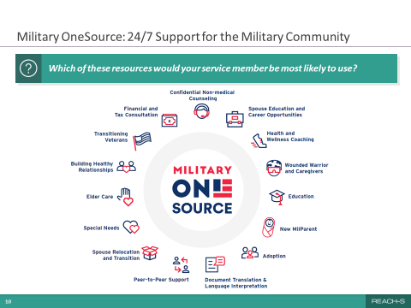
ANIMATIONS:
None.

MATERIALS:
None.

MAIN DISCUSSION POINTS:
On this slide, we will discuss the following topics:
- Programs Offered by Military OneSource

SAMPLE TALKING POINTS:
[Topic 1: Programs Offered by Military OneSource]
ASK:
- Have you ever experienced or heard about anyone else’s experience with Military OneSource?

SAY:
- As we’ve discussed, Military OneSource offers confidential non-medical counseling to service members and their families, but it’s actually much more than that. It’s a great place to go when you don’t know where to start.
- In a nutshell, Military OneSource is a free, 24/7 call center and website with “chat” options that provides comprehensive information on every aspect of military life, including deployment, reintegration, physical fitness, stress management, relocation, parenting, taxes and financial planning. Literally, you name it and they probably have something about it on their website!
TIP: If many participants attended Session 1, you do not have to review all of the Military OneSource resources shown in the figure. Focus on resources that would address issues mentioned earlier in the session. Alternatively, ask the participants which resources they would like to learn more about.

- I’m going to walk you through some of the programs that Military OneSource offers, many of which are available day or night. As I describe them, I want you to think about how they could be useful for your service member and for you, and then we’ll discuss your thoughts.
- First and foremost, Military OneSource offers confidential non-medical counseling for help with military life issues, such as relationship conflicts, stress management, adjustment and deployment challenges, and grief or loss. The counseling can be delivered face to face or by phone, online chat, or secure video, and you can receive up to 12 sessions per issue. What’s cool is that while you’re on the phone with the consultant, they will help you schedule your first appointment with a local non-medical counseling provider. It makes it so easy to get started!
- Military OneSource also offers financial counseling by phone, video and in person to help you establish a budget and answer questions about savings, investment and debt. Military OneSource also offers free phone tax consultations and electronic filing of a federal tax return and up to three state returns through its website.

TIP: To keep participants engaged, feel free to ask a question, such as “Who here gets stressed out about taxes? Wouldn’t it be nice to get some free support during that time of year?”

- Military OneSource can also connect you with a health and wellness coach to help your service member, or you, achieve physical fitness, weight loss, stress management or nutritional goals. So if you’re struggling to find a good fitness routine, they can help you get on track. Coaches can offer their support by phone, online chat and video.
- And if your service member feels like talking to someone who can understand them, Military OneSource also offers peer-to-peer support with consultants who have first-hand life experience of being a service member or a military spouse.
- Military OneSource also offers their own mobile resilience tools. These are different than the ones we discussed on the last slide and are completely free! Here’s an interesting fact: The most frequently downloaded tool from Military OneSource is the Chill Drills, which has now also been made into an app.

TIP: You do not have to review all of the following tools and services. Highlight the ones you think are most relevant to the audience.

Military OneSource Tools
- Chill Drills are a set of deep-breathing relaxation recordings designed to lower your heart rate, lower your blood pressure and reduce the level of stress hormones in your body. There are six audio/video files that cover the following topics:
- What’s a Chill Drill
- Tuning In
- Releasing Stress
- Easing Back Pain
- Getting to Sleep
- Music to Chill By

Military OneSource Services
- Information and Referral: Master’s level consultants provide information and referral on a wide range of topics including deployment, reintegration, financial, relationship issues, grief, spouse employment and education, parenting and life skills.
- Confidential Non-medical Counseling: Licensed and credentialed clinical providers are available for up to 12 sessions per issue, to address daily life issues before they compromise military and family readiness.
- Spouse Education and Career Opportunities: Certified career coaches provide expert education and career guidance to military spouses, as well as offer comprehensive information, tools and resources to support career exploration; education, training, and licensing; employment readiness; and career connections.
- Health and Wellness Coaching: Service members and their families can get help achieving their health and wellness goals. Coaches offer support for different areas of wellness—from weight management, fitness and nutrition to stress management and life transitions.
- Wounded Warrior and Caregivers: This consultation provides immediate assistance to wounded, ill, injured and recovering service members, their families and their caregivers. Consultants offer information about health care, facilities and benefits.
- Education: Consultants can connect service members and their dependents to programs, schools, and services aligned with their educational needs. They also offer information about local public and private schools, support choosing a college, help finding financial assistance, and referrals for tutoring, scholarships and grant programs.
- New MilParent: Expectant parents and parents of children age 5 and under can get personalized consultant support and resources for self-care, sleep issues, toilet training, managing difficult behaviors, single parenting, finding child care and more.
- Adoption: Military OneSource consultants can help military families begin the adoption process, find military-related financial assistance, and identify agencies that offer additional support and resources. Consultants also offer information about adoption agencies and support groups.
- Document Translation & Language Interpretation: Language interpretation is available 24/7 in more than 150 languages. Official document translations are certified and notarized, when needed.
- Peer-to-Peer Support: Peer-to-peer support consultants are veterans, current members of the Reserve Component or military spouses. They offer experience, knowledge, training, tools and other resources to help identify and meet the needs of those they support.
- Spouse Relocation and Transition: Consultants help military spouses create individualized action plans and find relevant resources related to housing, child care, education, work-life referrals, health and wellness coaching, non-medical counseling services and more.
- Special Needs: Consultants help address questions and concerns about the care and education of family members with special needs—both children and adults. They can provide information about the Exceptional Family Member Program, special education cycle, specialized doctors and more.
- Elder Care: Military OneSource consultants can connect those caring for elders with local resources for seniors and provide guidance on what to consider before parents or older relatives need long-term care.
- Building Healthy Relationships: Consultants use an education-based, motivational interviewing model to support those seeking to build a healthy relationship foundation or maintain an already successful relationship. Consultations are available in seven curriculum areas with guided exercises on topics including staying connected while away, reconnecting after deployment and communication refreshers.
- Transitioning Veterans: Consultants provide personalized support to service members in the process of transitioning to civilian life. They help transitioning service members identify goals, navigate benefits and resources, such as VA assistance, and prepare for civilian career and education opportunities.
- Financial and Tax Consultation: Online e-filing software and tax consultants can help service members and their families with tax situations unique to the military. Accredited financial counselors can assist with budgeting, money management, debt, and other financial topics to include savings and retirement plans.

ASK:
- So now that we’ve talked about some of the various Military OneSource services, which ones do you think will appeal to your service member the most?
- What about you?

TIP: Continue relying on motivational interviewing techniques to steer the conversation in the optimal direction.

SLIDE 11: Military OneSource Testimonials
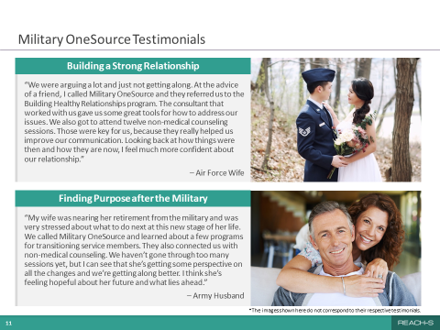
ANIMATIONS:
None.

MATERIALS:
None.

MAIN DISCUSSION POINTS:
On this slide, we will discuss the following topics:
- Military OneSource Testimonials

SAMPLE TALKING POINTS:
[Topic 1: Military OneSource Testimonials]
SAY:
- So let’s take a look at a couple of testimonials that are based on real events.
- An Air Force spouse says:
- “We were arguing a lot and just not getting along. At the advice of a friend, I called Military OneSource and they referred us to the Building Healthy Relationships program. The consultant that worked with us gave us some great tools for how to address our issues. We also got to attend 12 non-medical counseling sessions. Those were key for us, because they really helped us improve our communication. Looking back at how things were then and how they are now, I feel much more confident about our relationship.”
- And an Army spouse says:
- “My spouse was nearing her retirement from the military and was very stressed about what to do next in her life. We called Military OneSource and learned about a few programs for transitioning service members. They also connected us with non-medical counseling. We haven’t gone through too many sessions yet, but I can see that she’s getting some perspective on all the changes and we’re getting along better. I think she’s feeling hopeful about her future and what lies ahead.”

TIP: Another option to build engagement is to ask different participants to read the two scenarios.

ASK:
- What are your takeaways from these testimonials?

TIP: Try to steer the discussion towards positive takeaways about the utility of reaching out for help.

SLIDE 12: Practice Call
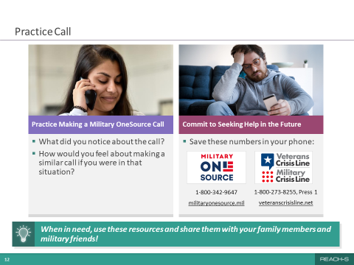
ANIMATIONS:
This slide will first appear with only the left section. You will then be cued to bring up the right section of the slide.

MATERIALS:
Room phone or facilitator’s cellphone; participant cellphones.

MAIN DISCUSSION POINTS:
On this slide, we will discuss the following topics:
- Conduct a “Live” Practice Call to Military OneSource
- Ask for a Commitment to Use Military OneSource in the Future

SAMPLE TALKING POINTS:
[Topic 1: Conduct a “Live” Practice Call to Military OneSource]
CUE:
Click to advance the left section of the slide.

SAY:
- Now I’d like to demonstrate how easy it is to actually call Military OneSource!

ASK:
- Could I have a volunteer who will help me make the call?
SAY:
- Here’s how it’s going to work. We’re going to pick an issue to call about as a group. We won’t give out any personal details, and we’ll work through the call together, step by step, just to see what sort of support Military OneSource could offer with the issue we picked. Any takers?

TIP: Once you have facilitated a few REACH—S sessions and know what to expect, feel free to change the format of this activity from a large group call into one where participants make the calls in pairs. You can check in with each pair during the calls to ensure things are going well. If they need your help with guiding the call, feel free to assist.

CUE:
If no one volunteers, pick someone who you think will feel comfortable making the call in front of the group. You could also make the call by yourself.

SAY:
- Thank you for volunteering, [name of participant]. Let’s pick an issue to call about.

TIP: If participants don’t suggest specific topics, suggest calling about help with managing a long-distance relationship or feeling stressed at work. If participants make several suggestions, select the most appropriate and least contentious one. As an alternative, if participants can’t decide on a topic, feel free to suggest one that came up earlier in the discussion.

CUE:
Once you decide on a topic as a group, help the spouse make the call to Military OneSource using the speakerphone on the room phone. Aim for the call to take no more than five minutes. Identify yourself at the beginning of the call as the “REACH—S session facilitator” and introduce the spouse. Let the Military OneSource triage consultant know that you’re making this call in front of a group and that you would like to skip through the collection of demographics and go straight to the issue you’re calling about. If the room doesn’t have a phone or it’s not working, make the call using the speaker option on your cellphone.

TIP: Remember that Military OneSource can provide support for non-medical issues, such as stress, relationship problems, workplace challenges and financial concerns. The practice calls should focus on those types of issues. Don’t use examples that are more likely to require therapy or medication to treat, such as depression, anxiety attacks, PTS or substance abuse. Because the call center may have a duty to warn, avoid making calls about legal matters, such as drunk driving offenses.
Example Practice Call (simplified)
Below is an example of how a typical call might go. Please review it ahead of time. Be familiar with the script, but don’t read it verbatim during the call. Also, be sure to modify what you say to focus on the issue your group selected. You want the conversation to flow naturally. In the example below, you are the caller. This is a simplified example of how the conversation might flow and what questions you may be asked by the triage consultant. Feel free to provide your own name and phone number or make up a fictional one.
Caller: Hi, I’m calling because I heard you might be able to help me with a problem we’re having at home.
Military OneSource: Hi, can I get your name and a number to reach you in case we lose contact?
Caller: Sure, my name is ______. You can reach me at ______-_______-_________. I wanted to let you know that I’m calling as part of a REACH—S session, so this is just a practice call, and I will be talking about a fictional situation. But for the purposes of this call, please treat me as though I am a military spouse calling in with an issue.
Military OneSource: Great. Now tell me a little bit about why you called us today.
Caller: Well, we’re having some disagreements at home. I’ve got two kids and the house is never clean. And I’m feeling lonely lately since my spouse works long hours. I’m always nagging him to help around the house and he says he doesn’t have time. He’s also struggling with work stress and general unhappiness with his job. It’s really starting to stress both of us out.
Military OneSource: Well, first, let me say, I’m sorry you’re going through this. We’ll do our best to help you. Let me tell you about some of the resources we can provide. The first is non-medical counseling. You can do it together with your spouse or individually. It is … [Describes it].
Caller: That sounds like it could be helpful. Is it like therapy? Is it going to cost us? Will I need to use TRICARE?
Military OneSource: Well Ma’am, it’s a free service through Military OneSource. Confidential non-medical counseling is solution focused and it’s not like therapy in several ways … [Clarifies the difference between non-medical counseling and therapy]. We also have a peer-to-peer support program staffed with military spouses and ... [Explains what peer-to-peer support is].
Caller: Both programs sound like they can help. I’m interested in both of them, but I’m concerned about privacy. I don’t want anyone in my spouse’s shop knowing what we’re doing.
Military OneSource: Both resources are confidential; however, they do have a duty to warn under certain circumstances. Can I review the “limits of confidentiality” with you? [Reviews limits of confidentiality].
Caller: That’s great news. We were really worried about that. When can we get started?
Military OneSource: Great! I’m glad we found something that works for you. I just need to collect some information from you….

SAY:
- Thank you, _________ [name of participant]! That went really well.
- Now, when you call Military OneSource on your own, they’ll need a bit more information to get started. They’ll need to know your spouse’s service branch, pay grade, and installation. Finally, they’ll ask for both of your personal email addresses.

ASK:
- How did you think the call went?
- How would you feel about making a similar call if you were in this situation?

TIP: Reinforce participant strengths by reflecting and amplifying positive comments about their willingness to reach out.

CUE:
Click to advance the right section of the slide.

[Topic 2: Ask for a Commitment to Use Military OneSource in the Future]
ASK:
- Do you think you could commit to calling Military OneSource if you or your service member were struggling with something in the future?

SAY:
- If you have your phone with you, put these two numbers into your contacts right now: Military OneSource: 800-342-9647, and MCL/VCL: 800-273-8255.
- Now you’ll be prepared. Also, if you see someone in your family or a military friend struggling with something in their life, you’ll be able to pull out your phone and share these resources with them.

SLIDE 13: Suicide Prevention Skills
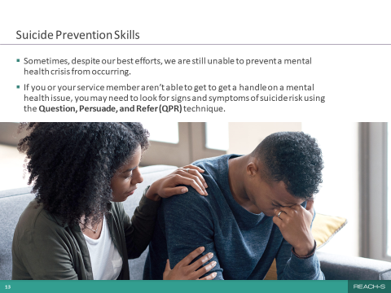
ANIMATIONS:
None.

MATERIALS:
None.

MAIN DISCUSSION POINTS:
On this slide, we will discuss the following topics:
- Brief Introduction to Question, Persuade, and Refer

SAMPLE TALKING POINTS:
[Topic 1: Brief Introduction to Question, Persuade, and Refer]
SAY:
- Sometimes, despite our best efforts, we’re not able to prevent a mental health crisis from occurring in ourselves or our spouse.
- If you or your service member aren’t able to get ahead of a mental health issue, you may need to look for signs and symptoms of suicidality. I recognize that this can be uncomfortable to address. However, I have some tools that can help you feel more confident and empowered to help your spouse or a friend, or even a stranger, if needed.

SLIDE 14: Signs and Symptoms of Suicide Risk
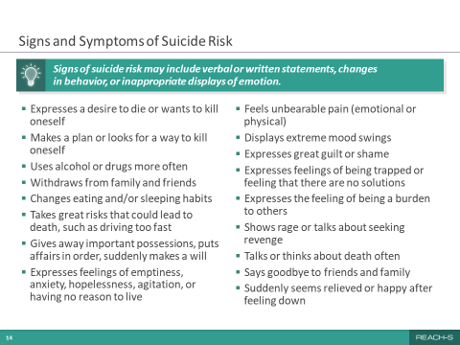
ANIMATIONS:
None.

MATERIALS:
None.

MAIN DISCUSSION POINTS:
On this slide, we will discuss the following topic:
- Signs of Suicidality

SAMPLE TALKING POINTS:
[Topic 1: Signs of Suicidality]
SAY:
- The first most basic thing to understand is that signs of suicidality can include verbal or written statements, changes in behavior and displays of emotion.
- Let’s review some of the signs and symptoms of suicide risk to look out for in yourself, your service member, or somebody else.

TIP: You don’t have to go through all of the signs identified on the slide. Select ones to review and expand upon that you feel will be relevant to the audience.

- Expresses a desire to die or wants to kill oneself.
- Makes a plan or looks for a way to kill oneself.
- These first two can be the clearest signs.
- Uses alcohol or drugs more often.
- Withdraws from family and friends.
- Changes eating and/or sleeping habits.
- This can mean an increase or decrease in food intake or hours slept.
- Takes great risks that could lead to death, such as driving too fast.
- Gives away important possessions, puts affairs in order, suddenly makes a will.
- Expresses feelings of emptiness, anxiety, hopelessness, agitation or having no reason to live.
- Feels unbearable pain (emotional or physical).
- Displays extreme mood swings, from very sad to very calm or happy.
- You might notice relationship and family dynamics changing due to the mood swings.
- Expresses great guilt or shame.
- Expresses feelings of being trapped or feeling that there are no solutions.
- Expresses the feeling of being a burden to others.
- Shows rage or talks about seeking revenge.
- Talks or thinks about death often.
- Says goodbye to friends and family.
    - This can go hand in hand with giving away favorite possessions.
- None of these signs or symptoms individually necessarily point to a deeper issue. However, when enough of them appear together, they may suggest a risk for suicide.
- If you observe these signs, have a conversation with your service member about their mental health.
- One way to start the conversation is to use the Question, Persuade and Refer technique, described on the next slide.

SLIDE 15: Question, Persuade, Refer (QPR)
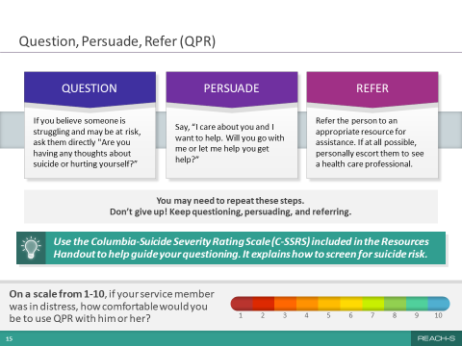
ANIMATIONS:
This slide will first appear with only the Question box on the top left side. You will then be cued to advance the Persuade box, Refer box, and finally the rest of the slide.

MATERIALS:
None.

MAIN DISCUSSION POINTS:
On this slide, we will discuss the following topics:
- Definition of QPR
- Brief Introduction to the Columbia-Suicide Severity Rating Scale

SAMPLE TALKING POINTS:
[Topic 1: Definition of QPR]
SAY:
- Just as people who are trained in CPR and the Heimlich maneuver help save thousands of lives each year, people trained in Question, Persuade and Refer, or QPR, know how to recognize the warning signs of a suicide crisis and how to question, persuade and refer someone for help.
- QPR is designed to offer hope and help you take action when you’re concerned that someone you know may be at risk for suicide. You’ll feel more confident because it gives you the tools to know how to respond in a stressful situation.
- So let’s go over each QPR step.
- Question: If you believe someone is struggling and may be at risk, ask them directly “Are you having any thoughts about suicide or hurting yourself?”
- Some people worry that asking this question will cause the person to think about suicide when they hadn’t before, but research shows that that really isn’t the case.
- It’s the most direct way to find out what the person is thinking.
- Most suicidal people need to “tell their story.” Telling it often provides relief.
- Active listening without interjecting judgment or opinions is critical.
- Telling one’s story to a caring third party may help restore the person’s ability to think more clearly and cope more successfully.
- If they say “Yes,” or you think they might have not told the truth, then go to the next step.

CUE:
Click to advance the “Persuade” box.

SAY:
- Persuade: Say something like “I care about you and I want to help. Will you go with me or let me help you get help?”
- This is where you make an appeal to your love or friendship. It helps the other person feel cared for and perhaps even experience a glimmer of hope.
- The goal of persuasion is to form a positive relationship and to confirm that the person is willing to accept help and find life-affirming solutions.
- Anticipate resistance, especially if the person has made a detailed suicide plan. For those who feel they have few or no reasons for living, persuading them to accept a referral or treatment could save their life.
- Just by giving the distressed person your full attention and getting them to answer your questions, you’ve already demonstrated your compassion and interest in what happens to them.

CUE:
Click to advance the “Refer” box.

SAY:
- Refer: Refer the person to an appropriate resource for assistance. If at all possible, personally escort them to the resource.
- You may encounter resistance to getting help. Find out how willing they are to, in fact, save their own life.
- If the suicidal person begins to stall, argue and disagree with what are reasonable steps to immediately reduce suicide risk and accept help, the person should be seen as soon as possible by a mental health professional.
- Some people who are distressed do not want to share their thoughts of suicide when you first ask them. You may need to repeat these steps more than once.
- This is a process. So don’t give up! Keep questioning, persuading and referring.
- Anyone can use the QPR technique. Using it is a skill you’ll have for the rest of your life. That’s powerful!

CUE:
Click to advance the rest of the slide.

[Topic 2: Brief Introduction to the Columbia-Suicide Severity Rating Scale]

- The C-SSRS can help you with your questioning. It contains guidance on how to ask someone about their level of risk for suicide. It’s included in the handout you’ll receive at the end of this session.
- The C-SSRS is complementary to the QPR technique we just discussed.
- The C-SSRS helps you understand someone’s level of risk for suicide using “Yes” or “No” questions.
- An example question is “Have you wished you were dead or wished you could go to sleep and not wake up?”

ASK:
- Are there any questions or thoughts about what we’ve just reviewed?
- On a scale from 1 to 10, if you saw your service member, someone you care about or a stranger in extreme distress, how likely would you be to use QPR with them?

TIP: If you get low ratings as responses, review the QPR process or the C-SSRS as needed. Use motivational interviewing skills to guide the discussion. Ask “What do you think it would take to move this rating up higher on the scale?” Consider sharing a personal experience to prompt more discussion.

SLIDE 16: Takeaways
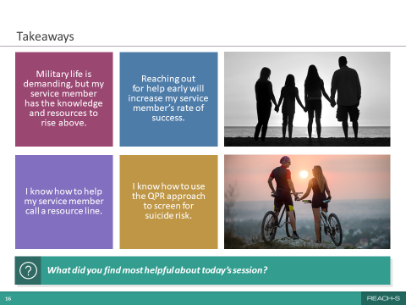
ANIMATIONS:
None.

MATERIALS:
None.

MAIN DISCUSSION POINTS:
On this slide, we will discuss the following topics:
- Key Takeaways

SAMPLE TALKING POINTS:
[Topic 1: Key Takeaways]
CUE:
If a chaplain, MFLC, Military OneSource representative or mental health clinic POC is attending the session, introduce them to participants and have them briefly describe their services.

SAY:
- We’ve almost reached the end of the session. Here are some of the key takeaways that I hope you carry with you after you leave this room.
- Let’s try something a little different. I’m going to pick four of you to read these out loud to us.

ASK:
- [Participant name], could you please start us off with the first one?
CUE:
Continue until all takeaways have been read.

ASK:
- What did you find most helpful about today’s session? Is there something you’re taking away that isn’t listed here?

TIP: Be open to criticism about the session while also emphasizing the overall purpose of the session.

SAY:
- Thank you so much for taking the time to attend today’s session. I know it’s not easy to make time in your schedule when you have work or children to attend to.
- I’ll be passing out [or emailing] a handout that has a lot of great resources, some of which we talked about today.
- If you haven’t attended Session 1, try to attend it soon! Session 1 focuses on the important topic of self-care for you as a military spouse.

TIP: If you already know the schedule for Session 1, let the participants know.

- Thank you again for attending, and thanks for taking part in the discussions. I think we really made some connections and learned some things from each other.
- I’m going to stick around if you have any questions or comments for me.

TIP: Feel free to provide your contact information to participants.

10.0 REACH—S REFERENCES

10.1 Sections 2.0 and 3.0
- Eaton, K. M., Hoge, C. W., Messer, S. C., Whitt, A. A., Cabrera, O. A., McGurk, D., Cox, A., & Castro, C. A. (2008.) Prevalence of mental health problems, treatment need, and barriers to care among primary care-seeking spouses of military service members involved in Iraq and Afghanistan deployments. Military Medicine, 173(11), 1051-1056.
- Hoge, C. W., Castro, C. A., Messer, S. C., McGurk, D., Cotting, D. I., & Koffman, R. L. (2004). Combat duty in Iraq and Afghanistan, mental health problems, and barriers to care. New England Journal of Medicine, 351(1), 13-22.
- Kessler, R. C., Berglund, P., Demler, O., Jin, R., Koretz, D., Merikangas, K. R., Rush, A.J., Walters, E.E., Wang P.S. (2003). The epidemiology of major depressive disorder: Results from the national Comorbidity Survey Replication (NCS-R). Journal of American Medical Association, 289(23), 3095-3105.
- Lewy, C. S., Oliver, C. M., & McFarland, B. H. (2014). Barriers to mental health treatment for military wives. Psychiatric Services, 65(9), 1170-1173.
- Verdeli, H., Baily, C., Vousoura, E., Belser, A., Singla, D., & Manos, G. (2011). The case for treating depression in military spouses. Journal of Family Psychology, 25(4), 488-496.
- De Burgh, H. T., White, C. J., Fear, N. T., & Iversen, A. C. (2011). The impact of deployment to Iraq or Afghanistan on partners and wives of military personnel. International Review of Psychiatry, 23(2), 192-200.
- Mailey, E. L., Mershon, C., Joyce, J., & Irwin, B. C. (2018). “Everything else comes first”: A mixed-methods analysis of barriers to health behaviors among military spouses. BMC Public Health, 18(1), 1013.
- Office of People Analytics (2019). February 2018 Status of Forces Survey of Active Duty Members: Tabulations of responses (OPA Report No. 2019-014).
- Wigfield, A., & Eccles, J. S. (2000). Expectancy-value theory of achievement motivation. Contemporary Educational Psychology, 25, 68-81.

10.2 Session 1

SLIDE 3: MILITARY SPOUSE CHALLENGES
- De Burgh, H. T., White, C. J., Fear, N. T., & Iversen, A. C. (2011). The impact of deployment to Iraq or Afghanistan on partners and wives of military personnel. International Review of Psychiatry, 23(2), 192-200.
- Drummet, A. R., Coleman, M., & Cable, S. (2003). Military families under stress: Implications for family life education. Family Relations, 52(3), 279-287.
- Eaton, K. M., Hoge, C. W., Messer, S. C., Whitt, A. A., Cabrera, O. A., McGurk, D., Cox, A., & Castro, C. A. (2008.) Prevalence of mental health problems, treatment need, and barriers to care among primary care-seeking spouses of military service members involved in Iraq and Afghanistan deployments. Military Medicine, 173(11), 1051-1056.
- Lambert, J. E., Engh, R., Hasbun, A., & Holzer, J. (2012). Impact of post-traumatic stress disorder on the relationship quality and psychological distress of intimate partners: A meta-analytic review. Journal of Family Psychology, 26(5), 729-737.
- Larson, M. J., Mohr, B. A., Adams, R. S., Ritter, G., Perloff, J., & Williams, T. Jeffery, D. D., & Tompkins, C. (2012). Association of military deployment of a parent or spouse and changes in dependent use of health care services. Medical Care, 50(9), 821-828.
- Lewy, C. S., Oliver, C. M., & McFarland, B. H. (2014). Barriers to mental health treatment for military wives. Psychiatric Services, 65(9), 1170-1173.
- Mailey, E. L., Mershon, C., Joyce, J., & Irwin, B. C. (2018). “Everything else comes first”: A mixed-methods analysis of barriers to health behaviors among military spouses. BMC Public Health, 18(1), 1013.
- Mansfield, A. J., Kaufman, J. S., Engel, C. C., & Gaynes, B. N. (2011). Deployment and mental health diagnoses among children of US Army personnel. Archives of Pediatrics & Adolescent Medicine, 165(11), 999-1005.
- Nichols, L. O., Martindale-Adams, J., Graney, M. J., Zuber, J., & Burns, R. (2013). Easing reintegration: Telephone support groups for spouses of returning Iraq and Afghanistan service members. Health Communication, 28(8), 767-777.
- Office of People Analytics. (2018). February 2016 Status of Forces Survey of Active Duty Members: Tabulations of responses (OPA Report No. 2016-035).

SLIDE 4: BARRIERS TO HELP SEEKING
- De Burgh, H. T., White, C. J., Fear, N. T., & Iversen, A. C. (2011). The impact of deployment to Iraq or Afghanistan on partners and wives of military personnel. International Review of Psychiatry, 23(2), 192-200.
- Eaton, K. M., Hoge, C. W., Messer, S. C., Whitt, A. A., Cabrera, O. A., McGurk, D., Cox, A., & Castro, C. A. (2008). Prevalence of mental health problems, treatment need, and barriers to care among primary care-seeking spouses of military service members involved in Iraq and Afghanistan deployments. Military Medicine, 173(11), 1051-1056.
- Hoge, C. W., Castro, C. A., Messer, S. C., McGurk, D., Cotting, D. I., & Koffman, R. L. (2004). Combat duty in Iraq and Afghanistan, mental health problems, and barriers to care. New England Journal of Medicine, 351(1), 13-22.
- Lewy, C. S., Oliver, C. M., & McFarland, B. H. (2014). Barriers to mental health treatment for military wives. Psychiatric Services, 65(9), 1170-1173.
- Nichols, L. O., Martindale-Adams, J., Graney, M. J., Zuber, J., & Burns, R. (2013). Easing reintegration: Telephone support groups for spouses of returning Iraq and Afghanistan service members. Health Communication, 28(8), 767-777.
- Verdeli, H., Baily, C., Vousoura, E., Belser, A., Singla, D., & Manos, G. (2011). The case for treating depression in military spouses. Journal of Family Psychology, 25(4), 488-496.

SLIDE 5: MENTAL HEALTH RESOURCES FOR MILITARY SPOUSES
- Army Chaplain Information: https://www.goarmy.com/chaplain/about.html
- Air Force Chaplain Information: https://www.airforce.com/careers/specialty-careers/chaplain
- Navy Chaplain Information: https://www.navy.com/careers/navy-chaplain
- MCL/VCL: https://www.veteranscrisisline.net/get-help/military-crisis-line
- Military OneSource Benefits and Resources: https://www.militaryonesource.mil/benefits-and-resources
- Non-medical Counseling Resources: https://www.militaryonesource.mil/confidential-help/non-medical-counseling/non-medical-counseling-resources
- Definition of Duty to Warn: https://www.dodig.mil/Portals/48/Documents/Policy/649004p.pdf?ver=2017-04-25-160923-757
- Military and Family Life Counseling Program: https://www.militaryonesource.mil/confidential-help/non-medical-counseling/military-and-family-life-counseling/the-military-and-family-life-counseling-program
- Family Readiness System: https://www.militaryonesource.mil/family-relationships/family-life/keeping-your-family-strong/family-readiness-system
- Army Family Readiness Group: https://www.myarmyonesource.com/familyprogramsandservices/familyprograms/familyreadinessgroup-frg/default.aspx
- Air Force Key Spouse Program: https://www.afpc.af.mil/Benefits-and-Entitlements/Key-Spouse-Program
- Navy Ombudsman Program: https://www.cnic.navy.mil/ffr/family_readiness/fleet_and_family_support_program/work-and-family-life/ombudsman_program.html
- Marine Corps Family Readiness Office: https://www.marforres.marines.mil/family-readiness-office/
- Military Hospitals and Clinics: https://www.tricare.mil/mtf
- Emergency Care: https://www.tricare.mil/FindDoctor/Appointments/Emergency

SLIDE 6: MOBILE RESILIENCE TOOLS
- Breathe2Relax:
https://apps.apple.com/us/app/breathe2relax/id425720246
https://play.google.com/store/apps/details?id=org.t2health.breathe2relax&hl=en_US&gl=US
- Mindfulness Coach:
https://apps.apple.com/us/app/mindfulness-coach/id804284729
https://play.google.com/store/apps/details?id=gov.va.mobilehealth.ncptsd.mindfulnesscoach&hl=en_US&gl=US
- Sesame Street for Military Families:
https://apps.apple.com/us/app/sesame-for-military-families/id550520652
https://play.google.com/store/apps/details?id=com.sesameworkshop.SSMFresources&hl=en_US&gl=US
- Couples Coach:
https://apps.apple.com/us/app/couples-coach/id1457019070
https://play.google.com/store/apps/details?id=gov.va.mobilehealth.ncptsd.couplescoach&hl=en_US&gl=US
- Chill Drills:
https://apps.apple.com/us/app/id1552953408
https://play.google.com/store/apps/details?id=mil.dod.mcfp.chilldrills&hl=en_US&gl=US
- Positive Activity Jackpot:
https://apps.apple.com/us/app/positive-activity-jackpot/id1464064861
https://play.google.com/store/apps/details?id=t2.paj&hl=en_US&gl=US

SLIDE 7: FEAR OF BEING PERCEIVED AS BROKEN
- Eaton, K. M., Hoge, C. W., Messer, S. C., Whitt, A. A., Cabrera, O. A., McGurk, D., Cox, A., & Castro, C. A. (2008). Prevalence of mental health problems, treatment need, and barriers to care among primary care-seeking spouses of military service members involved in Iraq and Afghanistan deployments. Military Medicine, 173(11), 1051-1056.
- Mailey, E. L., Mershon, C., Joyce, J., & Irwin, B. C. (2018). “Everything else comes first”: A mixed-methods analysis of barriers to health behaviors among military spouses. BMC Public Health, 18(1), 1013.
- Mayo Clinic. (2017). Mental health: Overcoming the stigma of mental illness. https://www.mayoclinic.org/diseases-conditions/mental-illness/in-depth/mental-health/ART-20046477#:~:text=Some%20of%20the%20harmful%20effects%20of%20stigma%20can,cover%20your%20mental%20illness%20treatment%20More%20items...%20
- National Alliance on Mental Health. (2018). Navigating a mental health crisis: A NAMI resource guide for those experiencing a mental health emergency. https://www.nami.org/Support-Education/Publications-Reports/Guides/Navigating-a-Mental-Health-Crisis/Navigating-A-Mental-Health-Crisis?utm_source=website&utm_medium=cta&utm_campaign=crisisguide

SLIDE 8: SWITCHING PROVIDERS
- Department of Defense. (2021). TRICARE Choices for National Guard and Reserve Handbook. https://tricare.mil/-/media/Files/TRICARE/Publications/Handbooks/NGR_HB.ashx

SLIDE 9: PRACTICAL CONCERNS
- American Psychological Association. (2007). The psychological needs of U.S. military service members and their families: A preliminary report. https://www.apa.org/about/policy/military-deployment-services.pdf
- Eaton, K. M., Hoge, C. W., Messer, S. C., Whitt, A. A., Cabrera, O. A., McGurk, D., Cox, A., & Castro, C. A. (2008.) Prevalence of mental health problems, treatment need, and barriers to care among primary care-seeking spouses of military service members involved in Iraq and Afghanistan deployments. Military Medicine, 173(11), 1051-1056.
- Lewy, C. S., Oliver, C. M., & McFarland, B. H. (2014). Barriers to mental health treatment for military wives. Psychiatric Services, 65(9), 1170-1173.
- Verdeli, H., Baily, C., Vousoura, E., Belser, A., Singla, D., & Manos, G. (2011). The case for treating depression in military spouses. Journal of Family Psychology, 25(4), 488-496.

SLIDE 12: THE IMPORTANCE OF SELF-CARE
- Brown, B. (2010). The gifts of imperfection: Let go of who you think you’re supposed to be and embrace who you are. Hazelden Publishing.
- Scott, E. (2020). Why self-care can help you manage stress. Verywell Mind.
https://www.verywellmind.com/importance-of-self-care-for-health-stress-management-3144704

SLIDE 13: SELF-CARE AND MENTAL WELLNESS STRATEGIES
- Beauchemin, J., Hutchins, T. L., & Patterson, F. (2008). Mindfulness meditation may lessen anxiety, promote social skills, and improve academic performance among adolescents with learning disabilities. Complementary Health Practice Review, 13(1), 34-45.
- Grossman, P., Niemann, L., Schmidt, S., & Walach, H. (2004). Mindfulness-based stress reduction and health benefits: A meta-analysis. Journal of Psychosomatic Research, 57(1), 35-43.
- Halliwell, E. (2020). Why mindfulness meditation begins with the breath. https://www.mindful.org/6-reasons-why-mindfulness-begins-with-the-breath
- Healthline. (2019). 10 breathing techniques. https://www.healthline.com/health/breathing-exercise#resonant-breathing
- Kabat-Zinn, J. (2017). Defining mindfulness. Mindful. https://www.mindful.org/jon-kabat-zinn-defining-mindfulness
- Mindful. (2020). What is mindfulness? https://www.mindful.org/what-is-mindfulness

10.3 Session 2

SLIDE 3: SERVICE MEMBER CHALLENGES
      - Office of People Analytics. (2020). February 2018 Status of Forces Survey of Active Duty Members: Tabulations of responses (OPA Report No. 2016-035).

SLIDE 4: SERVICE MEMBER BARRIERS TO HELP SEEKING
- Hoge, C. W., Castro, C. A., Messer, S. C., McGurk, D., Cotting, D. I., & Koffman, R. L. (2004). Combat duty in Iraq and Afghanistan, mental health problems, and barriers to care. New England Journal of Medicine, 351(1), 13-22.
- Momen, N., Strychacz, C.P., & Viirre, E. (2012). Perceived stigma and barriers to mental health care in Marines attending Combat Operational Stress Control Program. Military Medicine, 177(10), 1143-1148.
- Office of People Analytics. (2018). February 2016 Status of Forces Survey of Active Duty Members: Tabulations of responses (OPA Report No. 2016-035).

SLIDE 5: HANDLING THINGS ON THEIR OWN
- Office of People Analytics. (2018). February 2016 Status of Forces Survey of Active Duty Members: Tabulations of responses (OPA Report No. 2016-035).

SLIDE 6: FEAR OF BEING PERCEIVED AS BROKEN
- Office of People Analytics. (2020). February 2018 Status of Forces Survey of Active Duty Members: Tabulations of responses (OPA Report No. 2016-035).

SLIDE 7: MENTAL HEALTH TREATMENT AND CAREER OUTCOMES
- Defense Counterintelligence and Security Agency. (2020). Mental Health and Security Clearances. https://www.dcsa.mil/Portals/91/Documents/DODCAF/resources/DCSA-OnePager_MentalHealth_SecurityClearances.pdf
- Defense Personnel and Security Research Center. (2020). Analysis of unpublished Office of People Analytics data. Seaside, CA: Author.
- Mayo Clinic. (2019). Stress symptoms: Effects on your body and behavior. https://www.mayoclinic.org/healthy-lifestyle/stress-management/in-depth/stress-symptoms/art-20050987
- Mental Health America. (2021). The B4Stage4 philosophy. https://www.mhanational.org/b4stage4-philosophy
- Rowan, A.B., & Campise, R.L. (2006). A multisite study of Air Force outpatient behavioral health treatment-seeking patterns and career impact. Military Medicine, 171(11), 1123-1127.
- Verve Health. (2021). The importance of stress management. https://verve-health.com/the-importance-of-stress-management

SLIDE 8: MENTAL HEALTH RESOURCES FOR SERVICE MEMBERS
- Army Chaplain Information: https://www.goarmy.com/chaplain/about.html
- Air Force Chaplain Information: https://www.airforce.com/careers/specialty-careers/chaplain
- Navy Chaplain Information: https://www.navy.com/careers/navy-chaplain2
- MCL/VCL: https://www.veteranscrisisline.net/get-help/military-crisis-line
- Military OneSource Benefits and Resources: https://www.militaryonesource.mil/benefits-and-resources
- Non-medical Counseling Resources: https://www.militaryonesource.mil/confidential-help/non-medical-counseling/non-medical-counseling-resources
- Information on Military and Family Life Counseling Program: https://www.militaryonesource.mil/confidential-help/non-medical-counseling/military-and-family-life-counseling/the-military-and-family-life-counseling-program
- Definition of Duty to Warn: https://www.dodig.mil/Portals/48/Documents/Policy/649004p.pdf?ver=2017-04-25-160923-757
- Military Hospitals and Clinics: https://www.tricare.mil/mtf
- Emergency Care: https://www.tricare.mil/FindDoctor/Appointments/Emergency

SLIDE 9: MOBILE RESILIENCE TOOLS
- Mindfulness Coach:
https://apps.apple.com/us/app/mindfulness-coach/id804284729
https://play.google.com/store/apps/details?id=gov.va.mobilehealth.ncptsd.mindfulnesscoach&hl=en_US&gl=US
- Couples Coach:
https://apps.apple.com/us/app/couples-coach/id1457019070
https://play.google.com/store/apps/details?id=gov.va.mobilehealth.ncptsd.couplescoach&hl=en_US&gl=US
- PTSD Family Coach:
https://apps.apple.com/us/app/ptsd-family-coach/id804318041
https://play.google.com/store/apps/details?id=gov.va.mobilehealth.ncptsd.ptsdfamilycoach&hl=en_US&gl=US
- T2 Mood Tracker:
https://apps.apple.com/us/app/t2-mood-tracker/id428373825
https://play.google.com/store/apps/details?id=com.t2.vas&hl=en_US&gl=US
- Chill Drills:
https://apps.apple.com/us/app/id1552953408
https://play.google.com/store/apps/details?id=mil.dod.mcfp.chilldrills&hl=en_US&gl=US

SLIDE 14: SIGNS AND SYMPTOMS OF SUICIDE RISK
            - National Institute of Mental Health. (2019). Suicide prevention. https://www.nimh.nih.gov/health/topics/suicide-prevention/index.shtml

SLIDE 15: QUESTION, PERSUADE, REFER (QPR)
- Susman, D. (2018). How using QPR can prevent suicides. Psychology Today. https://www.psychologytoday.com/us/blog/the-recovery-coach/201802/how-using-qpr-can-prevent-suicides
- The Columbia Lighthouse Project. (2021). The Columbia protocol for families, friends, and neighbors. https://cssrs.columbia.edu/the-columbia-scale-c-ssrs/cssrs-for-families-friends-and-neighbors
- QPR Institute. (2021). What is QPR? https://qprinstitute.com/about-qpr

APPENDIX A: REACH—S Virtual Sessions

A1. Facilitating a Virtual REACH–S Session
Similar to an in-person REACH—S session, a virtual REACH—S session has six key components:
- Facilitator introduction and overview of the REACH—S session.
- A conversation about the unique challenges that military spouses (Session 1) or service members (Session 2) face and how they relate to reaching out for help.
- An interactive discussion about the top barriers to help seeking reported by military spouses (Session 1) or service members (Session 2) and solutions to these barriers.
- A practice call to Military OneSource made by the facilitator and a volunteer participant from the audience in front of the group. The participants will generate ideas for call topics that are relevant to those attending the REACH—S session. The practice call is designed to show how easy it is to call this resource for help. The facilitator can also ask group members to pair up and make the call themselves to create a more realistic and immersive experience.
- An interactive discussion about the importance of self-care (Session 1) or warning signs of suicide risk and Question, Persuade, Refer (QPR) technique (Session 2).
- Review of takeaways and distribution of Resources Handout.

A2. Creating an Optimal Virtual Environment
You may be wondering how to maximize engagement and how to make your virtual REACH—S session as useful as possible to your participants. We have outlined some tips below to help you lead a successful REACH—S session virtually.
- Review your virtual platform’s presentation options. Practice how to display a split screen, so that both you and the REACH—S slides are visible while presenting. If this is not an option, practice toggling back and forth between the REACH—S slides and your camera.
- Practice delivering REACH—S virtually several times, so that you are adept at using the platform, understand how to manage the chat feature, and know how to troubleshoot any technical issues.
- Practice sharing your screen. If there is a co-facilitator, they can help by sharing their screen with the REACH—S slides and advancing the slides. This will allow you to give more attention to the participants.
- Record yourself presenting a REACH—S session, if possible. Review the recording and take note of how you can improve.
- Ask participants to join the REACH—S session 15 minutes early, so they can test their audio and video and become familiar with the virtual platform.
- When interacting over video, set clear expectations and guidance for the session. Communication with participants is key, as some may have never used a virtual platform before. Spend a few minutes during Slides 1 or 2 reviewing when/how participants should use specific features of the virtual platform.
- Let participants know they should keep their cameras on and video visible (when possible) to create the feeling of an interactive session.
- Recruit a participant to help you make the practice call to Military OneSource, ahead of time or during your session. It is often easiest to make the practice call with a cellphone on speakerphone. Place the phone’s speaker as close to the computer’s microphone to ensure participants can hear clearly. You will begin the call and the volunteer will then share a scenario that they need support with. Remember to ask participants whether they can hear clearly and adjust as needed.
- Let participants know how to communicate with you during the session when they wish to ask or answer a question. Some virtual platforms have options indicating the user would like to speak.
- Audio and chat box—Let participants know how the audio controls for the session will be structured. Options include:
    - Ask participants to mute themselves if there is background noise in their location, but do not mute them yourself. Ask them to raise their hand to indicate that they would like to speak. This option will allow everyone to talk freely without the hindrance of having to use the mute controls.
    - Mute everyone until you ask a question or someone raises their hand to indicate that they would like to speak. At that point you would unmute the individual who raised their hand or unmute all to allow session participants to speak freely.
    - Mute everyone and have participants comment or respond to questions by typing in the chat box. You or a co-facilitator can read aloud the questions/responses and then provide a verbal response. Participants can raise their hands to indicate they have written something in the chat box. Please note: This option should only be used as a last resort because the sessions are meant to be interactive and using a chat box feature often diminishes the feeling of interactivity.
    - Make sure all audience members know where to locate their mute button and chat box.
    - Use a hands-free headset when possible; they allow for easier control of other platform tools and features, improved audio and a generally more authentic delivery.
- Specific platform options—some virtual platforms have extra options that you can use throughout your session to make it more interactive. For example, Zoom for Government has a virtual dry-erase board and a polling feature that you can use to ask the audience to rate items on a scale. You will need to make sure the audience is aware of the expectation to respond to polls when they come up. There are several slides in REACH—S Sessions 1 and 2 when participants are asked to provide a rating on a scale from 1 to 10.
- Convey participant expectations from the outset. You may want to ask participants to follow these ground rules:
- Avoid cellphone use and make sure your phone is in silent mode.
- Don’t work on other tasks, such as checking email, during the virtual session.
- Sit in a quiet area, free from loud background noises.
- If you have to leave, return as soon as possible.
- Communicate that there will be no designated breaks during the session, but that participants can step away from the session as needed without informing you. If you notice that participants need an energizing activity, feel free to pause for a 1- to 2-minute “stretch break.”
- Remind participants to make themselves comfortable (e.g., sit in a comfortable chair, have some water on hand).
- Handling technical difficulties:
- If, as a facilitator, you are having technical difficulties, create a protocol for the entire group to follow. Options include reconvening in 5 to 15 minutes or rescheduling the REACH—S session for another day. Choose what will work best for all participants.
  - If you are conducting the virtual REACH—S session on site at a military installation, contact an IT representative for support.
- If participants are having video/audio difficulties, suggest that they try signing out and signing back in.
- If participants are having internet connectivity issues, suggest that they try restarting their router or verifying that there is a Wi-Fi connection.
- Resist the urge to go into “briefing mode” when you are displaying the slides. Go through your talking points ahead of time and look for breaks where discussion could occur and plan how you will ask questions or call on participants to participate.

A3. Equipment Specifications
The main visual aid for leading a virtual REACH—S session consists of the slide deck. The following supplies are also necessary.
ELECTRONIC  - Approved virtual platform  - Laptop/computer with webcam and microphone  - Laptop charger (if needed)  - Audio speakers  - REACH slide file saved to desktop  - Telephone/personal cellphone with a speaker function (on vibrate or silent mode)  - Internet access | NON-ELECTRONIC  - Paper and notepad to take note of any questions  - Water/some kind of beverage*  * Optional

A4. Facilitator Preparation

CHECKLIST OF KEY ACTIVITIES FOR FACILITATING A VIRTUAL REACH—S SESSION
Below is a checklist of key activities to complete before and after a virtual REACH—S session. Preparation for leading a REACH—S session begins 1 to 2 weeks prior to the REACH—S session, and additional preparation occurs on the day of the session to ensure things run smoothly. Please also review the Building Participant Engagement in a Virtual Session section following this checklist.
 | Checklist of Key Activities for a Virtual REACH—S Session
2 Weeks Before The Session | - Identify the room where you will be conducting your virtual REACH—S session and make sure there is a presentable background (e.g., free of clutter, well-lit).  - View what the background looks like on camera at the time of day you will be presenting.  - Plan 30 minutes for setup, 90 minutes for the REACH—S session itself, and 30 minutes for following up with participants and sending out materials.  - Confirm that you have access to an approved virtual platform and have the correct login information.  - Ensure that you are comfortable navigating the virtual platform features to share your screen, mute participants, etc.  - Send participants a calendar invitation that includes details about date, time and instructions for how to set up the virtual platform.  - Ask participants to join the session 15 minutes early, so they can get comfortable, as well as “live check” their audio and video.  - Obtain participant cellphone numbers in case they need to be contacted while enacting the Virtual Distress Protocol.  - Invite local resource representatives to attend (e.g., chaplain, MFLC, financial counselor, mental health clinic POC) and include them on the invitation.  - Watch the Session 1 and Session 2 REACH—S demonstration videos featuring a virtual REACH—S session with military spouses.
1 Week Before The Session | - Send reminder emails to participants.  - Fill in the Local Resources section of the Resources Handout on pages 8-9, 12, and 24 with any specific installation and local resources you wish to share with your target audience (e.g., chaplain, mental health clinic information; see APPENDIX D: How to Find Local Resources for further guidance).  - Confirm availability of any local resource representatives you have invited to attend (e.g., chaplain, MFLC, financial counselor, mental health clinic POC).  - Review the Virtual Distress Protocol.
1 Day Before The Session | - Conduct a dry run of the virtual session, making sure your camera is set up where you would like it to be and that your audio is working; if you have a co-facilitator(s), be sure to practice together.  - Ensure you have all necessary equipment available.
1 Hour Before The Session | - Log on to the virtual platform at least 30 minutes early to set up the virtual room.  - Have REACH—S slide deck open and ready.  - Test your phone’s speakerphone to make sure it is working.  - Check that you have all necessary equipment on hand.  - Have participant phone numbers on hand.  - Use a session roster to take note of the names of all who attended.
After The Session | - Submit the final session roster and any evaluation/feedback forms (if used) to appropriate local POC.  - Follow up with any participant(s) whose questions require further research.  - Email REACH—S slides and Resources Handout to all participants along with any other relevant handouts.  - Review what went well and what will need improvement for the next virtual session.

BUILDING PARTICIPANT ENGAGEMENT IN A VIRTUAL SESSION
Prepare for your virtual REACH—S session by planning for an engaging discussion with your participants that grabs and holds their attention, encourages sharing and builds connection. A virtual session can occur with a larger group of up to 20 participants as long as you are able to achieve these goals and feel comfortable managing a group of this size.
- Let participants know if/when you need to pause to cue up or prepare something and announce what is about to occur. This will help keep their attention during transition times.
- Practice and model patience. You will need to build in pause time to allow participants to connect to the session, type in their answers, unmute themselves before speaking, etc.
- Invite a co-facilitator. Having a co-facilitator is very useful for providing technical and content support. While the lead facilitator is speaking or leading the discussion, the co-facilitator can monitor the chat, provide feedback, address questions that arise and help stimulate conversation. As the lead facilitator poses questions for discussion, if nobody responds, the co-facilitator can respond first to encourage others to participate.
- Make the session interactive. Get participants to speak up and call on people by name.
- Work hard to build engagement by being warm and welcoming. If you have a co-facilitator, they can assist by being the first one to speak up. If only a few participants speak up, it is fine to move on to the next topic, thanking the ones who did. In the virtual environment, not everyone may feel comfortable sharing.
- If you have participants in the audience who like to share, call on them by their name when you pose questions to the group and ask them to share their thoughts.
- Ask interesting and thought-provoking questions. The Facilitator’s Manual provides suggested questions to ask, or you can personalize questions to your audience. Good questions are ones that encourage people to share their experiences and opinions. Review APPENDIX B: Motivational Interviewing Worksheets for more tips on how to ask good questions.
- Observe participants’ faces to track nonverbal cues and monitor the chat box to assess their level of engagement. Then make adjustments to the way you lead the session in order to keep participants focused.
- Use the chat box to your advantage.
- Remind participants to use the chat box to respond and share their thoughts. If you notice participants hesitating to respond on video, you can encourage them to type their answers in the chat box. They might feel more comfortable with this response mode. Using polls is also an effective way to build interaction during the session.
- Make sure you are paying attention to the chat box responses. Read some of them out loud and respond using motivational interviewing techniques (e.g., reflective listening). This will show participants that you appreciate their participation and value the input they are adding to the session.

A5. Virtual Distress Protocol
There is minimal risk that REACH—S will cause psychological or physical distress to participants. However, if a participant becomes distressed, stop or pause the session by letting participants know you will be taking a 10-minute break, that you will be muted during the break, that everyone can leave the virtual session open, and that you will be returning in a few minutes. Reach out to the distressed individual via a phone call to gauge how they are feeling. Assess the severity of the participant’s distress and then contact the chaplain (or the mental health clinic representative and/or MFLC, if present) and request that they attend to the participant’s needs. Work with the individual and chaplain (or enlisted religious affairs personnel/mental health support staff/MFLC) to determine whether follow-up mental health care is necessary.
OPTING TO SEEK MENTAL HEALTH CARE
Assess the situation and ask the participant if they would like to contact a provider in the local mental health clinic or MTF. If you determine that the participant is at high risk for distress or would like to speak with a provider to possibly seek mental health care, contact the local clinic/MTF using a three-way call and remain with the participant on the line while they wait for follow-up from the mental health care provider. In this situation, communicate with the participants and session coordinator about rescheduling the session for another day.
OPTING NOT TO SEEK MENTAL HEALTH CARE
If the participant chooses not to contact a mental health care provider at that time and is at a low level of distress, ask if they would like to continue with the REACH—S session or be excused. If the participant chooses to leave, ask the participant to coordinate with the chaplain or contact a family member or a friend for support. Ask the participant if you can call them later in the day to see how they are doing.
EVENT REPORTING AND FOLLOW-UP
Report the event to the local REACH—S POC and follow up with the participant and the attending mental health care provider (if one was seen) to ensure a safe outcome.

APPENDIX B: Motivational Interviewing Worksheets

B1. Motivational Interviewing Principles and Techniques

Motivational Interviewing Principles
Develop Discrepancy (DD) by emphasizing the importance of reaching goals and making changes to the way things are.
Express Empathy (EE) by understanding the other person’s perspective and feelings without judging or evaluating them.
Avoid Arguing (AA) by not telling the other person that their opinion is wrong.
Roll with Resistance (RR) by getting out of the way of resistance and not engaging it.
Support Self-Efficacy (SS) by providing information, modeling actions and practicing together.
Motivational Interviewing Techniques
Open-Ended Questions (O): Ask questions that do not get a one-word response and encourage the other person to express themselves.
Affirmations (A): Make sincere statements that focus on someone’s strengths and boost their self-confidence.
Reflective Listening (R): Use new words to restate what you just heard and show the other person that you are hearing, acknowledging and understanding their perspective.
Summaries (S): Make a statement that sums up what the other person has just said and end it with an invitation to correct you if you got it wrong.

B2. Motivational Interviewing Self-Assessment
Do I listen more than I talk?
Or am I talking more than I listen?
Do I keep myself sensitive, open and neutral to this person’s issues, whatever they may be?
Or am I talking about what I think the problem is?
Do I invite this person to talk about and explore their own ideas for change?
Or am I jumping to conclusions and possible solutions?
Do I encourage this person to talk about their reasons for not changing?
Or am I forcing them to talk only about change?
Do I ask permission to give my feedback?
Or am I presuming that my ideas are what they really need to hear?
Do I reassure this person that ambivalence to change is normal?
Or am I telling them to take action and push ahead with a solution?
Do I help this person identify successes and challenges from their past and relate them to present change efforts?
Or am I encouraging them to ignore or get stuck on old stories?
Do I seek to understand this person?
Or am I spending a lot of time trying to convince them to understand me and my ideas?
Do I summarize for this person what I am hearing?
Or am I just summarizing what I think?
Do I value this person’s opinion more than my own?
Or am I giving more value to my viewpoint?
Do I remind myself that this person is capable of making their own choices?
Or am I assuming that they are not capable of making good choices?
Adapted from: https://www.centerforebp.case.edu/client-files/pdf/miremindercard.pdf

B3. Motivational Interviewing Self-Test
A 24-year-old man says: “I really feel awful. Last night I got drunk and I don't even remember what I did. This morning I found out that the screen of the television is busted and I think I probably did it because my spouse isn't even talking to me. I don't think I'm an alcoholic, you know, because I can go for weeks without drinking. But this has got to change.”
Code each of the following responses using the Motivational Interviewing principles and the OARS techniques: For example, by saying “sounds pretty scary,” are you Expressing Empathy (EE)? Are you engaging in Reflective Listening (R)? None of these?
- Sounds pretty scary.
- Although the police were not called this time, what would happen if they were?
- You feel like you were out of control.
- You’re feeling confused.
- Although you can go weeks without drinking, have you ever tried not drinking for a few months?
- I’m worried about you and your spouse.
- That’s not the first time something like this happened.
- Do you think this is going to get worse if you don’t take action?
- You don’t think you’re an alcoholic, yet you’re doing some extreme things.
- What is it that makes you want to keep drinking?
- What are the three best reasons for you stop drinking?
- So now your TV is broken.
- Your spouse is frustrated with your behavior.
- How important would you say is it for you to make a change, on a scale from 1 to 10, where 1 is not at all important and 10 is extremely important?

B4. Helpful Responses Questionnaire
The following quotes are things that a person might say to someone else about a problem they are having. Recalling the Motivational Interviewing principles of DD, EE, AA, RR, SS and the OARS techniques, write one to two sentences about the next thing you might say if you wanted to be helpful.
1. A 36-year-old man says:
“My neighbor really makes me mad. He's always over here bothering us or borrowing things that he never returns. Sometimes he calls us late at night after we've gone to bed and I really feel like telling him to get lost.”
YOUR RESPONSE:
2. A 24-year-old woman says:
“I’m in a long-distance relationship. It started out fun and we really care about each other, but now that we’re apart, it’s so hard. We don’t talk on the phone as much as we used to and he goes out a lot on the weekends, which kind of bothers me. I could see this relationship leading to marriage, but I’m just not sure how we can make it work.”
YOUR RESPONSE:
3. A 21-year-old man says:
“I'm really mixed up. A lot of my friends like to drink to the point of blackout. They always want me to come along and I don't want them to think I'm weird or something, but I don't really want to go down that road. I want to be able to function the next day.”
YOUR RESPONSE:
4. A 30-year-old parent says:
“My daughter is a good girl. She's never been in trouble, but I worry about her because her grades are slipping. Lately she has loud outbursts and then cries. We try to talk to her about what’s going on at school, but she just goes to her room. We try to get her to do her homework, but she won't listen.”
YOUR RESPONSE:
5. A 23-year-old woman says:
“My life just doesn't seem as fun anymore. I'm always feeling stressed. I can’t eat like I used to because I’m gaining weight. Nothing good ever happens to me. I’m losing touch with my friends back home. Sometimes I wonder whether it's worth staying in the military.”
YOUR RESPONSE:
Adapted from Miller, W. R., Hedrick, K. E., & Orlofsky, D. (1991). The Helpful Responses Questionnaire: A procedure for measuring therapeutic empathy. Journal of Clinical Psychology, 47, 444-448.

APPENDIX C: Question 21 on the Standard Form 86
This appendix contains Question 21 from the Standard Form 86 Questionnaire for National Security Positions (SF-86), the Questionnaire for National Security Positions, which was revised in November 2016. As a facilitator, you can use this appendix as an informational resource to help you address questions about Question 21 reporting requirements. The full form is available at: https://www.opm.gov/forms/pdf_fill/sf86.pdf

APPENDIX D: How to Find Local Resources
This appendix will assist you with identifying local resources for pages 8-9, 12, and 24 of the Resources Handout. Recall that you will need to populate these pages with resources applicable to your target audience. Below we walk you through the process for how to accomplish this task.

D1. Local Resource Sections in the Handout
- The design of the Resources Handout allows for customization and insertion of information specific to your target audience and installation. Areas highlighted in yellow throughout the Resources Handout indicate where you can fill in this information. For each of these resources, you will need to fill in the resource name, phone number, physical address, email address and website, if applicable.
- Pages 8-9 (Local Mental Health Resources): fill in the contact information for installation chaplain, military and family life counselor, Family Readiness System, Military and Family Support Center, mental health clinic, substance abuse program and emergency room.
- Page 12 (Local Sexual Assault, Abuse and Prevention Resources): fill in the contact information for domestic abuse victim advocate, sexual assault response coordinator, Family Advocacy Program and family violence prevention services.
- Page 24 (Practical Concerns): fill in the contact information for child care, transportation and medical provider services.
- To find these local resources, go to your installation’s website. As listed in the following section, there are multiple ways to find the installation website and specific local resources. Once you have found the correct installation, search for each of the local resources needed and add the appropriate information to pages 8-9, 12 and 24.
- Alternatively, you can visit or call your local installation and talk to administration services. Introduce yourself and ask about resources available at the installation. If you are able to, visit in person to get a better feel for the services provided.
- If there is a local resource not included in the handout that you wish to include, simply add it to the applicable section. Alternatively, if a local resource listed in the handout is not available at your installation, simply delete it.
- Please ensure that adding or deleting resources does not alter the appearance and/or structure of the Resources Handout.
- Finally, after making your edits, manually update the page numbers in the table of contents.

D2. How to Find Local Resource Information

Military OneSource
- The Military OneSource website will contain the majority of the local resources you will need to fill in pages 8-9, 12 and 24. You can search for specific installation resources, state resources and programs by going to this link: https://installations.militaryonesource.mil
- You can also click on View All Installations and search by your specific state and installation/unit or filter by region or service branch.
- Once you click on your specific installation, you will be able to view resources for Base Essentials and Military and Family Support Services. Clicking on a service will take you to a description of available resources and local office information on the right side of the page (see pictures provided), such as address, direct phone number and hours.
- Available military and family support services at each installation include:
- Child and Youth Services
- Education
- Health
- Exceptional Family Member Program
- Housing
- Legal
- Military and Family Support
- Morale, Welfare and Recreation
- Moving
- Transportation
- There is also an option to register and create a Military OneSource account with a username and a password. If you do this, you will be able to view local information on topics, such as schools, amenities and home market values.
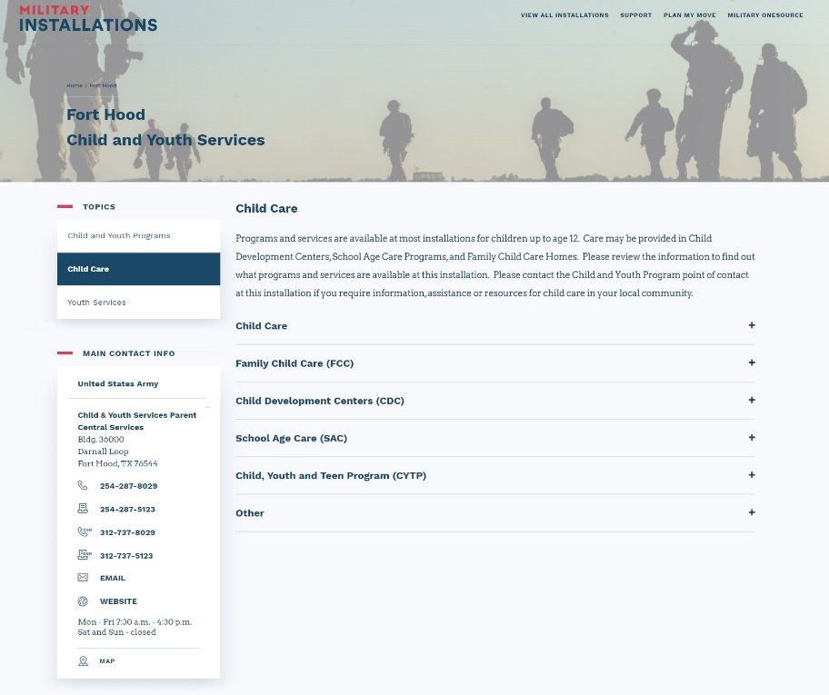

Google
- You can also search for local installation resources using Google or your preferred search engine. On the installation website, there will be various resources, trainings and information about the installation. You will also find local information, such as visitor information and emergency phone numbers. Navigate through the website and explore the various resources and services that your installation provides.
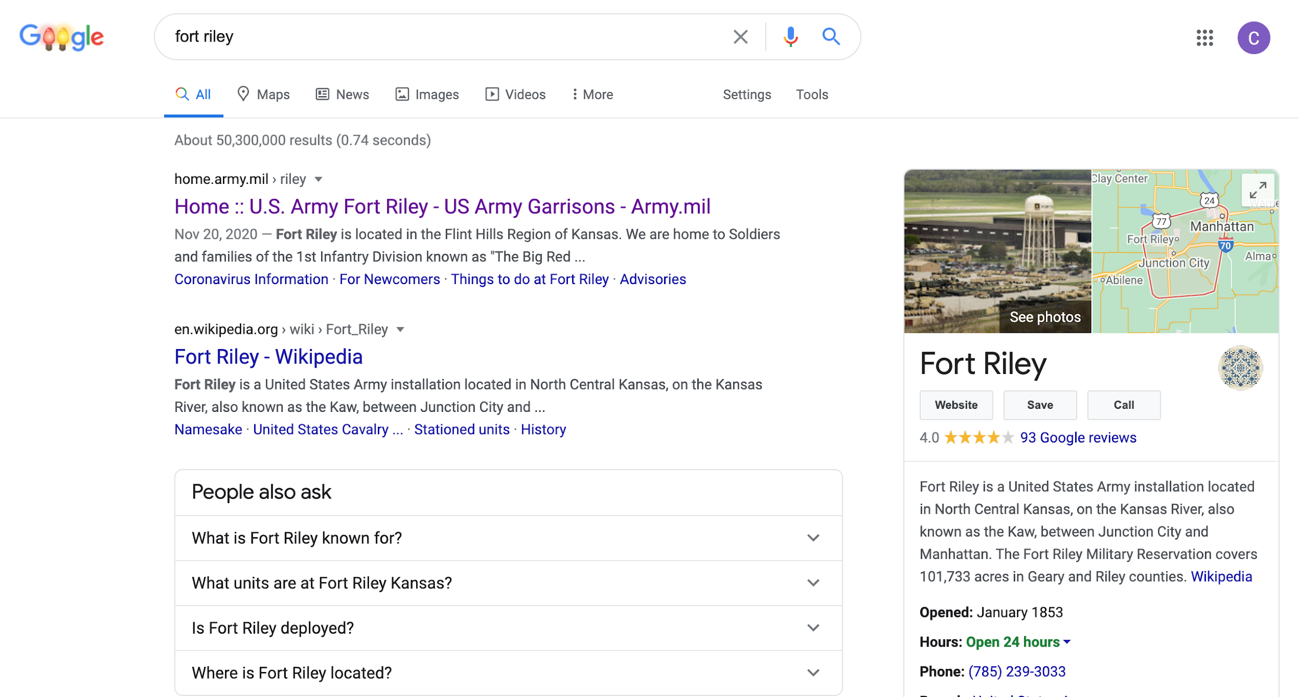

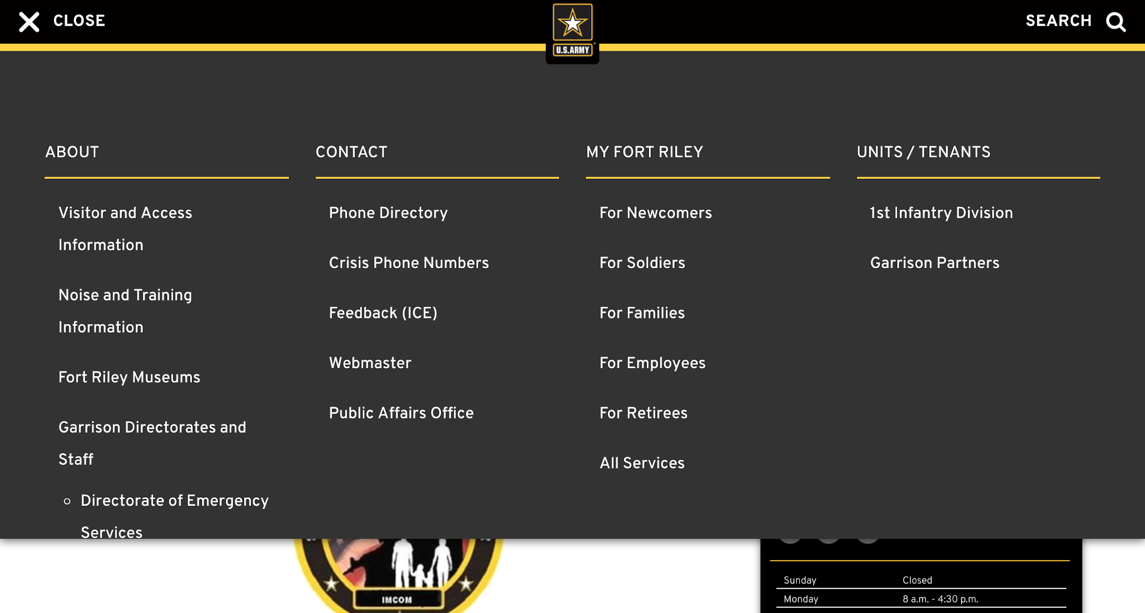

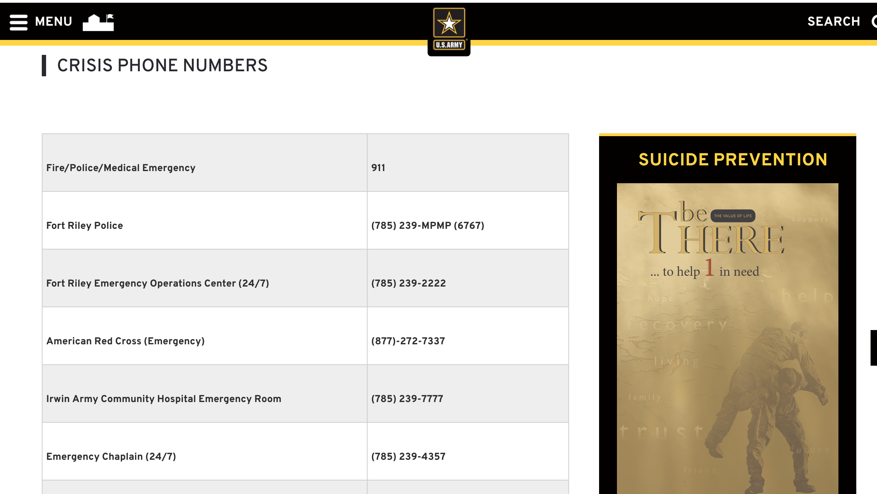

Local Social Media Groups
- If you have a Facebook account, you can search for local groups at your installation using its name or other related search terms. While some of the Facebook groups may be accessible to the public, others may require you to submit a request to join. Facebook community groups can be an excellent source of information about local resources for your REACH—S sessions.

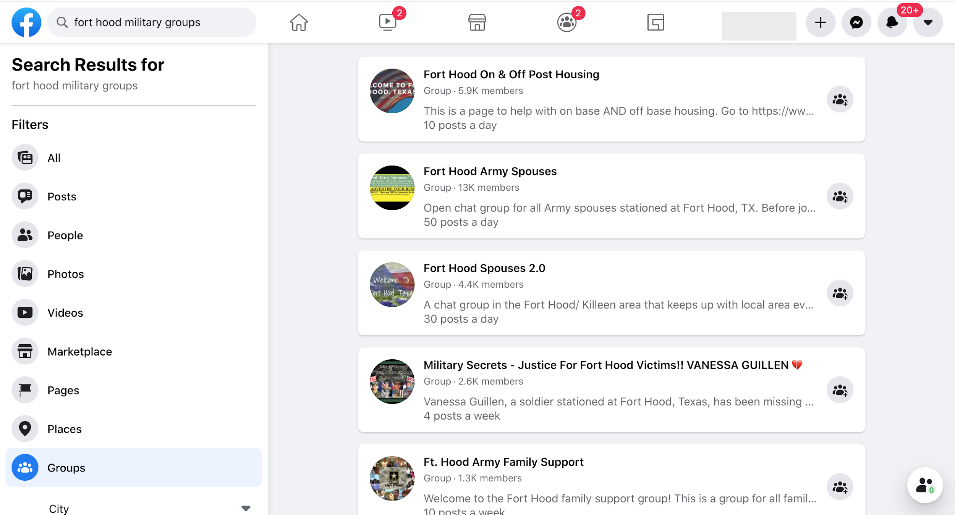

Family readiness system and Installation Resources
- You can also contact your installation Family Readiness System to inquire about specific resources that you had trouble identifying via the other channels.

Even though the primary audience for REACH—S are military spouses and significant others, we recognize that parents play a similarly important role in influencing service members to reach out for help, and encourage them to attend as well.
The virtual option was added to accommodate COVID-19 social distancing requirements. See APPENDIX A: REACH—S Virtual Sessions for guidance on how to conduct a virtual REACH—S session using an online meeting platform.
³⁻¹¹ See Section 10.0 REACH—S REFERENCES for citations referenced in Sections 2.0 and 3.0.
¹²If you lack the experience of responding to a mental health crisis, please enlist the support of a chaplain or a suicide prevention coordinator by inviting them to attend the REACH—S session. Also, review the distress protocol outlined in Section 8.9.

