Resources Handout

RESOURCES EXIST, ASKING CAN HELP— SPOUSE

TABLE OF CONTENTS
TABLE OF CONTENTS 1
Purpose 2
Mental Health Resources 3
Counseling Resources 3
Crisis Response 4
Referrals and Information 5
Trainings 7
Local Mental Health Resources 8
Columbia – Suicide Severity Rating Scale (C-SSRS) 10
Sexual Assault, Abuse, and Prevention Resources 11
Referrals and Information 11
Local Resources 12
Employment Resources 13
Service Branch Resources 14
Army 14
Navy 15
Marine Corps 16
Air Force and Space Force 17
National Guard/Reserve 18
Social Media, Video, and Mobile Resources 20
Blogs, TED Talks, Apps, and Reports 20
Facebook Groups 20
Mobile Apps 22
Other Important Resources 24
Practical Concerns 24

Version 1, MAY 2021 (OPA-2021-035, PERSEREC-PA-20-21)

Purpose
Whether you prefer to connect with someone by telephone, via e-mail or in person, this collection of national and local resources will help you find the best possible solution for your needs. The resources in this handout are designed to connect you to the support, answers and information you may need to overcome difficult challenges and reach your goals. The resources are grouped into six major categories: 1) Mental Health Resources; 2) Sexual Assault, Abuse and Prevention Resources; 3) Employment Resources; 4) Service Branch Resources; 5) Social Media, Video and Mobile Resources; and 6) Other Important Resources. We encourage you to explore and use these resources to help you and your family thrive.
Resources cited and the appearance of hyperlinks do not constitute endorsement by the Department of Defense of this website or the information, products or services contained therein. For other than authorized activities, such as military exchanges and Morale, Welfare and Recreation sites, the Department of Defense does not exercise any editorial control over the information you may find at these locations. Such links are provided consistent with the stated purpose of this Department of Defense-sponsored publication.

Mental Health Resources

Counseling Resources

Military OneSource
Provides free confidential non-medical counseling, resources and support to address a variety of issues, reduce stress, improve emotional well-being and build important skills to tackle life’s challenges.
Eligibility:
- All service members and their families
- Veterans and their families for 365 days after separation date
- Surviving spouses and their children
Available 24/7 by phone, secure video or online chat.
800-342-9647
https://www.militaryonesource.mil/confidential-help/non-medical-counseling

Give an Hour
Provides free mental health counseling and therapy from a network of licensed mental health professionals.
Eligibility:
- All service members and their families
- Veterans and their families
- Survivors of large disasters and traumas
Available in person, by phone or secure video.
https://giveanhour.org

Department of Defense Employee Assistance Program, or EAP
Provides free confidential counseling and resources to help people work through life challenges that may adversely affect job performance, health and personal well-being.
Eligibility:
- DOD civilian employees
Available 24/7 by phone or Monday-Friday, 7 a.m. to 5:30 p.m. CT by live chat.
866-580-9046
https://magellanascend.com

Vet Centers
Provides free confidential community-based counseling services to assess and treat mental health issues, including professional readjustment counseling.
Eligibility:
- All service members and their families
- Veterans and their families
Available 24/7 by phone.
877-WAR-VETS (927-8387)
https://www.vetcenter.va.gov

Installation Chaplains
Provides free religious services and resources; individual, family, premarital and marital counseling; and pre/post deployment assistance. Chaplains offer total confidentiality.
Eligibility:
- All service members and their families
Available in person or by phone.*

*See page 2 for chaplain’s contact information.

Mental Health Resources

Crisis Response

Disaster Distress Helpline
Provides free immediate crisis counseling for anyone experiencing emotional distress due to any natural or human-caused disaster.
Eligibility:
- Everyone
Available 24/7 by phone.
800-985-5990
https://www.samhsa.gov/find-help/disaster-distress-helpline

National Suicide Prevention Lifeline
Provides free confidential support and resources for people in suicidal crisis or emotional distress.
Eligibility:
- Everyone
Available 24/7 by phone or online chat.
800-273-8255
https://suicidepreventionlifeline.org

Military/Veterans Crisis Line
Provides free confidential crisis support and resources to those in distress.
Eligibility:
- All service members and their families
- Veterans and their families
Available 24/7 by phone, text or online chat.
800-273-8255, Press 1; or Text 838255
In Europe: Call 00800 1273 8255 or DSN 118
In Korea: Call 0808 555 118 or DSN 118
In Afghanistan: Call 00 1 800 273 8255
or DSN 111
https://www.veteranscrisisline.net

Mental Health Resources

Referrals and Information

Substance Abuse and Mental Health Services Administration, or SAMHSA
Provides free confidential treatment referral and information services (in English and Spanish) for individuals and families dealing with mental and/or substance use disorders.
Eligibility:
- Everyone
Available 24/7 by phone.
800-662-4357
https://www.samhsa.gov/find-help/national-helpline

National Alliance on Mental Illness, or NAMI
Provides free information, resource referrals, and support to people living with mental health conditions.
Eligibility:
- Everyone
Available Monday-Friday, 10 a.m. to 6 p.m. ET by phone or text.
800-950-NAMI (6264), text “NAMI” to 741741
Email: info@nami.org
https://www.nami.org/Your-Journey/Veterans-Active-Duty

InTransition
Provides free specialized coaching and assistance with mental healthcare to service members and veterans relocating to another assignment, returning from deployment, transitioning between services, transitioning out of the military or when a new mental health provider is needed.
Eligibility:
- All service members
- Veterans
Available 24/7 by phone.
800-424-7877
International Toll Free: 800-424-4685
Collect: 314-387-4700
https://www.pdhealth.mil/resources/intransition

Families Overcoming Under Stress – FOCUS
Provides a wide range of free effective prevention services customized to the needs of service members and their loved ones. Assists couples and families with various resources, such as resilience training, education workshops, consultations or skill-building groups focused on specific needs.
Eligibility:
- All service members and their families
Available by phone or e-mail.
310-794-2482
Email: info@focusproject.org
https://focusproject.org/about

American Association for Suicidology
Promotes the understanding and prevention of suicide and provides free resources and support to those affected by it.
Eligibility:
- Everyone
Available by phone or e-mail.
202-237-2280
Email: info@suicidology.org
https://suicidology.org/resources

Mental Health Resources

Referrals and Information (cont.)

Psychological Health Resource Center
Provides free programs and resources for psychological healthcare support, combat stress, reintegration, treatment for mental health conditions and many other topics.
Eligibility:
- All service members and their families
- All veterans and their families
Available 24/7 by phone, online chat, or email.
866-966-1020
Email: resources@phcoe.org
https://www.pdhealth.mil/resources/call-centers/psychological-health-resource-center

Alcoholics Anonymous
Provides free help and information for anyone who wants to stay sober or help other alcoholics achieve sobriety.
Eligibility:
- Everyone
Available by phone, online or in person.
https://www.aa.org

Narcotics Anonymous
Provides free recovery support from the effects of drug addiction with a 12-step program and regular attendance of group meetings.
Eligibility:
- Everyone
Available by phone, online or in person.
818-773-9999 x133
https://www.na.org/meetingsearch/

Al-Anon
Offers a free peer support group to families recovering from the effects of someone else’s drinking by connecting and sharing experiences with one another.
Eligibility:
- Everyone
Available by phone, online or in person.
888-425-2666
https://al-anon.org/al-anon-meetings/

SMART Recovery
Provides free mutual support meetings to empower participants to achieve independence from addiction by using a science-based 4-Point Program. The meetings focus on techniques to help participants change their life from one that is self-destructive and unhappy to one that is constructive and satisfying.
Eligibility:
- Everyone
Available by phone, online or in person.
440-951-5357
https://www.smartrecovery.org/about-us

Mental Health Resources

Trainings

Signs of Suicide (SOS) for Secondary Students in DOD Schools
Provides training that teaches students how to identify warning signs of suicide and depression through video and guided discussion in a single class period. At the end of the session, students complete a seven-question screening for depression (anonymous or signed — the school can decide) to further encourage help-seeking and connect students at risk with trusted adults. The training can be administered in person or virtually.
Eligibility:
- Everyone
https://www.mindwise.org/what-we-offer/suicide-prevention-programs

OXYGEN Program
Offers a free program that helps military couples strengthen their relationship by working on communication in a fun, non-threatening environment. The program teaches couples how to resolve conflict, create emotional intimacy, achieve greater empathy and improve their parenting skills.
Eligibility:
- All service members and their families
- All veterans and their families
Available in person.
https://strongerfamilies.com/what-we-do

“Simple Things Save Lives” Video
Provides free research-based information on patterns of social and behavioral risks that may be observed on social media preceding suicide. The video also includes steps for intervening in a crisis and referring someone at risk for suicide to appropriate care.
Eligibility:
- Everyone
https://www.dspo.mil/SimpleThings

Yellow Ribbon Suicide Prevention Education Training
Coordinates education, training, and collaboration efforts with local and national resources to build sustainable suicide prevention programs that empower individuals and communities through leadership, awareness and education.
Eligibility:
- Everyone
Available by phone or e-mail.
303-429-3530
Email: ask4help@yellowribbon.org
https://yellowribbon.org.

Mental Health Resources

Local Mental Health Resources

REACH-S Facilitator: Please update the fields highlighted in yellow with resources applicable to your installation and target audience.

Installation Chaplains
Provides free religious services and resources; individual, family, premarital and marital counseling; and pre/post-deployment assistance. Chaplains offer total confidentiality.
Eligibility:
- All service members and their families
Available in person or by phone.
ADD RESOURCE NAME HERE
ADD PHONE # HERE
ADD EMAIL HERE

Military and Family Life Counselors, or MFLCs
Supports service members and their families with free confidential non-medical counseling focused on life skills topics, such as anger management, conflict resolution, parenting and child communication, relationships issues and deployment stress. MFLCs are trained to work with the military community and do not keep written records.
Eligibility:
- All service members and their families
Available in person or by phone or secure video.
ADD RESOURCE NAME HERE
ADD PHONE # HERE
ADD EMAIL HERE

Family Readiness System
Network of agencies, programs, services and individuals that promote the readiness and quality of life of service members and their families.
Eligibility:
- All service members and their families
Available in person or by phone.
ADD RESOURCE NAME HERE
ADD PHONE # HERE
ADD WEBSITE HERE

Military & Family Support Center
Provides free information, support and services to help balance the demands of military life through trainings, workshops and one-on-one consultations.
Eligibility:
- All service members and their families
Available in person or by phone.
ADD RESOURCE NAME HERE
ADD ADDRESS HERE
ADD PHONE # HERE
ADD WEBSITE HERE

Mental Health Clinic
Provides treatment on numerous mental health diagnoses, as well as individual, group and medication therapy.
Eligibility:
- Active-duty service members
Available in person or by secure video.
ADD RESOURCE NAME HERE
ADD ADDRESS HERE
ADD PHONE # HERE
ADD WEBSITE HERE

Substance Abuse Program
Provides substance abuse counseling and treatment.
Eligibility:
- All service members and their families
Available in person or by phone.
ADD RESOURCE NAME HERE
ADD ADDRESS HERE
ADD PHONE # HERE
ADD WEBSITE HERE

Mental Health Resources

Local Mental Health Resources (cont.)
REACH-S Facilitator: Please update the fields highlighted in yellow with resources applicable to your installation and target audience.

Emergency Room
Provides medical treatment for anyone requiring immediate attention.
Eligibility:
- All service members and their families
Available in person.
ADD RESOURCE NAME HERE
ADD ADDRESS HERE
ADD PHONE # HERE
ADD WEBSITE HERE

Mental Health Resources

Columbia–Suicide Severity Rating Scale (C-SSRS)

A screening questionnaire used for suicide assessment that is:
- Simple — questions can be asked in a few minutes
- Efficient — resources redirected to where they are most needed
- Effective
- Free — training provided if needed
- Evidence-supported
- Universal.
This tool can be used as a self-assessment or with anyone who may be at risk. Proactively asking questions in a supportive environment can be the best way to identify people who are at risk and get them the help they need. Asking is the first, critical step in suicide prevention.
https://cssrs.columbia.edu

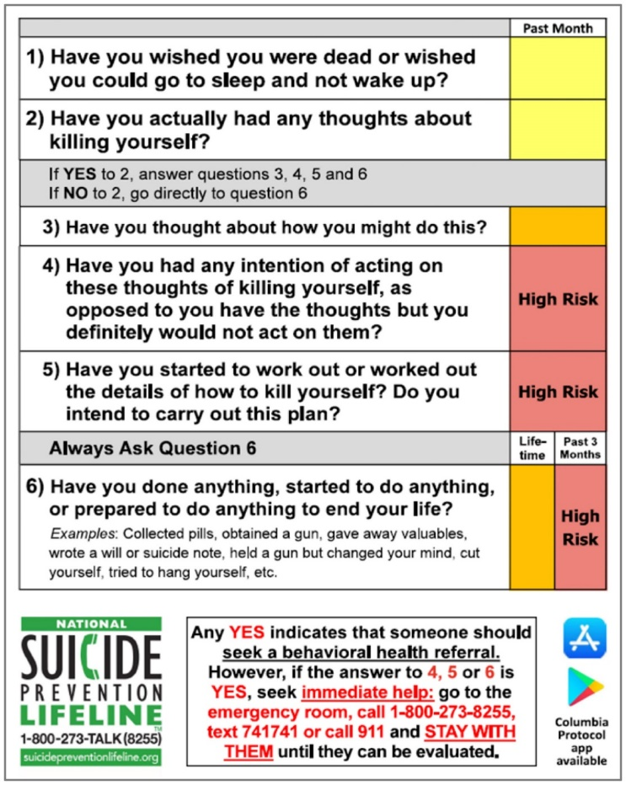

Sexual Assault, Abuse and Prevention Resources

Referrals and Information*

Sexual Assault Prevention and Response, or SAPRO
Oversees DOD sexual assault policy and provides free information and resources for victims of sexual assault.
Eligibility:
- Everyone
Available Monday-Friday, 8 a.m. to 5 p.m. ET by phone.
571-372-2657
https://www.sapr.mil/about-sapro

Rape, Abuse, and Incest National Network, or RAINN
Offers free confidential support services to survivors of sexual assault. When you call, you will be routed to a local RAINN affiliate organization based on the first six digits of your phone number.
Eligibility:
- Everyone
Available 24/7 by phone or online live chat.
800-656-4673
https://rainn.org

Transitional Compensation Program
Provides financial assistance to military spouses who are victims of domestic abuse in the event the active- duty service member has been administratively separated or court-martialed for a dependent abuse offense.
Eligibility:
- Military spouses
Contact the Family Advocacy Program at your installation to learn more.
https://www.militaryonesource.mil/family-relationships/relationships/relationship-challenges-and-divorce/transitional-compensation-help-for-victims-of-abuse

National Domestic Violence Hotline
Provides free information and assistance to anyone affected by domestic violence.
Eligibility:
- Everyone
Available 24/7 by phone.
800-799-7233

Safe Helpline
Provides free anonymous help, information and resources to military members affected by sexual assault.
Eligibility:
- All service members
- Military spouses
- Dependent children 18 years of age and older
- DOD civilian employees and their family dependents 18 years of age and older when they are stationed or performing duties outside of the United States
- U.S. citizen DOD contractor personnel when authorized to accompany armed forces in a contingency operation OCONUS and their U.S. citizen employees
Available 24/7 by phone or online live chat.
877-995-5247
https://www.safehelpline.org/

* See page 2 for counseling resources for sexual assault.

Sexual Assault, Abuse, and Prevention Resources

Local Resources
REACH-S Facilitator: Please update the fields highlighted in yellow with resources applicable to your installation and target audience.

Domestic Abuse Victim Advocate
Assists clients in determining what to do, where to get help and how they choose to report the assault.
Eligibility:
- Service members and their families experiencing domestic abuse
Available 24/7 by phone.
ADD PHONE # HERE

Sexual Assault Response Coordinator, or SARC
Serves as the single point of contact to coordinate sexual assault victim care. Tracks the services provided from the initial report of a sexual assault through disposition and resolution of the victim’s healthcare and support service needs.
Eligibility:
- Service members and their families
Available by phone.
ADD PHONE # HERE

Family Advocacy Program, or FAP
Provides services to address challenges that contribute to abusive and neglectful relationships.
Eligibility:
- Active-duty service members and their families
Available in person or by phone.
ADD ADDRESS HERE
ADD PHONE # HERE
ADD WEBSITE HERE

Family Violence Prevention Services
Provides housing/shelter assistance, counseling and legal services to individuals affected by domestic violence.
Eligibility:
- Service members and their families
Available 24/7 by phone.
ADD PHONE # HERE
Add WEBSITE HERE

Employment Resources

Military Spouse Employment Partnership
Connects military spouses with hundreds of partner employers who have committed to recruit, hire, promote and retain military spouses.
Eligibility:
- Military spouses
https://myseco.militaryonesource.mil/portal

USAJOBS
Provides a non-competitive process designed to help military spouses find jobs in the federal government.
Eligibility:
- Military spouses
https://www.usajobs.gov/Help/working-in-government/unique-hiring-paths/military-spouses/

Spouse Ambassador Network
Provides free military spouse education and employment resources. The Spouse Ambassador Network is a group of like-minded organizations that are affiliated with the Military Spouse Employment Partnership and are dedicated to raising awareness of military spouse education and employment resources.
Eligibility:
- Military spouses
https://myseco.militaryonesource.mil/portal/content/view/1494
Hiring Our Heroes – U.S. Chamber of Commerce Foundation
Provides free employment tools, development opportunities and resources to connect the military community with civilian companies.
Eligibility:
- All service members
- Military spouses
- Veterans
https://www.hiringourheroes.org/military-spouses

Spouse Education and Career Opportunities Program
Provides free education and personalized career guidance to military spouses worldwide and offers comprehensive resources and tools for all stages of career progression.
Eligibility:
- Military spouses
https://myseco.militaryonesource.mil/portal

CareerOneStop
Provides free employment, education and relocation resources.
Eligibility:
- All service members
- Military spouses
- Veterans
https://www.careeronestop.org/MilitarySpouse/default.aspx

Service Branch Resources

Army

Family Readiness Group
Provides family members with free resources, support and information about their soldier’s Army unit.
Eligibility:
- Soldiers and their family members
- Department of Army civilians and their family members
https://www.armyfrg.org/skins/frg/home.aspx

Army Morale, Welfare and Recreation Program
Supports readiness and resilience by providing a variety of activities and services, find your local MWR through website below.
Eligibility:
- Soldiers and their family members
- Civilian employees
- Military retirees
- Eligible participants for as long as they are associated with the Army
https://www.armymwr.com

Army Emergency Relief
A non-profit organization that provides funds to help soldiers who have experienced an emergency with immediate financial needs, such as rent, utilities and emergency travel. Find your local office through website below.
- Soldiers and their family members
https://www.armyemergencyrelief.org/assistance/
GoArmy Families
Provides free information and resources on what to expect when you or your loved one joins the Army.
Eligibility:
- Everyone
https://www.goarmy.com/parents/army-families.html

Army Strong Bonds
A unit-based, chaplain-led program that builds resiliency by strengthening Army families. Strong Bonds is conducted offsite using a retreat format in order to provide a fun, safe and secure environment to discuss relocations, deployments and other military lifestyle stressors.
Eligibility:
- Soldiers and their family members
https://www.strongbonds.org

Service Branch Resources

Navy

Family Suicide Prevention Gatekeeper Training
A suicide prevention training designed to teach Navy families how to accurately assess and respond to someone at risk for suicide. For more information on how to receive this training, contact your installation chaplain or the Fleet and Family Support Program, or FFSP.
Eligibility:
- Sailors and their family members
https://www.mynavyhr.navy.mil/Support-Services/21st-Century-Sailor/Suicide-Prevention/Command-Leaders/Gatekeeper/

Navy-Marine Corps Relief Society
Provides emergency financial assistance with basic living expenses, such as food, rent, utilities, assistance with emergency transportation, funerals, medical and dental bills, essential car repair, pay problems and other emergency needs. Assistance is provided with loans or grants, depending on financial need. Find your local office through website below.
Eligibility:
- Sailors and their family members
https://www.nmcrs.org/pages/call-or-visit-an-nmcrs-office-today

Naval Services Family Line
Provides families with free mentoring, education and resources to create a strong home front.
Eligibility:
- Navy, Marine Corps and Coast Guard families

https://www.nsfamilyline.org

Navy Morale, Welfare and Recreation Program
High-quality, customer-focused, programs and services that contribute to resiliency, retention, readiness and quality of life.
Eligibility:
- Sailors and their family members
https://www.navymwr.org

Fleet and Family Support Program
Supports individual and family readiness through free programs and resources that help Navy families stay resilient, well-informed and adaptable in the Navy environment.
Eligibility:
- Sailors and their family members
https://www.cnic.navy.mil/ffr/family_readiness/fleet_and_family_support_program.html

Navy Ombudsman
Communicates regularly with command families, provides free information and outreach, appropriate referral resources and acts as an advocate for command families.
Eligibility:
- Sailors and their family members
https://www.cnic.navy.mil/ffr/family_readiness/fleet_and_family_support_program/work-and-family-life/ombudsman_program.html

Service Branch Resources

Marine Corps

Marine Parents
Provides free support, information and creates opportunities for the public to support military troops through outreach programs.
Eligibility:
- Marines and their family members
https://www.marineparents.com/

Marine Corps Community Services
A comprehensive set of programs that support and enhance the operational readiness, war-fighting capabilities and quality of life.
Eligibility:
- Marines and their family members
- Marine retirees
- Civilians associated with the Marine Corps
https://www.usmc-mccs.org

Operational Stress Control and Readiness Program
Teaches Marines to help each other by understanding the stages of operational stress with a four-tier color system that makes identifying who needs help fast and easy.
Eligibility:
- Marines
Available in person.
https://usmc-mccs.org/articles/having-trouble-with-stress-talk-to-an-oscar-member/

Family Readiness Office
Reinforces the relationship between the unit, the unit members and their families.
Eligibility:
- Marines and their family members
Available in person.
https://usmc-mccs.org/services/family/unit-personal-and-family-readiness

Combat and Operational Stress Control
Training to prevent, identify and reduce stress as early as possible to promote long-term health and well-being among Marines and their family members.
Eligibility:
- Marines and their family members
https://www.marsoc.marines.mil/Unit-Home/Personal-Family-Readiness/COSC/

Navy-Marine Corps Relief Society
Provides emergency financial assistance with basic living expenses, such as food, rent, utilities, assistance with emergency transportation, funerals, medical and dental bills, essential car repair, pay problems and other emergency needs. Assistance is provided with loans or grants, depending on financial need. Find your local office through website below.
Eligibility:
- Marines and their family members
https://www.nmcrs.org/pages/call-or-visit-an-nmcrs-office-today

Marine Awareness and Prevention Integrated Training
A “one-stop shop” for training and education on behavioral health-related topics. Designed to proactively manage challenging situations and improve your ability to address behavioral health issues, such as substance abuse, suicide, family advocacy and combat and operational stress, before they become unmanageable.
Eligibility:
- Marines and their family members
https://www.usmc-mccs.org/articles/mapit-umapit-map-what/

Service Branch Resources

Air Force and Space Force

Spouse Resiliency Toolkit
An interactive website that empowers military spouses with resilience skills and provides free resources and tools to strengthen military families and mission readiness. Each module of the toolkit offers opportunities to watch, read, listen and interact with the content.
Eligibility:
- Air Force spouses
https://spousert.wpengine.com/introduction

Heart Link
Program that provides free information to help Air Force spouses get to know their surroundings and adjust to Air Force life with ease.
Eligibility:
- Air Force spouses
Available in person.
https://afas.org/community-programs/

Air Force Emergency Financial Assistance
Helps relieve any financial distress and provides assistance in financing higher education goals.
Eligibility:
- Airmen and their family members
https://www.afas.org

Key Spouse Program
Provides free information and support to enhance readiness, personal and family resiliency, and establish a sense of Air Force community.
Eligibility:
- Airmen and their family members
https://www.afpc.af.mil/Benefits-and-Entitlements/Key-Spouse-Program

Air Force Resilience
Website that provides tools, programs, resources and connections to local and national assistance for crisis prevention, intervention, and postvention.
Eligibility:
- Airmen and their family members
https://www.resilience.af.mil/

Family Suicide Prevention Training
A free video-based bystander intervention training that helps Air Force families recognize warning signs of distress, understand different options for intervening, and available resources. Encourages viewers to appreciate the importance of being proactive and developing strong protective factors.
Eligibility:
- Airmen and their family members
https://wingmanonline.org/Programs/Video-Training-Modules

Behavioral Health Optimization Program
Provides mental health assessments, education, consultation, and treatment including individual and group counseling. Reach out to your primary care provider or your installation military treatment facility to receive more information on how to begin this program.
Eligibility:
- Airmen and their family members
https://www.military.com/military-report/af-behavioral-health-optimization-program.html

Blue Grit Podcast
Free podcast that features conversations with current and former military leaders, mental health experts, elite athletes, veterans and other individuals who have overcome significant adversity.
Eligibility:
- Airmen and their family members
https://soundcloud.com/user-52299767

Service Branch Resources

National Guard/Reserve

Personal and Family Readiness Toolkit
Provides free information, worksheets and checklists to ensure preparation for deployment and resources for family support.
Eligibility:
- National Guard members and their families
https://www.nationalguard.mil/Portals/31/Documents/ARNGpdfs/familyresources/Family-Readiness-Toolkit.pdf

Navy Reserve Resources
Provides contact information for resources to support and inform Navy Reserve members.
Eligibility:
- Navy Reserve members and their families
https://www.mynrh.navy.mil

Guard and Reserve Family Readiness Toolkit
Provides free information about benefits and entitlements, pre/post-deployment readiness and resources to empower families.
Eligibility:
- National Guard and reserve members and their families
http://asktop.net/wp/download/14/CDR ToolKit-FRG.pdf

Yellow Ribbon Reintegration Program
Promotes the well-being of National Guard and reserve members, their families and communities by connecting them with free resources throughout the deployment cycle.
Eligibility:
- National Guard and reserve members and their families
Available in person or by phone.
303-429-3530
https://www.yellowribbon.mil
Joint Services Support for the National Guard
Provides free information about the resources and programs available to the National Guard members and their immediate family at the state and unit level, as well as how to make the most of federal benefits and resources provided for all service members.
Eligibility:
- National Guard members and their families
Available 24/7 by phone, secure video, or online chat.
800-342-9647
https://www.militaryonesource.mil/national-guard/joint-services-support-program

Army Reserve Family Programs
Provides a single gateway to responsive family crisis assistance and helps Army Reserve soldiers and their families connect to resources within their community.
Eligibility:
- Army Reserve soldiers and their families
http://www.usar.army.mil/Family-Programs

Marine Reserve Family Readiness Officer
Military point of contact that manages and promotes all unit family readiness. Find your unit’s FRO on website provided.
Eligibility:
- Marines, sailors, and their families
https://www.marforres.marines.mil/family-readiness-office

Service Branch Resources

National Guard/Reserve (cont.)

National Guard Family Program
Provides free support and resources to educate families on every phase of Guard life — from planning for deployment to coming home.
Eligibility:
- National Guard members and their families
https://www.militaryonesource.mil/national-guard/national-guard-family-program

TRICARE Choices for National Guard and Reserve Handbook
Provides free information about the TRICARE options for National Guard and reserve members.
Eligibility:
- National Guard and reserve members and their families
https://tricare.mil/-/media/Files/TRICARE/Publications/Handbooks/NGR_HB.ashx

Social Media, Video and Mobile Resources

Blogs, TED Talks, Apps and Reports

Blog Brigade
Provides free blogs on self-care, experiences, challenges and military life tips from other military spouses.
https://blog-brigade.militaryonesource.mil

How Right Now
Provides free resources and inspiration to help you stay positive and remind you of your strengths.
https://howrightnow.org/

TED Talks
Features free talks on individuals’ military perspective and experiences.
https://www.ted.com/topics/military

Weight of Gold
Explores the mental health challenges that Olympic athletes often face.
https://www.hbo.com/documentaries/the-weight-of-gold

Clinician's Corner Blog
Provides free blogs that discuss current topics of interest for psychological healthcare providers in the Military Health System.
https://pdhealth.mil/news/blog

Morale, Welfare and Recreation Digital Library
Provides free online resources to service members and their families, such as e-books, audiobooks, databases and reference books that can help you learn a new skill, keep kids engaged and help with their homework, or prepare you to land your next job.
https://www.militaryonesource.mil/recreation-travel-shopping/recreation/libraries/morale-welfare-and-recreation-digital-library

Facebook Groups
To view any of the Facebook Groups resources and information, you will need to have an active Facebook account. Some of these groups are private and you will need to request to join the group.

FOCUS Project
Offers training designed to strengthen couples and families in readiness for tomorrow. Builds on current strengths and teaches new strategies to enhance communication, problem solving and goal setting.
Eligibility:
- Military families and couples
310-794-2482
Email: info@focusproject.org
https://www.facebook.com/FOCUSResiliencyTraining

Military Families Homeschool
Connects military families to people and resources for homeschooling help.
Eligibility:
- Military families
https://www.facebook.com/groups/569811153040974

PTSD Support for Family and Spouses
Provides support to those suffering from PTSD and their family, friends, spouses and significant others.
Eligibility:
- Everyone
https://www.facebook.com/groups/1928956160740695

Social Media, Video and Mobile Resources

Facebook Groups (cont.)

Military Spouse Mental Health Support Group
Provides support for military spouses who may be battling a mental illness or know someone who is.
Eligibility:
- Military spouses
https://www.facebook.com/groups/341538876521018

National Military Family Association
Provides support and programs to strengthen and enhance the quality of life for every military family.
Eligibility:
- Military families
https://www.facebook.com/militaryfamily

Social Media, Video and Mobile Resources

Mobile Apps
Scan the QR code by using your cellphone camera. Point your camera at the QR code and it will prompt you to open your web browser where you will see the option to download the app either on the App Store or Google Play, depending on your device (IOS or Android). Download the app and begin using it!

My Military OneSource App
A free app that connects users to resources available through Military OneSource to help them reach their goals, overcome challenges and thrive.
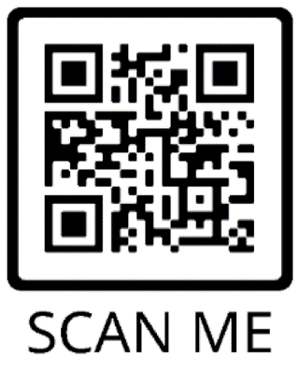

Defense Health Agency Apps
A collection of apps that provides information and support to individuals dealing with behavioral health issues and traumatic brain injury. The apps can be downloaded for free on either Android or iOS devices.
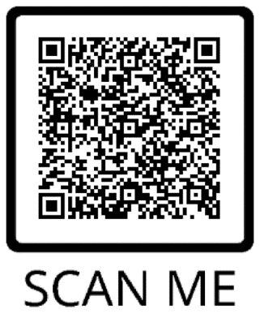

Chill Drills
A free app developed for the military community that provides a collection of audio exercises to help users relax and manage their symptoms of stress.
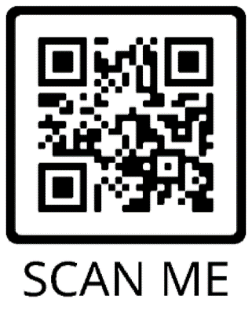

Mindfulness Coach
A free app developed by the VA offering a slow-paced, self-guided training program designed to help people understand and adopt a simple mindfulness practice.

Couples Coach
A free app developed by the Veterans Administration that provides an opportunity for partners to improve their relationship and explore new ways to connect.
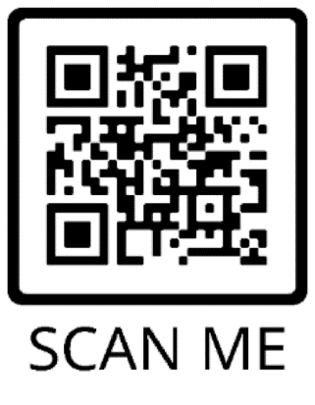

Social Media, Video and Mobile Resources

Mobile Apps (cont.)

T2 Mood Tracker
A free app that allows users to monitor their moods on six scales (anxiety, stress, depression, brain injury, post-traumatic stress, general well-being). Users can also add or customize additional scales. T2 Mood Tracker compiles the user’s ratings in each of these areas and creates a graph to help see patterns.
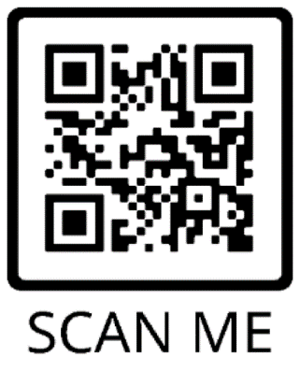

Breathe2Relax
A free app that provides a hands-on diaphragmatic breathing exercise that helps stabilize mood and control anger.
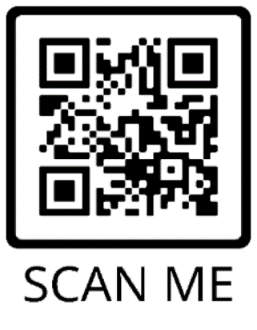

Virtual Hope Box
A free app that provides simple tools to help individuals with coping, relaxation, distraction and positive thinking.
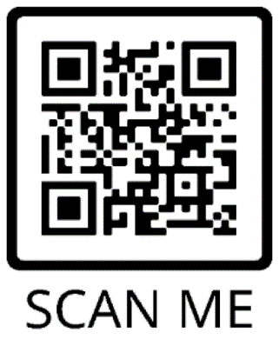

Sesame Street for Military Families
A free app that provides access to engaging videos, articles, storybooks, parent guides and more to help military families support their preschool and school-aged children as they encounter transitions common to military life.
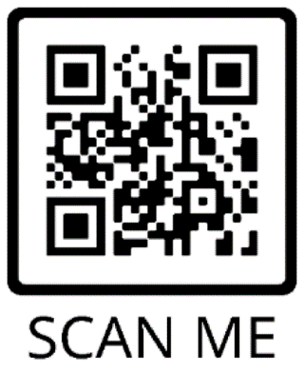

PTSD Family Coach
A free app developed by the VA that provides extensive information about PTSD, how to take care of yourself, how to take care of your relationship with your loved one or with your children, and how to help your loved one get the treatment they deserve.
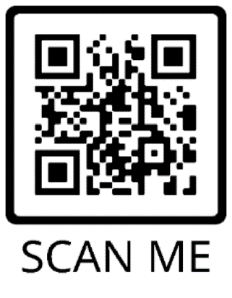

Positive Activity Jackpot
A free app developed by the DHA that uses pleasant event scheduling, a behavioral therapy, to overcome depression and build resilience. The app helps users find local activities, provides suggestions and invite friends to any activities.
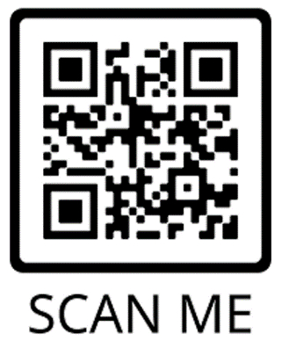

Other Important Resources

Practical Concerns
REACH-S Facilitator: Please update the fields highlighted in yellow with resources applicable to your installation and target audience.

Child Care — MilitaryChildCare.com
Provides free access to comprehensive information on military-operated and military-subsidized child care options worldwide.
855-696-2934, select option 1
https://militarychildcare.com
ADD LOCAL CHILD CARE SERVICE CONTACT INFO HERE

Child Care – Military OneSource
Provides free access to a national database of more than a million caregivers to find hourly, flexible and on-demand child care.
800-342-9647
https://www.militaryonesource.mil/family-relationships/parenting-and-children/military-childcare-services

Transportation
Connects you with local resources that include public transportation, installation shuttle, car pool and Lyft/Uber information.
https://www.va.gov/healthbenefits/vtp/resources.asp
ADD LOCAL PUBLIC TRANSPORTATION CONTACT INFO HERE

Busy Schedule
Provides information about free resources, programs and tools to help manage challenges and navigate through military life.
800-342-9647
https://www.militaryonesource.mil/family-relationships/spouse/spouse-resources/

Finding a Provider
Helps you find a provider whether you are relocating, traveling or looking for a new doctor near home.
https://www.tricare.mil/FindDoctor
ADD LOCAL PROVIDER RESOURCE WEBSITE HERE

Personal Career Concerns
Connects you with free, personalized and confidential help to assist with your career. This resource can be especially helpful when transitioning out of the military or PCSing.
800-342-9647
https://www.militaryonesource.mil/confidential-help/specialty-consultations/spouse-relocation-transition

Difficulty Scheduling Appointments
Provides access to information on how to book appointments, depending on your insurance plan. Enables you to ask questions, get healthcare advice and find out if you should get care.
TRICARE Nurse Advice Line
800-TRICARE (874-2273), select option 1.
https://www.tricare.mil/FindDoctor/Appointments

Navigating Insurance
Provides free resources and information on various healthcare services available and connects you with a consultant to receive personalized assistance.
800-342-9647
https://www.militaryonesource.mil/health-wellness/healthcare/health-care-resources

Cost
Helps calculate any costs related to healthcare services depending on insurance plan.
https://www.tricare.mil/Costs
Provides a variety of resources to save money and manage expenses.
https://www.militaryonesource.mil/financial-legal/personal-finance/personal-finance-resources

