

# Military Spouse Recruitment Guide

RESOURCES EXIST, ASKING CAN HELP- SPOUSE

## TABLE OF CONTENTS

**TABLE OF CONTENTS 1**

**Purpose 2**

**Utilizing Family Readiness System and Installation Resources 3**

Other Installation Outreach Ideas 3

**Leveraging Social Media 4**

Sample Social Media Posts 5

**Scheduling Considerations 7**

**Elevator Pitch for Leadership and Military Spouses 8**

Sample Elevator Pitch for Leadership 8

Sample Elevator Pitch for Military Spouses and Partners 8

**REACH-Spouse Logo Images 9**

Logo 1 9

Logo 2 9

**REACH-Spouse Recruitment Flyer 10**

Version 3, March 2024 (OPA-2021-035, PERSEREC-PA-20-21)

## Purpose

This guide is designed to assist you with recruiting military spouses for your REACH-Spouse sessions. We understand that recruitment can be challenging and there is no one-size fits all solution for all facilitators and installations. Importantly, we frequently hear from past facilitators that while getting people “in the door” can be hard, many military spouses leave the REACH-Spouse session with a renewed sense of appreciation and optimism. We encourage you to use the ideas in this guide as you see best fit for your individual recruitment situation.

We strongly recommend that you come up with an “elevator pitch” to use as part of your recruitment efforts. For example, when you speak with military spouses and other stakeholders about this program, you can share that “REACH-Spouse is meant to empower military spouses to take charge of their mental health and well-being. It is also meant to “peel back the curtain on their service members’ barriers to care and teach spouses critical suicide prevention skills.”

Most importantly, we’ve learned from past REACH-Spouse facilitators that military spouses are more likely to attend your session if they have been contacted personally or have been told about it by a close friend, co-worker, or someone they know. For this very reason, we recommend contacting potential attendees in person, by phone, text message, or email. Although it is more time consuming, individual outreach is much more likely to result in a session full of engaged spouses.

## Utilizing Family Readiness System and Installation Resources

Each service branch has its own family readiness program (e.g., Family Readiness Group [FRG], Fleet & Family Support Center, Airman and Family Readiness Center, etc.) that organizes regular events for military families. Consider reaching out to the family readiness program specific to your service branch to request that they share information about the planned REACH-Spouse sessions at their events for military spouses. The FRG may also be able to connect you with unit-level FRG Leaders (Army), Key Support Liaisons (Air Force), Ombudsmen (Navy), and Family Readiness Officers (Marine Corps) who have their own mailing lists with military spouse contact information. Monthly or quarterly Spouse Forum events hosted by the FRG could be another great avenue for advertising the REACH-Spouse sessions.

### Other Installation Outreach Ideas

* Connect with installation and unit-level chaplains to see if they have ideas on how to advertise the sessions and which spouses to invite.
* Chaplains often organize their own events for military families where REACH-Spouse sessions can be advertised; they also often maintain their own email lists for advertising events.
* Connect with Military and Family Life Counselor(s) (MFLCs) at your installation, if applicable, to see if they can assist with advertising the sessions to military families.
* It’s also a great idea to invite the MFLC to attend your REACH-Spouse session to act as a resource representative.
* Advertise REACH-Spouse sessions to spouses who are new to the installation at Newcomer’s Orientation events.
* Spouses tend to actively seek out resources during the first couple of months after making a permanent change of station (PCS) to a new location.
* Reach out to programs that directly support military spouses and families (e.g., Exceptional Family Member Program [EFMP], new parent support groups), and ask if you can advertise at their events and programs.
* Advertise REACH-Spouse sessions at pre-deployment briefings for military spouses.
* Reach out to leadership (e.g., first sergeants, unit commanders) to provide a brief overview of REACH-Spouse and ask if they can share information about the scheduled sessions with spouses in their unit. As an additional idea and a possible incentive, leaders might consider offering the service member time off in order for their spouse to attend the session. If childcare is an issue, this solution could work especially well.
* Post flyers in high traffic locations (e.g., on-base housing, community centers, local schools and childcare centers, dining facilities, Military Treatment Facility (MTF), Commissary, Starbucks, library).
* Connect with your installation’s advertising department to see if you can partner with them to advertise REACH-Spouse sessions on the installation’s website, flyers, or marquees.

## Leveraging Social Media

Social media is another helpful tool you can use to recruit military spouses for your REACH-Spouse sessions. It has a wide reach, allows for targeted advertising to specific audiences, is cost-effective, and interactive. Below, we have provided some tips for how to use social media to your advantage while advertising your sessions. We have also supplied some sample social media posts for various platforms that you can personalize as needed.

* We recommend using social media (e.g., Facebook, Instagram, LinkedIn, Twitter) to connect with spouses and share information about the scheduled REACH-Spouse sessions.
* You can share information about REACH-Spouse sessions in Facebook groups; join the relevant groups and share your session details with the members. Make sure to follow the group rules and avoid spamming.
* You can also create an event page on Facebook or LinkedIn and invite military spouses to attend. Make sure to include all relevant details, such as date, time, location, and a brief description of what the session will be about.
* If using Twitter, you can tweet engaging content about the upcoming REACH-Spouse session leading up to it; you can also share periodic updates about the session on Facebook and LinkedIn to generate interest and anticipation from prospective attendees.
* When advertising the sessions on social media, be sure to use visually appealing graphics. You can also use the REACH-Spouse logo found in this guide.
* You can encourage military spouses to share session details with their friends; just remember that these sessions are only for military spouses, significant others, and parents of service members. They are not for service members.
* Always check with your Public Affairs Office first to secure approval to share information about REACH-Spouse sessions on social media.
* Use the sample social media posts below to recruit spouses on approved platforms.
* Text highlighted in yellow and in all capital letters (i.e., date, time, location, email address, and phone number) will need to be personalized to your session’s information.
* To use the posts and image below, you can:

1. Copy and paste to transfer the information you like to the platform of choice.
2. Right click to save the images (if applicable).
3. Use your device’s screenshot capability to screenshot the post/image you are interested in and save it to your device.

### Sample Social Media Posts

#### Post 1

Are you a military spouse or a partner interested in learning more about resources available to you and your service member? REACH-Spouse sessions empower military spouses to take charge of their mental health and well-being! We provide resources and tools to connect those in need with the support they deserve. Let’s talk and learn together!

* REACH-Spouse Session 1 delves into **military spouse** challenges, resources, and self-care basics.
  + DATE, TIME, LOCATION
* Session 2 focuses on the **service member’s** challenges, resources, and suicide prevention skills for military spouses.
  + DATE, TIME, LOCATION

To learn more or sign up, please email EMAIL ADDRESS or call PHONE NUMBER.

#### Post 2

Military families face daily challenges that range from minor to really difficult. REACH-Spouse is a DoD program designed to help military spouses and partners overcome barriers to care and unique challenges, especially when it comes to their own and their service member’s mental health and well-being. REACH-Spouse offers two unique sessions that are designed to create an encouraging and supportive environment for spouses to connect with each other.

* REACH-Spouse Session 1 delves into military spouse challenges, resources, and self-care basics.
  + DATE, TIME, LOCATION
* Session 2 focuses on the service member’s challenges, resources, and suicide prevention skills for military spouses.
  + DATE, TIME, LOCATION

Email EMAIL ADDRESS or call PHONE NUMBER to learn more or sign up for one of the sessions!

#### Post 3

Many of us look for connection and validation from others, especially when we go through stress and tough times. If you are a military spouse or a partner to a service member, we have a program designed just for you! REACH-Spouse aims to help military spouses take charge of their mental health and well-being. There are so many great resources out there that can help you and your family! Come learn about them in a small group discussion with other military spouses. We will share our knowledge and support each other! Two sessions are offered:

* REACH-Spouse Session 1 delves into military spouse challenges, resources, and self-care basics.
  + DATE, TIME, LOCATION
* Session 2 focuses on the service member’s challenges, resources, and suicide prevention skills for military spouses.
  + DATE, TIME, LOCATION

Email EMAIL ADDRESS or call PHONE NUMBER to learn more or sign up for one of the sessions!

#### Suggested Graphic to Use with Social Media Posts

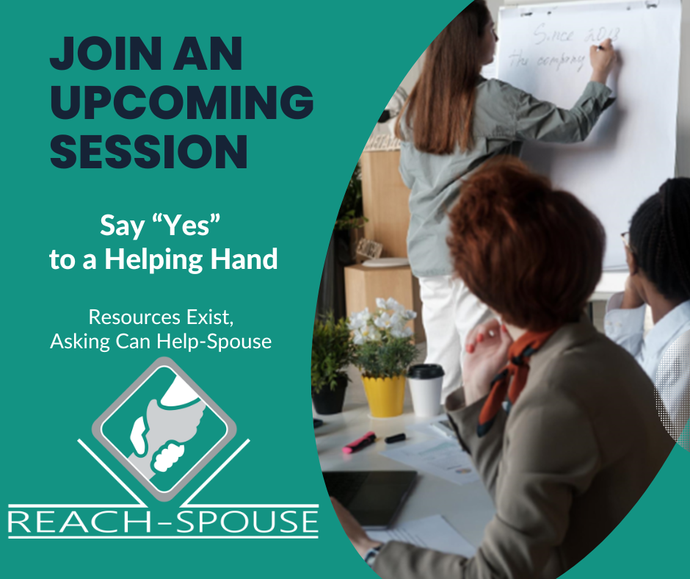

## Scheduling Considerations

When scheduling your REACH-Spouse sessions with military spouses, it is important to consider their family responsibilities and availability. Here are some scheduling tips to help maximize the attendance at your sessions:

* Time of day: Consider scheduling sessions during times that are convenient for stay-at-home parents, such as late morning or early afternoon when children may be napping or at school. Another option may include offering evening or weekend sessions to accommodate schedules of spouses who work during the day.
* Location: When selecting a location for your session, it is important to consider the proximity of the location to the attendees’ homes. If the majority of your attendees live on post, consider holding the session at a central location on base, for example, the Family Support Center, Education Center or Community Center. These centers often have conference rooms that can be reserved for events and meetings. If the majority of spouses do not live on base, then a local community center or a library might be a more suitable location.
* Format: Consider offering flexible session formats (e.g., in-person, hybrid, or virtual) to avoid the need for parents to travel or arrange for childcare. Appendix A of the REACH-Spouse Facilitator’s Manual explains how to prepare to lead a virtual REACH-Spouse session.
* Childcare: Consider offering childcare in an adjacent room or encouraging parents to bring their children to the session if needed.
* If it’s not possible to provide childcare, consider holding the REACH-Spouse session in a kid-friendly setting that already offers childcare or offers some child-friendly activities (e.g., the library). Bonus if you can provide snacks for the children!

## Elevator Pitch for Leadership and Military Spouses

An elevator pitch is a brief and compelling summary of your program that can be delivered in the time it takes to ride an elevator. Having an elevator pitch for REACH-Spouse is essential because it allows you to communicate the most important aspects of this program quickly and effectively to potential stakeholders and session attendees. Your elevator pitch should capture the essence of REACH-Spouse and its benefits for your installation’s community, and persuade potential stakeholders to take action (i.e., commanders to endorse and advertise this program to service members in their units and military spouses to attend your session). Your elevator pitch should be clear, concise, and memorable.

We encourage you to customize and use the elevator pitch examples below when describing the REACH-Spouse program to leadership and military spouses who may attend your session.

### Sample Elevator Pitch for Leadership

REACH-Spouse is a DoD-wide suicide risk prevention program that aims to get to the left of the boom. Its main goal is to destigmatize mental health and encourage military spouses to seek help early, before their problems spiral out of control. Research shows that many spouses often don’t know where to go for help or may not be willing to reach out to resources for help. Through REACH-Spouse, we aim to fill this gap by removing barriers to care and helping military spouses get the support they need for themselves and for their service member. There are two unique sessions led by a trusted facilitator who could be a military spouse or a civilian:

* Session 1 focuses on **military spouses’** barriers to seeking mental health care, resources for addressing these barriers, and self-care practices.
* Session 2 focuses on the **service members’** barriers to seeking mental health care and teaches military spouses valuable suicide prevention skills. Parents and not just military spouses could attend Session 2, as they are also important gatekeepers.

### Sample Elevator Pitch for Military Spouses and Partners

Being a military spouse is no easy feat and we often struggle with life issues and problems that others don’t face. REACH-Spouse is a DoD program designed to serve as an avenue for starting a conversation about these challenges with other military spouses. Its goal is to empower military spouses to take charge of their mental health and well-being. It’s also meant to peel back the curtain on what our service members go through by walking through their challenges and barriers to getting the help they need. There are so many great resources out there that can help you and your family!

There are two sessions being offered:

* Session 1 focuses on **military spouses’** barriers to seeking mental health care, resources for addressing these barriers, and self-care practices.
* Session 2 focuses on **service members’** barriers to seeking mental health care and teaches military spouses valuable suicide prevention skills.

## REACH-Spouse Logo Images

### Logo *1*



### *Logo 2*



## REACH-Spouse Recruitment Flyer

We created a REACH-Spouse recruitment flyer, found on the next page, that can be customized to advertise your sessions. This flyer can be sent electronically or it can be printed and posted around the installation.*

Some ideas on where to place/share the flyer on your installation may include:

* Child Development Center
* Schools
* Community Centers
* Library
* Clinic/Hospital
* Commissary
* Playgrounds
* Coffee Shops
* On-Base Housing
* Installation Fitness Center
* Morale, Welfare, and Recreation Center
* Other Spouse-frequented Areas

*Please keep in mind that you may need to ask for permission to post the flyer in certain places.

 

REACH-Spouse

Resources Exist, Asking Can Help-Spouse

REACH-Spouse is a program designed to empower you to take charge of your mental health and well-being. Please join us for a 2-hour small group discussion with other military spouses where you will learn how to confront barriers that stand in the way of getting help and how and where to reach out for support.

***Participants will learn how to:***

* **Overcome** challenges when it comes to seeking mental health support
* **Connect** with supportive resources
* **Meet** other military spouses who share similar struggles
* **Embrace** and practice self-care
* **Support** your service member’s mental health and well-being

**REACH-Spouse Session 1:**

*Overcoming Barriers, Finding Resources and Thriving as a Military Spouse*

* **Date and Time:**
* **Location:**

To sign up, contact:

**REACH-Spouse Session 2:**

*Supporting Your Service Member’s Mental Health and Well-Being*

* **Date and Time:**
* **Location:**

To sign up, contact: