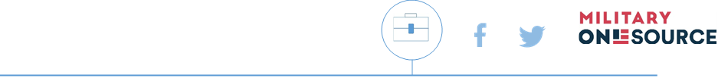
Military OneSource
Habit Hackers Toolkit

FACEBOOK POSTS | TWITTER POSTS | RICH MEDIA
Self-Reflection Social Post
Link: https://www.militaryonesource.mil/health-wellness/mental-health/mental-health-support/healthy-habits-to-better-yourself/
Tough times make it easier to fall into harmful habits, and military life is far from easy. Learn what to watch out for and where to turn if it’s time to regain control. [LINK] | Tough times make it easier to fall into harmful habits. Learn what to watch out for in your own life and where to turn if it’s time to regain control: [LINK]. #ReTheMe #SelfCare | 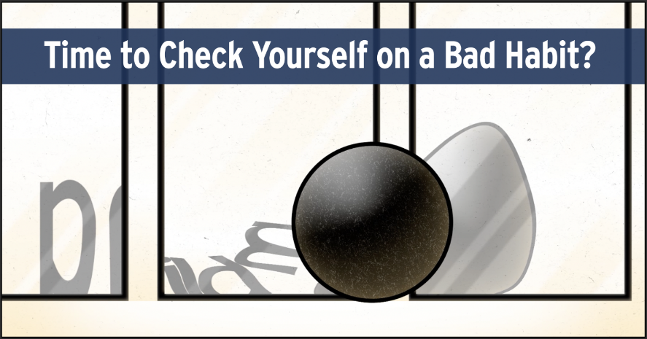

FACEBOOK POSTS | TWITTER POSTS | RICH MEDIA
Signs of Trouble Social Post
Link: https://www.militaryonesource.mil/health-wellness/mental-health/mental-health-support/healthy-habits-to-better-yourself/
Ever feel like you’re in over your head? Or like you’re losing ground to a bad habit? Take a second to reflect and learn where to get backup if it’s time to reclaim control. [LINK] | Ever feel like you’re losing ground to a bad habit? Take a second to reflect and learn where to get backup if it’s time to reclaim control: [LINK]. #ReTheMe #SelfCare | 



